KAHOOT
Our collaborative story and multilingual dictionary
Noemi from Slovakia created the quiz about our collaborative story in the Kahoot. The link is the following one: https://create.kahoot.it/details/collaborative-story/197d955c-565a-43d0-bd8e-7ef2d5673a73

Kika from Slovakia created for us the quiz about our multilingual media dictionary.
The link is: https://create.kahoot.it/share/our-multilingual-media-dictionary-kahoot-quiz/c1ca7352-a6e9-4a99-b36c-a5872f7831fe
.
When you join a challenge created by our Slovak team, you can play it in the app. at your own pace. In this game mode, questions and answers are displayed on the device screen. You can also launch and host games live directly from the app. You can use your iPad screen, put it up on a bigger screen using AirPlay and Apple TV, or Chromecast.
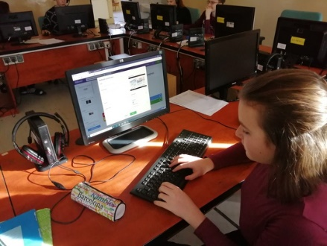
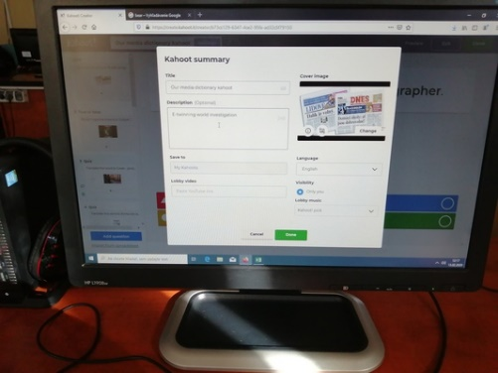
If you are not signed into the kahoot quizes, you can still play them as the guest. You can upload the kahoot directly into your tablets , or phones. When you click on the links , just press: play the quiz as the guest. After that you can choose classic, or team mode. You can join in through the notebooks, PC,in this case the web page you have to type is: www.kahoot.it, or tablets and phones directly through the downloaded app.Kahoot. Then just type the game pin and the quiz is ready to be played.

