How should your dream future look like?
Questionnaire
Team from Slovakia

Do you want to have kids?
Do you want to get married?
Do you want to live in the house or a flat?
Do you want to have a car?
Do you want to have a pet?
Do you want to travel?
Do you want to make something big in your life?
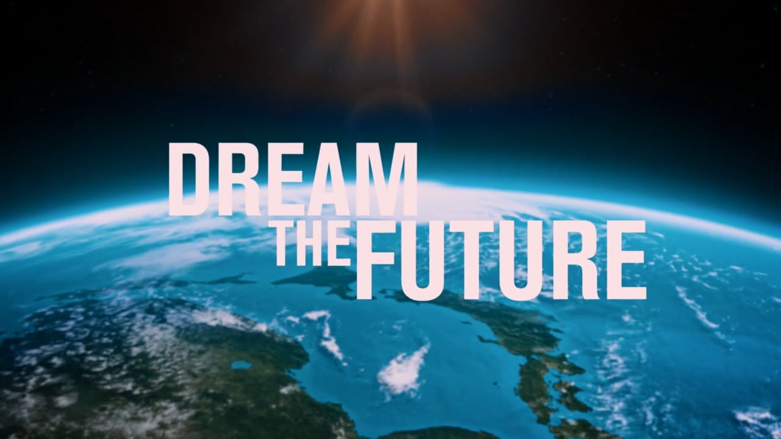
We have decided on this topic because these questions are addressed by every adolescent

