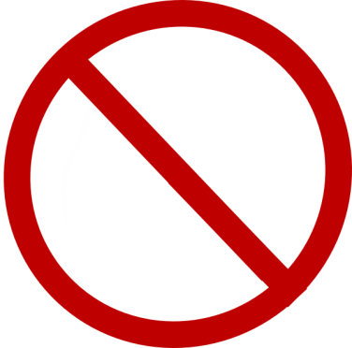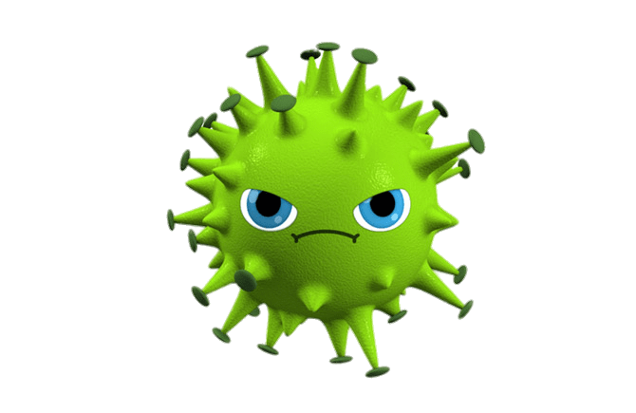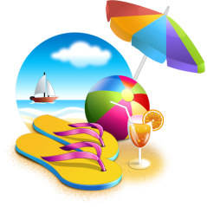

*To the future reader,*

I am writing to you as a result of my boredom during this lockdown. I must surely say to you that I hope you still respect those hygiene rules and that you take care of yourself and your beloved ones. I can tell you that it hasn’t been an easy journey and that most of us have dealt with either sadness, overthinking and many others. I hope besides these aspects that you understand how important nature is and that we are guests in this world, welcomed with open arms. I must tell you that if you don’t obey to the rules of protecting yours surroundings, in my departure I will surely haunt you so you roll out of bed until you understand clearly.

As an ending I would like to thank you and your generation for becoming a better version of humanity and finally performing what has nature have been waiting for centuries and even more. Take care of yourself and not only and never forget to learn from the mistakes that are buried in the past chapter! ☺

Luminita☺

