Romanian Myths and Legends

The Legendary Baba Dochia - The return of spring

Baba Dochia (baba=old woman, in Romanian), a legendary figure of Romanian folklore, is connected with the arrival of spring, and it is perhaps one of the most well-known figures of Romanian mythology. Some sources say she is the mother of Dragobete, while others claim that Dochia was the daughter of the legendary Dacian king, Decebalus., the brave Dacians being the Romanians’ ancestors.
The daughter of Decebal is said to have thrown herself off a steep rock to avoid being captured by the Roman emperor Traian when the latter defeated her father. Even today, that mountain rock wears the Dacian princess’ name and tourists can admire it on their way to Ceahlau Peak, in the Carpathian mountains.

History of Dracula

The myth of Dracula is connected to Vlad the Impaler, who was the leader of Transylvania ( a Romanian historical province) and one of the fiercest enemies of the Ottoman Empire. Stories of his cruelty rapidly spread throughout Europe. In Romanian history, he is known as Vlad Țepeș, and he is called "the Impaler" because his favorite method of execution was impalement. The name of Dracula has its origin in his father's name, Vlad Dracul. (in Romanian drac means devil)
All these stories made Vlad one of the best-known Romanian medieval rulers, but when Bram Stoker's Dracula was published, a connection was made for the first time between Vlad Dracula and vampirism. Thus, the famous Count who Bram Stoker initially named Count Vampyr came into existence under the name of Dracula. But contrary to popular belief, Bram Stoker had little knowledge of Vlad Țepeș.
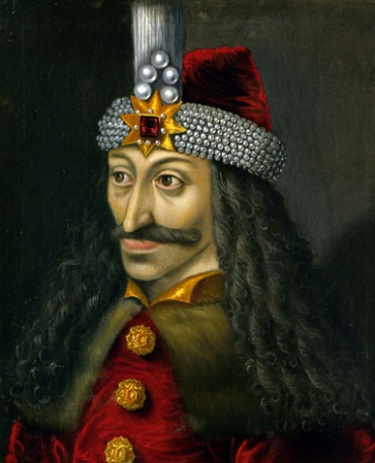 Portrait of Vlad the Impaler. Photo source: Wikipedia

The Ballad of Miorita – the defining Romanian myth

The Miorita ballad, is perhaps, the most eloquent Romanian folk poem ever created, summing up the most important beliefs of this nation. The poem is proof of the strong connection between man and nature in the Romanian people, and it inspired countless artists and poets throughout the years.This rhyme ballad has a very simple yet, profound story. Three shepherds from three regions of Romania – Moldavia, Wallachia, and Transylvania (Romanian historical provinces) – are going with their sheep in the mountains. The Moldavian Shepherd is though, wealthier, so the others, full of envy, come with a plan to kill him and steal his flock. But Miorita, the most faithful ewe of the Moldavian Shepherd, hears the plan and prevents her master(Miorita = the Romanian diminutive for ewe). The conversation between them is very emotional. Miorita asks the shepherd to take immediate measures to protect himself, but the shepherd does not do so. His reaction is rather intriguing. Death doesn't seem to scare him, in fact, he is willing to accept whatever will happen.
https://www.google.ro/url?sa=i&url=https%3A%2F%2Fmythslegendsblog.wordpress.com%2F2018%2F04%2F25%2Fthe-ballad-miorita%2F&psig=AOvVaw2mRd2OOrCHJOcPkEtEIB0R&ust=1591300371085000&source=images&cd=vfe&ved=0CAIQjRxqFwoTCMDPlou25ukCFQAAAAAdAAAAABAD

Sanziene – the Summer Fairies

The Sanziene are, together with Fates, mysterious fairies with magical powers that bless people and animals, strengthen marriages, and heal people. Their holiday is celebrated on the 24th of June each year, and it is filled with specific rituals, mainly focused on love and marriage.
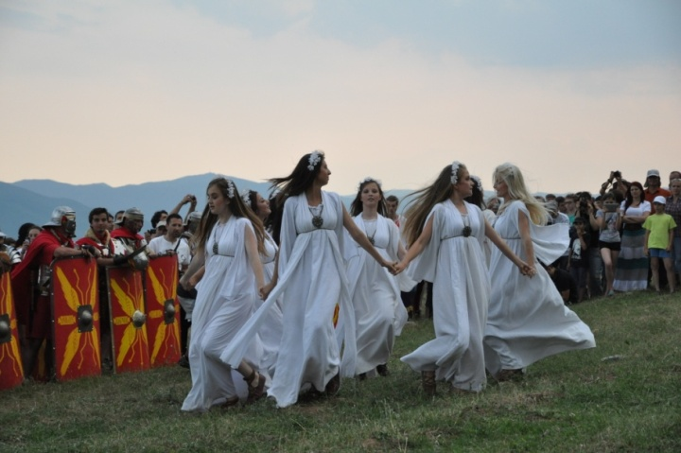https://ro.wikipedia.org/wiki/S%C3%A2nziene

