How Do We Communicate?
Slovak Team
Communicating with students during lockdown

Basically, we use two different teaching / learning school platforms. The main one is zsmtabraham.edupage.org mainly for the assignments , uploading different types of files and i tis also possible to create here online activities for your lessons. We can sign there directly from our school webpage. It’s really a good platform for systematic teaching and learning. The second one is bezkriedy.sk. We have also used Testy Alf. Students can practise here their skills and knowledge from different school subjects. At first I was a little bit afraid, but this period learnt me a lot. I have learnt how to use ZOOM. Now I use it every week for the online lessons with my pupils. The application that was really useful is also messenger. But there are still some students who send us their work via emails.
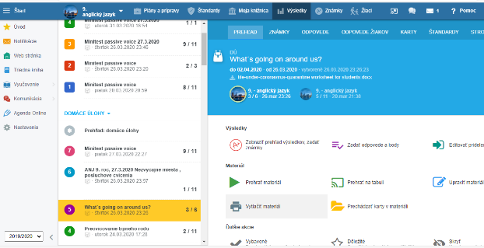
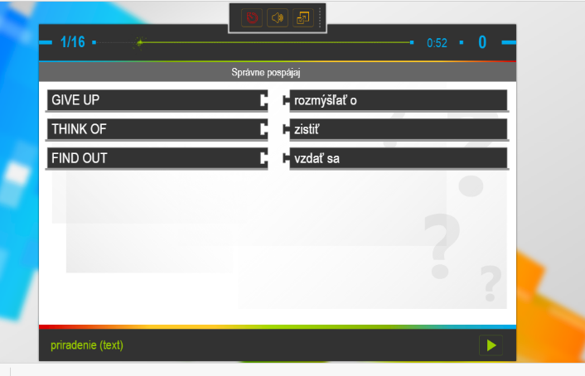
Testy ALF
Our second platform
Our main platform : edupage.org

