Fiche 6 anglais 4ème 1 et 2 ORDI eTwinning activities .
- Answer the online questionnaire ‘ ONLINE LEARNING’ . Suivez le lien et n’oubliez pas d’enregistrer vos réponses à la fin.
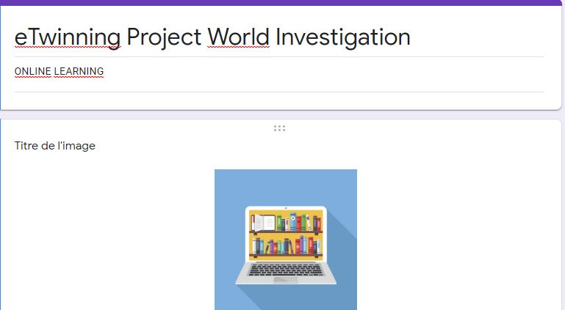

https://forms.gle/48drpuZphKS8As8g9

- Go to the following link and have a look at our partners’cookery pages. Then answer the following questions.
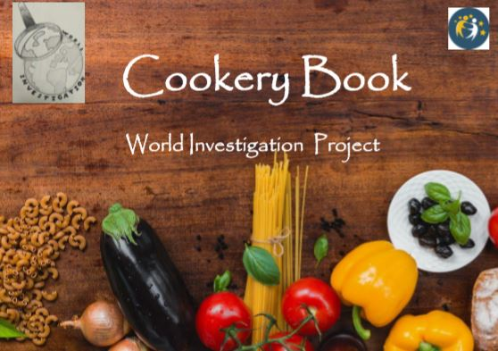

QUESTIONS
GREECE:
What is a Greek salad made of ?
What is the dish made of macaroni, béchamel and meat?
SLOVAKIA:
Is Kofola …? 1. A cake 2. An alcohol 3. A dessert
What is kapustnica?
What is the principal ingredient of LOKSE?
ROMANIA
Ciorba de Burta is a tripe soup right or wrong?
When is Cozonac eaten?

TURKEY
What does lahmacun look like ? (to look like ressembler)
Is there meat in Manti ?

MOROCCO
What is Baghrir? A sort of pancake a sort of couscous
What is the main ingredient of Bastilla?

CROATIA
What is the name of the Croatian Cabbage rolls? (roulé au choux)
Right or wrong ? Slavonia is a chocolate cake

JORDAN
What is the national dish of Jordan?
What kind of dish is Tushbera ?
KOREA
Bulgogi What does the word BUL mean in Korean?
Ttok-bok-ki is very popular in Korea . It is a
Rice cake? peanut cake? lemon cake?

3. Order your meal ! (passe ta commande) Imagine you are in an international restaurant ,Choose one dish per country
( présente tes choix en ajoutant une image de chacun des plats choisis)
Have a nice meal!

