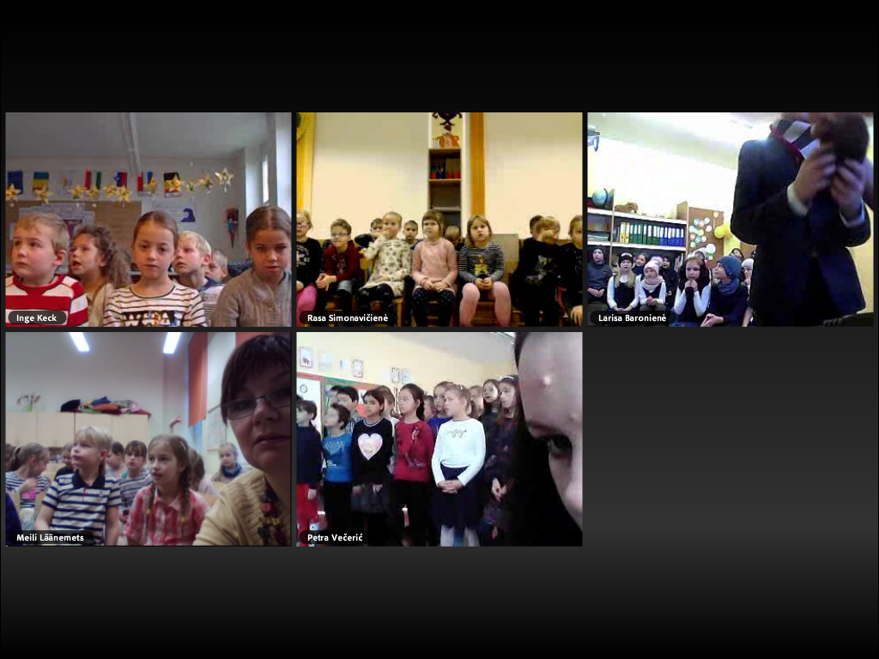
On the 24th of November ,2017 took place our first Live meeting.
During the meeting we sang the song „A handycraft man“. Every group did it very well.
After that we asked some English words from each other.
The meeting was very successful. Every group had prepared for it very well.

