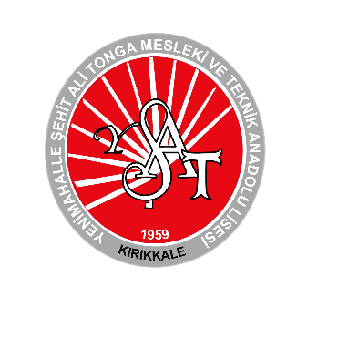

Agenda of the LTTA mobility meeting in Kırıkkale, Turkey
“Impacts of food systems on climate change-Impacts of climate change on food security and nutrition”

Date | Time | Type of activity | Cost
5. May 2022 - thursday |  | Arrival of teachers and students from partner schools
6. may 2022 - frıday | Welcoming at the school- Visits
 | 9 – 12:30 | Welcoming guests; Presentation of participants, schools, cities and countries, certificates-gifts ceremony, open buffet snacks at school (including local Turkish foods)
 | 13.00 -14:00 | University of Kırıkkale- Nutrition and Dietetics department- seminar on food security & sustainability and practices implemented in city- visiting labs
 | 14:00– 17:00 | Visits to nearby towns having products with geographical indication-Kılıçlar (onion/ store houses)- Delice (Mayi salt)- Kalecik (grapes and wine making)
 | 18:00- 19:00 | Dinner at Bahçeli Konak restaurant | 13 euro for each person= 200 turkish liras for each
7. May 2022 - saturday | Trip - Cappadocia-Ürgüp-Göreme-Uçhisar
 | 8:00- 11.00 | Departure of the bus in front of the hotel
 | 11:30 – 11.45 | Visiting underground cave storages for potatoes, lemon
 | 12:00 – 13:30 | Uchisar Castle, free time | 3,19 Euro for each person= 50 turkish liras
 | 13:45 – 14:30 | Lunch at restaurant - | 4,5 Euro for each person= 70 turkish liras
 | 15:00-16:00 | Zelve open air museum | 9,58 Euro for each person= 150 turkish liras
 | 16:15-18:00 | Avanos pottery making- free time
 | 18:15-21:00 | Turning back to hotel
8. May 2022 - sunday | Trip- Kırıkkale center- Keskin-Baliseyh-Delice-Çeşnigir Towns
 | 9.00-12.30 | Kırıkkale Local food/gastronomy center (Dinek), Kırıkkale, riding horse /atv safari/ zipline /  Delice Mayi Salt caves, Balıseyh lavender valley | Riding horse: 1,28 Euro for each person= 20 turkish liras for 5 minutes  Zipline: 1,60 Euro for each person= 25 turkish liras  ATV safari: 6,39 euro for each = 100 turkish liras
 | 13.00- 14.00 | Lunch at Çesnigir restaurant | 4 euro for each person= 50 -70 turkish liras
 | 14.00 – 15.00 | Keskin Sulu Cave, old pansions
 | 15.30-16.30 | Tour of Çeşnigir area, old caves, glass terrace, bridge from old times, boat tour on Redriver (the boats work by using sunlight instead of fuel) | Glass terrace enter: 0,64 euro =10 turkish liras for each person  Boat tour: 2 Euro =30 turkish liras
 | 17.00 – 18.00 | Dinner at Kebapcı Halil restaurant | 7-10 euros for each= 100-150 turkish liras
 | 19.00-21.00 | Free time- traditional wedding ceremony of Turkish couples  Students will have free time altogether at nearby park and cafes
9. May 2022 - monday | Departure of teachers and students from partner schools

- Transportation for cultural visits: 92 Euros for each person
- France= 92*5= 460 euro in total
- Serbia= 92*8= 736 euro in total
- Italy=92*4= 368 euro in total
- Greece=92*5= 460 euro in total

- From airport to hotel transfer:
France-Italy-Greece 250 euros, Serbia 300 euros
- Carmine hotel: Single room with breakfast and tax: 295 Turkish liras= 18,84 euros, Double room: 500 turkish lira = 31,93 euro, Triple room: 675 turkish liras=43,10 euro (I made the reservation of rooms that you sent me) Check in 5.5.2022- Check out 9.5.2022
- The hotel street is in the center having lots of cafes, fast food, coffee, …. The students can choose full menus for 3-5 euros. The activities above will be decided as to your wish. (boat tour, atv, horse riding, zipline…) You have the option to do or not. I just wrote all of them for the ones who want to try.
- For the menu at restaurants, you will decide here. (Red beef, kebap, red meat or chicken grill, with salads and appetizers, pita bread with vegetables or cheese or mince meat) Therefore, the menus will also include vegan diet.

Love Greetings,
Looking forward to see you
Kübra ERSAN

