Treasure Hunt in Nafpaktos
This is a team building activity that starts at school. Each transnational team will make use of the information pack, their orientation skills, creativity, and competitiveness in order to complete some missions, solve a series of problems and challenges, answer questions, take photos and videos in the quickest time possible while walking through the streets of Nafpaktos. Your team building activity in Nafpaktos will finish at Papoulis restaurant in the port. The awarding of the winners will take place in the final ceremony.

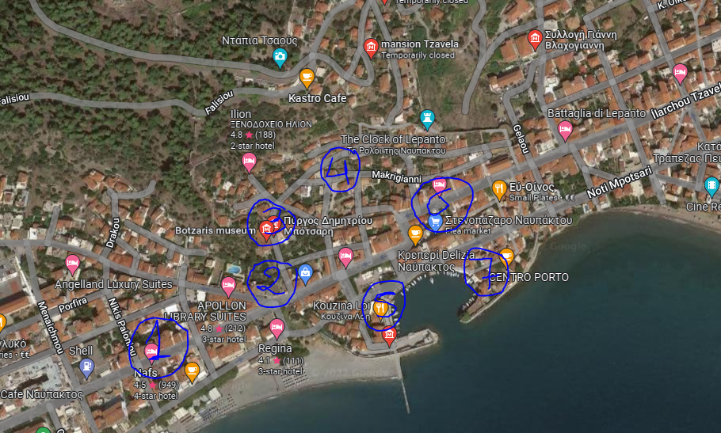

Information pack/missions
Mission 1
This Hall is an elegant building with an area of ​​520 sq.m. Its name is a tribute to Dimitrios Papacharalambous, who financed the purchase and construction of the building. This room consists of the main room with 325 seats, a tent, dressing rooms, and bathrooms. The purpose of the benefactor with the establishment of this hall was the realization of concerts, lectures, cinematographic and theatrical performances and entertainment dances, as well as the moral and spiritual education of the public.
- Find the place and take a group shelf photo in the stairs.
- Make a research so as to find where he was born and which other buildings have donated the same benefactor in our city.

Mission 2
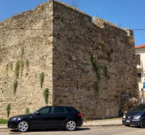
After ascending to the first castle wall, cross the main road, take a look at the Ottoman tower and the statue of Dimitrios Notis Botsaris. Walking to the paved road you will see a magnificent two building complex. It's known as the "Botsari Tower."

- Start taking a video of your team while walking in the area, describing what you see with a focus on the buildings’ architectural elements and whatever else impressed you.
Botsaris Tower was built in two phases in the 15th and 16th centuries. From the various architectural elements, the technocracy and in general from their interior decoration, we are led to the conclusion that Florentines and Venetians should have worked for their construction, as special craftsmen.
During the period when the Turks were holding Nafpaktos, they used it as a command post and as a residence for the Turkish commander. That is why they called it "seragi" which in Greek means mansion. After the surrender of Nafpaktos by the Turks to the Greeks, which, as is known from history, took place on April 18, 1829, the Greek government granted many of the former Turkish houses of Nafpaktos to homeless families of Souli, but also to families of Epirus, to settle in them, paying a sum of money proportional to the value of the house that would be given to them. This building complex was given to the family of the warlord fighter of the revolution 1821-1829, general Notis Botsaris.
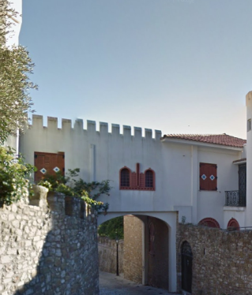
For this building complex, the impression prevailed that it was haunted. That is why they avoided it at night to approach and especially to pass under the "arch". The popular imagination that created this myth admitted that the element was the soul of the calf that was slaughtered in the foundation of the mansion, in order for its foundations to be strong and durable, at which time he considered the mansion as his own home and as his own people who lived in it. That is why he had undertaken the protection of the mansion and all those who lived in it. As they said, many had seen the element, some like a "black calf" and others like a "black horse" that did not matter unless you were trying or thinking of harming the mansion or the people who lived there, at which time it ate you.
The tower now belongs to the "Foundation of Demetrius and Aiglis Botsaris," and it houses a permanent exhibition of replicas of paintings, maps, and drawings from the Battle of Nafpaktos (1571 AD)

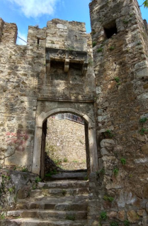
Mission 3
Between these two buildings passes a road, which starting from the western entrance of the city, leads to the Iron Gate which leads to the former mosque and consists of the only communication gate between the port of the Port and the district of the Mosque. Take a careful look at the machinolation box. Can you see the Horns of plenty (Amaltheia’s horn)? Legend says that this gate invites all the well-wishers to enjoy their stay but if you want to hurt the city a bad death could find you. That’s why there are these gaps in the underside. There was boiling oil placed so as to drop it to the attackers.
- Find the place and take a group photo in Sideroporta gate. Are you a well-wisher or an attacker?

Mission 4
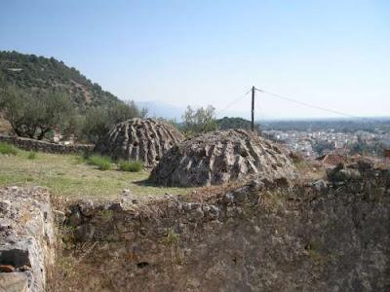
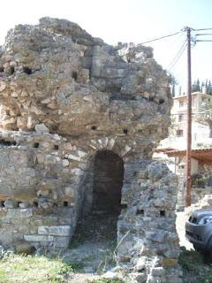
Continue a little bit so as to find yourself in the neighborhood of the Mosque with the small stone houses. Here after the liberation Souli fighters, who had also contributed to the liberation of the city, settled. You can now see the City Clock. It was erected in 1914 on the bastion of the second cornice of the castle and actually is called Bishop’s Serafeim Clock. Just above Clock there is the mansion of the Tzavela family. Tzavelas also contributed to the liberation of the city. This house is one of the few surviving old houses inside the Fortress. It has two floors with rich interior decoration. Recently, the building was completely renovated and hosts the 22nd Ephorate of Byzantine Antiquities. In the plateau of the Mosque district, the current square Giannis Vlachogiannis there’s a big plane tree and a stone fountain. A little above the remains from the base of a minaret are saved 2-3 turns from the narrow spiral staircase that twists on the central stone axis. Complexes of Turkish baths are preserved in relatively good condition.
We’ll visit all those another day while coming back from the Castle but now
- We would like to see a group photo with a view to the City Clock.

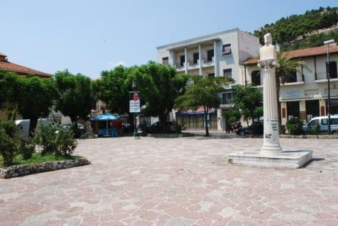
Mission 5
Go downhill; cross the main road and stop at the Port Square, where the bust of General Soutiotis Notis Botsaris rises in the center. The shadow of the two huge plane trees can cool you down, while at the same time you will have in front of you the view of the small picturesque Venetian port with a long history. The small, medieval port has an opening of 35 meters. Left and right to the entrance there are two towers which were constructed during the Venetian era. This is the lowest of the five enceintes and this is where the inner city is spread out. The port was an important transportation and commercial center that gave life to the city.
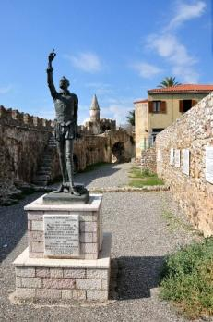
On the western arm of the port there are two statues of heroes that remind us of nautical events from the long history of this small town. The first is the famous Spanish writer Michael Cervantes Miguel de Cervantes was born in Madrid in 1547 .He became a soldier in 1570 and was badly wounded in the Battle of Lepanto; he lost his left hand. Since then the other name by which the greatest writer of the Spanish language was known was "EL MANCO DE LEPANTO”. He was captured by the Turks in 1575 and spent five years in prison. He was freed in 1580 and returned home. He died in 1616. Here you can see some commemorative marble inscriptions, tributes of the Embassies of the states involved in the Naval War. The place is called Park of Cervantes.
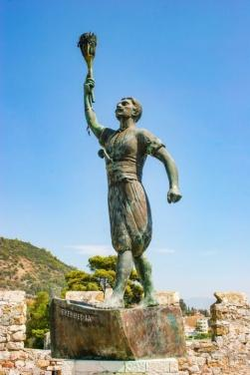
The other statue is the statue of Anemogiannis on the right tower of the medieval port. George Anemogiannis, also known as George of Paxous islands, was a hero and witness of the Greek revolution of 1821, a very brave man who lost his life as he was trying to set fire on Turkish ships outside our port. Although he managed to destroy some, the Turks got him and they roasted him on a spit, under the supervision of the Greek fleet. That’s why he seemed to keep a torch of fire and stand on a boat called “Freedom”.
- Take a group photo in front of the Statue of Cervantes
- Take a photo pretending you are George Anemogiannis.
- Take a group photo with a view to the Castle.

Mission 6
Go again to the Port Square. Continue at Stenopazaro, the old market of the city and at its end you will see the metropolitan church of Agios Dimitrios.
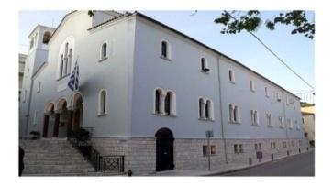
In its place there was a Byzantine church, which Bayezid II, in 1499, converted into a mosque and which in turn was transformed into a Holy Temple in 1830.
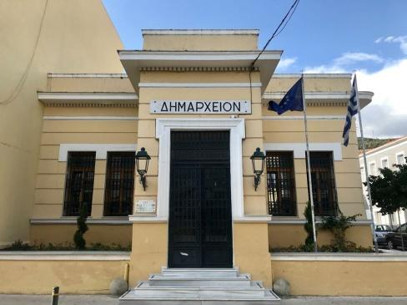
A little further is the City Hall. Here you can see the statue of an ambitious, altruistic and philanthropic doctor called Vardakoulas. At the base of the bust there’s a small inspirational epigram: "The rich doctor of the poor and the poor doctor of the rich"
Just above the City Hall is the Papacharalambous Library housed in a neoclassical building, built in 1955 by the city benefactor Dimitrios Papacharalambous. It is one of the best organized Public Libraries in the country with a rich collection of publications of local interest and part of the collection of the historian and writer Giannis Vlachogiannis, known as Giannis Epachtitis.
Just opposite the City Hall is the mansion of the writer Georgios Athanasiadis-Nova.

Mission 7

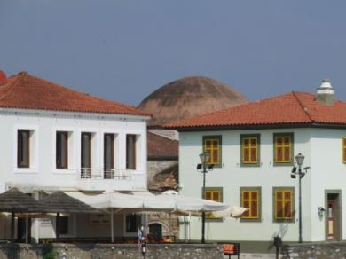
Walk back to Stenopazaro; cross the road so as to walk on the east pier of the port. At the edge of the eastern turret stands the naval lighthouse, a work of 1909. There is also the "Fethiye Mosque", erected by Sultan Bayezid II. Its name means the mosque of the conquest. Today, it’s renovated by the 22nd Ephorate of Byzantine Antiquities and can be visited for cultural events and exhibitions.
- Take a group photo in front of the City Hall
- Having in mind all those you have seen so far, what suggestion could you provide to the Mayor so that our city can become even more tourist friendly? Take a video with your messages to the Mayor.
- Take a group photo in the east pier of the port

Final Mission
Of course there is more to explore in our city-and we’ll do so in the next few days. Now it’s time to come to the end point (Papoulis restaurant). While waiting for your dinner to be served, please take part in this small Kahoot challenge! Be careful; don’t make use of your name but the name of your team! Of course, You can make use of this information pack, but remember: Time passes!!!

