IMPACT OF CLIMATE CHANGE ON ANIMALS MORPHOLOGY
Smaller and smaller animals, coats that change color... Studies showing the impact of global warming on the morphology of terrestrial fauna are multiplying. According to a new study, it would be responsible for another strange phenomenon: the enlargement of the brain of African elephants.
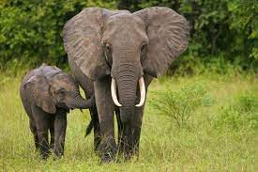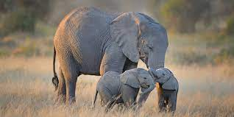
Out of the estimated 8 million animal and plant species on Earth, one million are now threatened with extinction. For the first time, researchers have managed to reconstruct a precise chronology of the evolution of the brain size of African elephants. Elephants' brains grow during periods of climate change to allow them to adapt and find solutions, for example by migrating more to find food or by developing a greater memory to better remember where to find water in times of drought.
in 2018, a study conducted by the University of Montana (USA) explained that the snowshoe hare - whose brown coat turns white in winter to camouflage itself in the snow and escape its predators - increasingly retains its brown hair year-round in the face of a lack of snow.
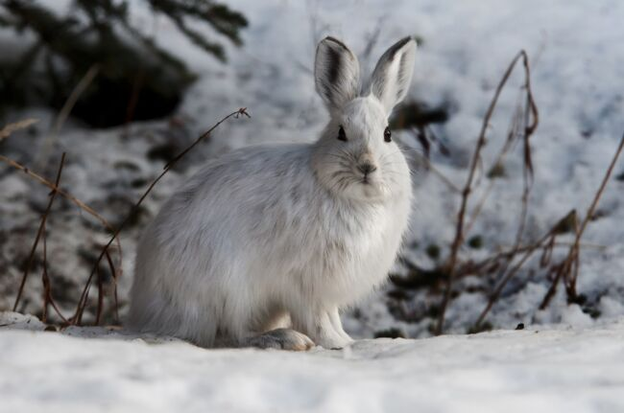
By Marie Prive- GEO- 02/07/2019

COMPREHENSION : answer the questions about the text
- Which animals are mentionned in the text ?
- How many millions species are threatened with extinction ?
- Why do scientists say that the elephants’brain grow during clime change periods ?
- Which colour is the snowshoe hare ?
- Which colour does it turn in winter ?
- Can you think about the reason why this change in colour won’t happen anymore ? ( it is linked to climate change)

