During this gallery walk, you are called to explore images related to each SDG providing multiple challenges that will influence our ability to meet the Sustainable Development Goals (SDGs). There are also some solutions.
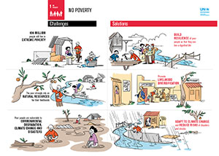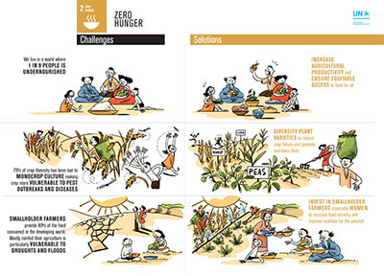

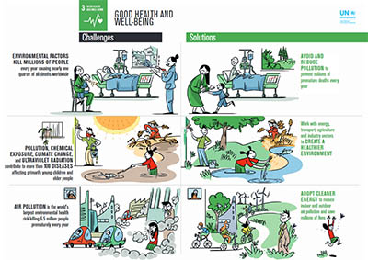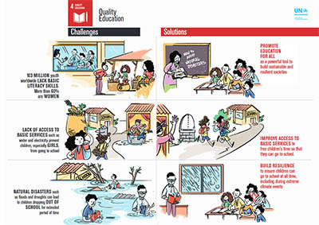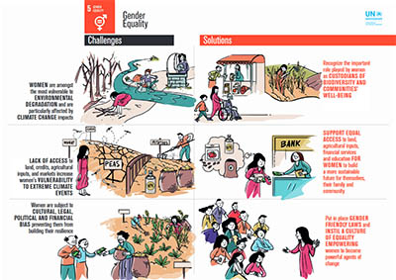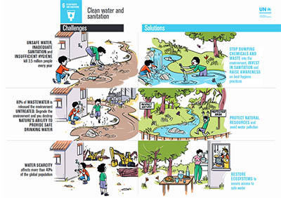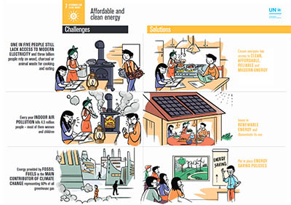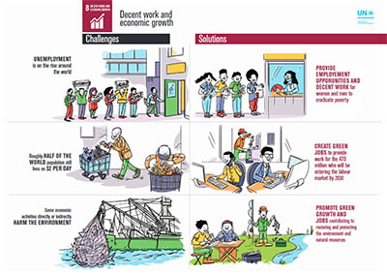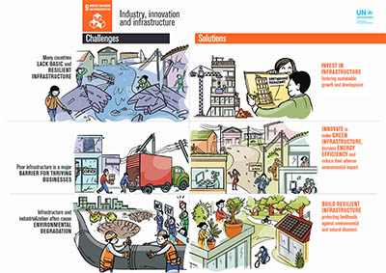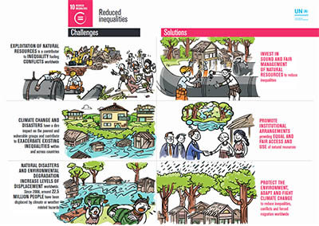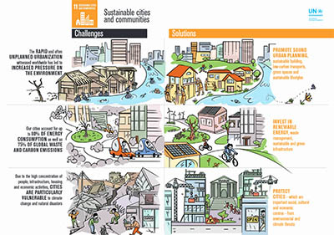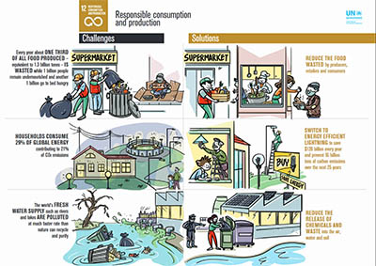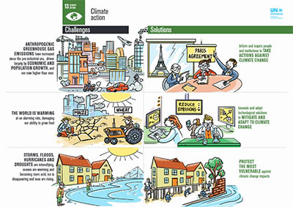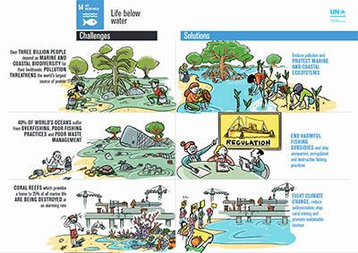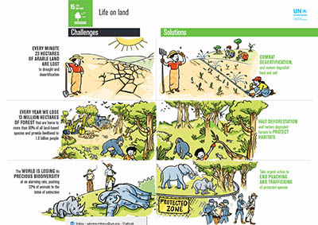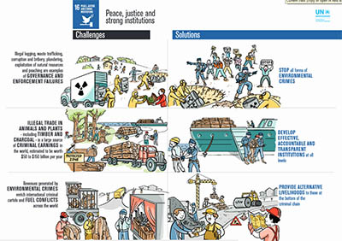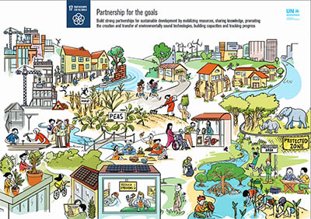Resource:https://www.unep.org/explore-topics/sustainable-development-goals/why-do-sustainable-development-goals-matter
Your task is to take a gallery walk in small groups (transnational teams) by dispersing around the room in a rotated way and provide some more solutions that could help achieve each SDG. How could technology and innovations help to achieve those SDGs?
Upon arriving at the first “station” write comments on the provided solutions or/and add some more and give responses in each one. You can also provide questions there, if something isn’t understandable. Please write in a pithy bulleted format and don’t repeat others' comments.
After a few minutes you have to rotate clockwise, to the next station. At the new station add new comments and respond to comments left by the previous group. This procedure continues until you have visited all stations. Then return to the station at which you started.
At this stage, you have to work on the following SDGs:
team 1: SDG1.2.3
team 2: SDG 4.5.6
team 3: SDG 7.8.9
team 4: SDG 10.11.12
team 5: SDG 13.14.15
team 6: SDG 16.17
Take a photo of all comments provided by all the teams by rotating to the stations regarding the above SDGs per team. Then sit down with your team so as to begin the "Report Out" stage. In this stage, you have ten minutes to discuss all those written for each SDG and upload to the activity padlet https://padlet.com/essayland2020/8kqu81pywj28d840:
- the photos taken
- a report as a group synthesizing what has been written about the solutions.
- your response in the question related to technology and innovation

