Our type of school
HLW Vöcklabruck

We are the Austrian students and we attend the „HLW Vöcklabruck“. In English it is called „Secondary school for economic professions“. This is a school with subjects like Accounting or Business Studies, furthermore we have cooking lessons for 5 hours a week and a subject called nutrition. Every pupil has to learn two modern languages: English and French. Apart from that some of us also learn Spanish.
This school lasts five years and we will graduate with the “Matura”. This is like the A-levels in the UK.
The school we attend is a private school.
In Austria we have got two semesters and at the end of every semester we get a school message with our grades on it.
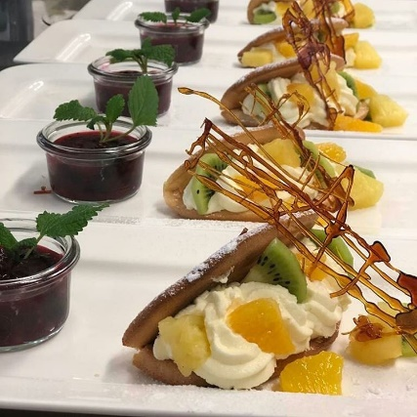
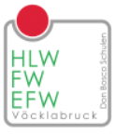
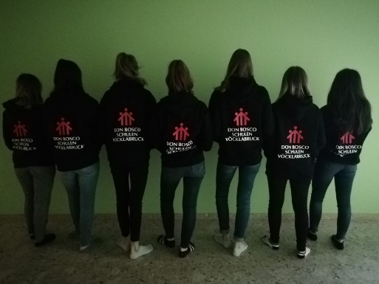
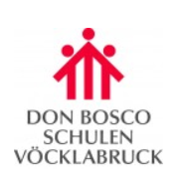
We have to do an internship after the third class. We can do it in Austria or in another European country. The work placement lasts 3 months and the pupils work in the kitchen or service of a restaurant or hotel.

