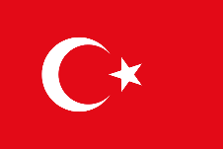
Krikkale (Turkey)

- Located 80 km east of Ankara
- Krikkale = broken castle
- Rapid rise in population

Turkey
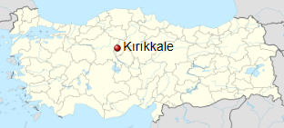

- declared a state in the Central Anatolia region of Turkey which is near Kızılırmak River = the red river
- the river is used to produce rice
- the natural vegetation is steppe type
- the culture is named „Kapadoka“
- some traditional foods are:
- Kahvalti (Breakfast): Sucuklu Yumurta, Sigara Böreği, Domates Salatası
- Çorbalar (Soups): Mercimek Çorbası, Bulgur Çorbası, Soğan Çorbası
- Meze (Starters): Antep Ezmesi, Havuç Ezmesi, Şakşuka
- Main Courses: Kebap, Köfte, Pide, Pilavlar
- Salads: Çoban salatası („Farmer’s Salad)“), Soğan salatası („Onion Salad“)
- Breads: Ekmek (White Bread), Francala (similar to our “Brötchen”)
- Desserts/Sweets: Baklava, Helva, Kemal Paşa Tatlısı
- The Downtown of Kirikkale is called „Kesik Town”
