Silvia Marrano
VOLLEYBALL
Sport is an important activity for our body because it keeps us healthy and strong. It is useful because it is a way to unload tension. Since I was a child, sports have always been my passion, in fact I play volleyball. Volleyball is a team sport that takes place between two teams of six players for each team. The goal of the game is to score points so that the ball touches the ground in the opponent’s field, separated by a net and at the same time prevent the opposing team from doing the same. Each team has a maximum of three touches to send the ball to the opposite field; players cannot block, throw or hold the ball.
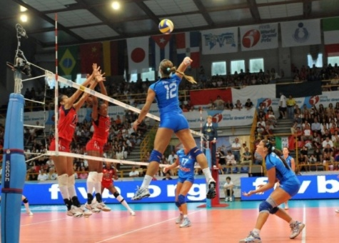
There are some “fundamentals” in volleyball. For “fundamentals” we intend specific actions that are carried out by the players of volleyball.
Volleyball skills are:
The DIG, it is use when the ball is too low to be dribbled or crushed.

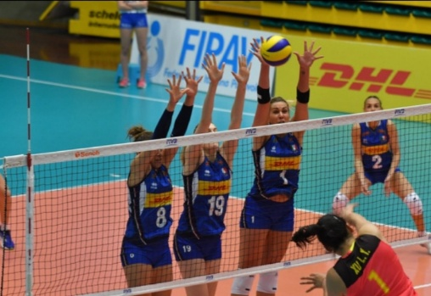

The ATTACK, it is used to send the ball into the opponent's field trying to get a point.

BLOCK - Also called "winning wall": used when multiple players jump in front of the attacker of the opposing team to prevent him from making a point.

The SET, it is one of the most important fundamental because with it we do almost all actions of attack.

