Crazy story of a little bunny

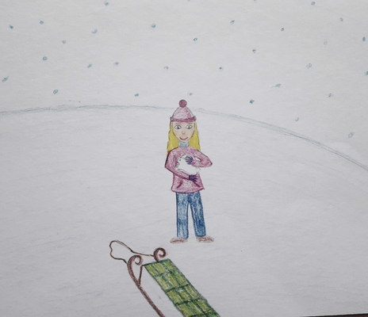
Once upon a time in a winter snowy country in a small village was living a little girl. When she saw how is snowing outside she said: „ I will take my sledge and go out“. She got dressed and went out. She put on her coat, boots, hat, gloves and a scarf.
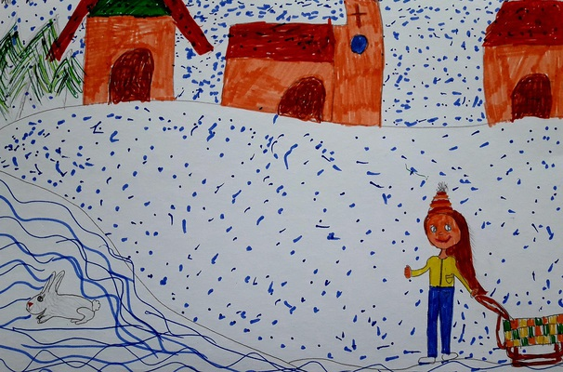
While she went out she saw this nice snowy lanscape. It was wonderfull.
She ran to a hill to enjoy the snow. When she was going up hill she met a small cute white bunny. It was covered with snow and she couldn´t see it. It moved and she was affarid of it. She picked it up and took off the snow.
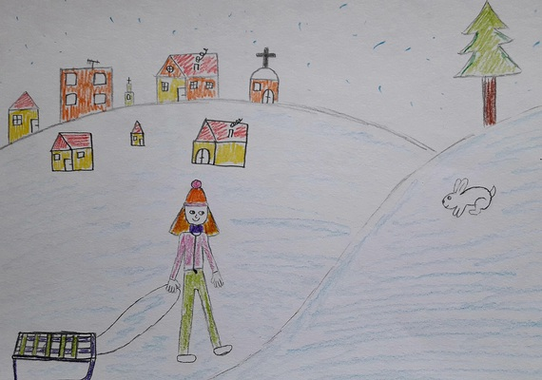
She decided to take it home and save it from the death freezing. She gave it a name Daisy. When they arrived home she put her on a blanket and she said: „Don´t worry, I will take care of you“.
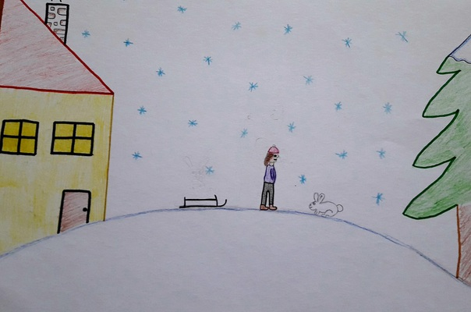

She puts her small bunny in front of the fireplace. She goes to the kitchen to take some carrots for the bunny. She gets carrots and goes back but she can’t see Daisy. She sees the blanket there. She is worried and looks for it. She finds it sleeping behind the sofa. Then she gets it on her lap gently. Daisy opens its eyes but it can’t move. It looks tired and ill. She gives the carrots to Daisy and tries to feed it. Meanwhile her mother comes back home. She is shocked when she sees a bunny at home.
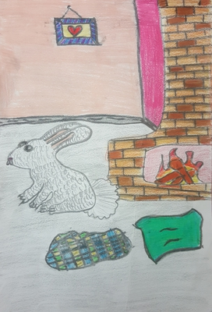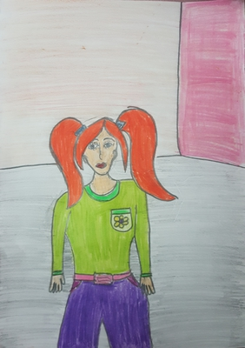
She asks her daughter:
-Where did you find this bunny?
Her daughter says:
-I found it while skiing with my sledge on the hill.
Her mother pities to bunny and lets her daughter to look after it.
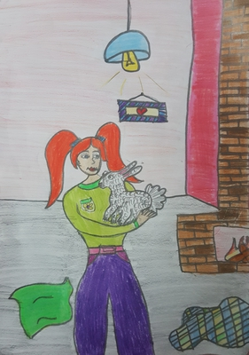
In the next morning, the girl goes out to take some woods to put into the fireplace but she can’t see the bunny when she comes back. She thinks Daisy escapes and she decides to chases it until she finds it.
She wears her thick clothes and goes out. She can’t see any sign outside. But, she doesn’t stop looking for Daisy. She goes far and gets lost. But, she doesn't know that Daisy is actually in front of the fireplace in the house. 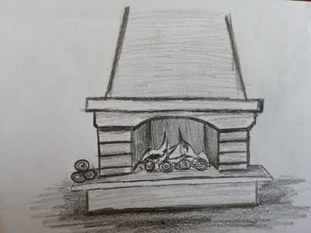

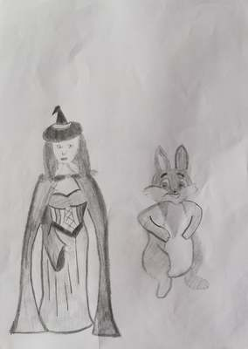
Daisy used her magic and hid herself because it was afraid. But the girl doesn't return. Daisy feels guilty and wonders the girl. Daisy goes after the girl. She looks for the girl.

After some time, Daisy hears a noise and sees the girl in a big hole. When the girl sees Daisy, she becomes happy:
Daisy! I was looking for you everywhere. But I fell.

Daisy turns around the hole.
I am sorry. Are you okay?
The girl is shocked.
Oh my God! A talking bunny!
Daisy answers:
I am so sorry. Actually, I didn’t leave your house. I was scared. I used my magic and became invisible.
The girl is shocked again.
How?
Daisy says:
I’ll tell you. But, I should rescue you first…
Daisy says:
„I don´t know your name, so I will call you Jane.“
The girl answers: „ Ohh sorry, my name is Mia, so call me Mia please“
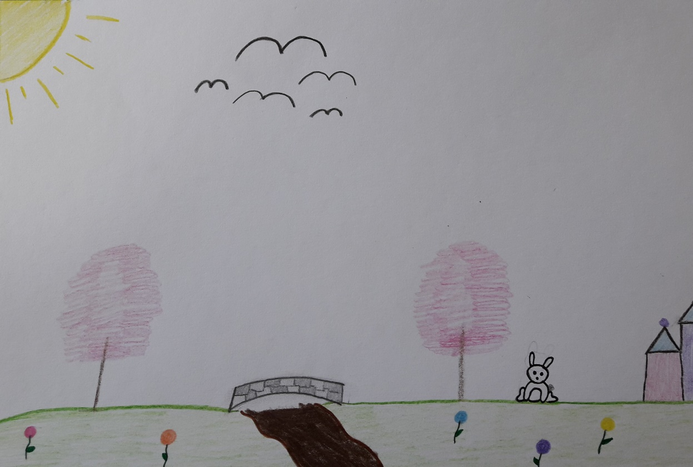
Daisy continue: „ I can do more than one magic.“ „I have got a magic bean. I will throw it to you and you will put it to the soil and it will grow up fast. So you can climb out of the hole.“
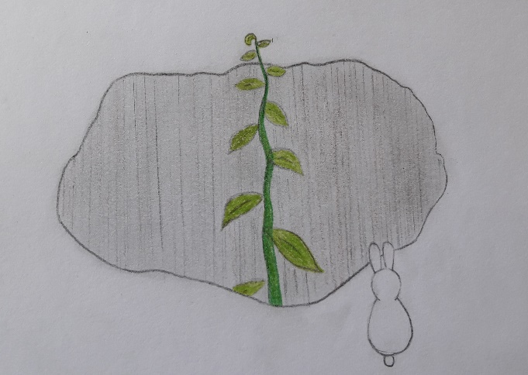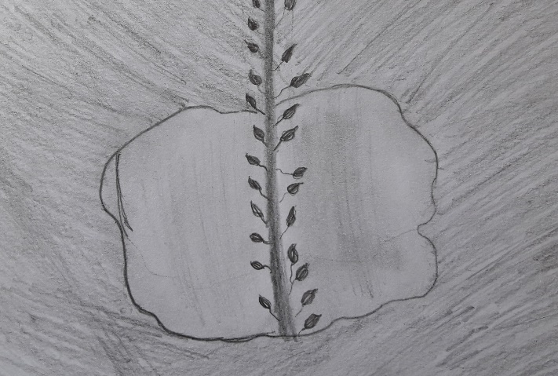
Everyone knows that to make a seed grow we need water. It´s winter and there is no water. But there is lot of snow.
Daisy says: „how do we make water?“ Mia shout from the hole: „ I have got matches in my pocket, because I wanted to make a fire before I went after you“
Daisy find a dry branch and make a fire to melt the snow and water the seed.
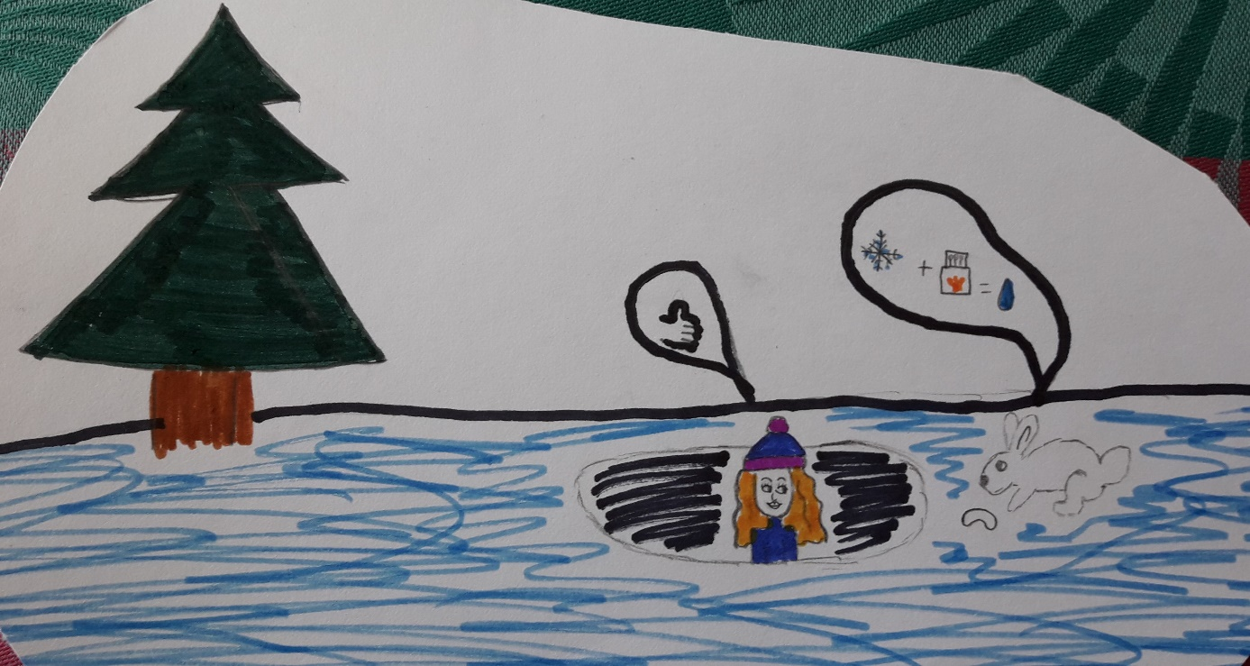
The seed grows very quickly and Mia can get out of the hole.
- „And now you will tell me about your magic“ said Mia.
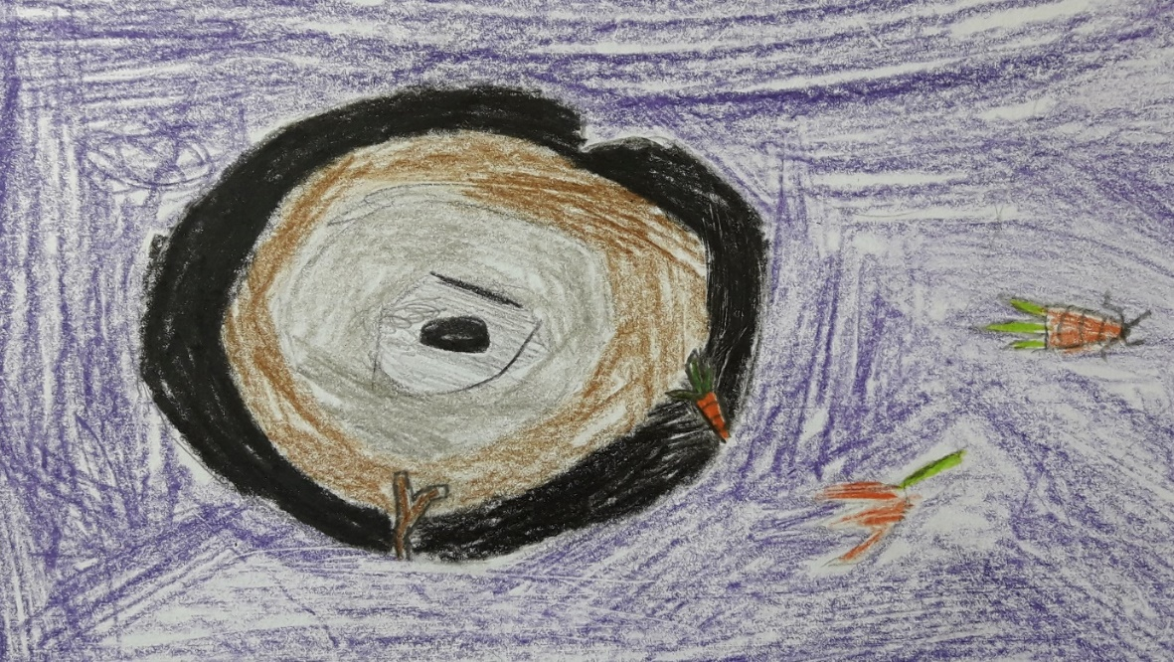

Daisy starts to tell its story:
-I have a magical village. Its name is “Magical Bunnies Village.” All of the bunnies can do magic there. We live there with our families.
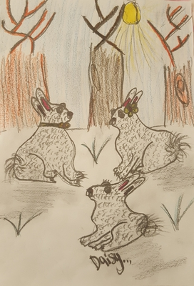
We have a huge cropland and we plant lots of magical carrots and get our power from these carrots.

In our village lives a bunny king. The bunny king rules the village in peace. There lived all of the bunnies with joy but one day our king got terribly sick.
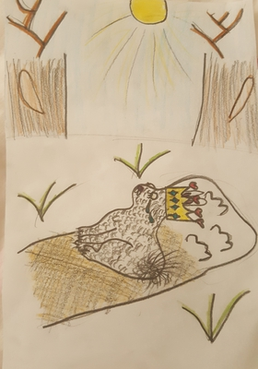
Then my father and mother went to the forest to find some healing herbs to make the king recover. There is a magical hole in our cropland to go to the forest but it’s dangerous for us to go there. The days passed but they didn’t come back. I went after them by passing the magical hole because I thought that evil witch captured them.

When I passed through the hole ,I got lost here.
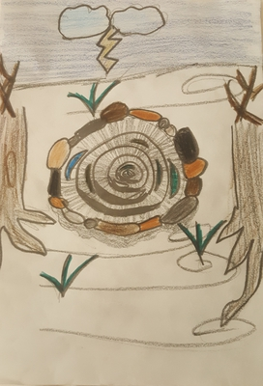
Mia gets surprised and also feels compassion for Daisy and she says…
Oh, I am sorry. I want to help you. We can find your mother and father. “But, it is dangerous” Daisy answered. Mia said “You are my best friend.” Daisy is happy. They look for the magical hole. They find it and enter. They see a black road. They are afraid. Daisy stops and says “Wait! There is a noise.” They hide. Daisy sees her mother and father. They are tied on a chair. Daisy runs “Mom! Dad!”. When she gets closed to her parents, the witch appears.
The witch laughs “Hello, baby bunny! You are small to help your parents.”
Daisy is afraid but shouts: “Leave them! Now! Let us go!”
The witch catches Daisy. Daisy’s mother cries. But, Mia comes suddenly. She hits the witch with a stone. The witch falls. Daisy saves her parents. The witch stands up and shouts “No! I am going to kill you!”. Mia throws carrots to Daisy and her parents. They eat carrots and disappear. The witch tries to catch Mia. Mia is afraid and tired. But, rabbits take the rope in their mouths and turn around the witch. They tie the witch. Daisy hugs her parents. Then, she runs to Mia.
Daisy says “Thank you very much, Mia”. Mia is happy, too. “We are best friends.”
They return to their homes. They always see each other and live happily.

