The snowmen story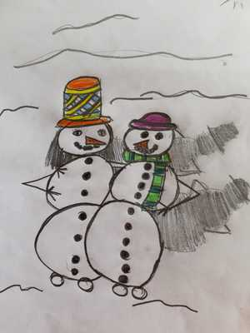
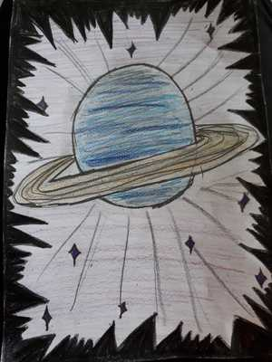
Once upon a time in a very cold country in the coldest planet ‘Uranus ’ live a lot of snowman families. They start to live here because it is the best and safest place for them. They can live here happily without any melting danger. All the snowman families have snowhuts.
The crystal fruits grow on the snowy trees and the snowman families eat them to survive.
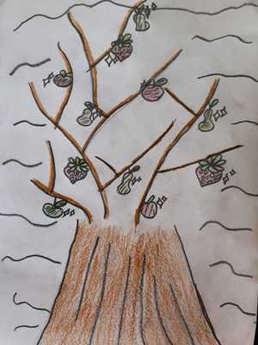
They have feet as snowballs and move by jumping. The snowkids spend their time mostly by ice skating on a frozen lake. They like their lives so much here. But they are scared of sun and fire so much and that’s why they choose this icy planet to keep surviving.
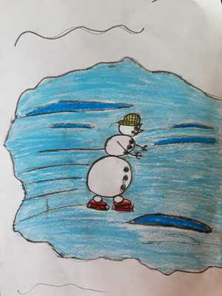
In this cold place, a snowkid named Alice lives with her family. She likes iceskating and also playing chess with her dad. She likes eating crystal fruits so much.
In a very cold and icy day , something very terrible happens and the snowman families start screaming and run away. Alice shouts to her mum and says:…

„Mum I´m scared, what happen?“
Mum: „Don´t know, but run fast, it´s getting warm. And we are approaching the Sun. The planets are no more where they have to be. 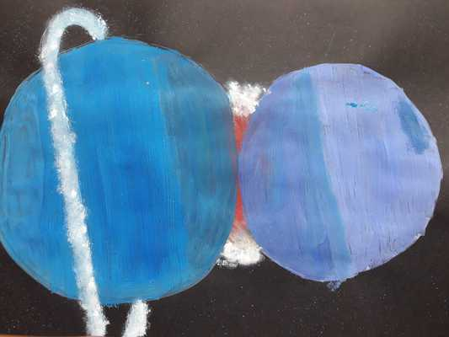 They are changing positions.“
The snowman astronoms are watching the Sun and they find out that the people on the Earth developp a powerfull ray which they were studying but this experiment got out of control. And the Sun started to move. It turned red and started to approach the Uranus.
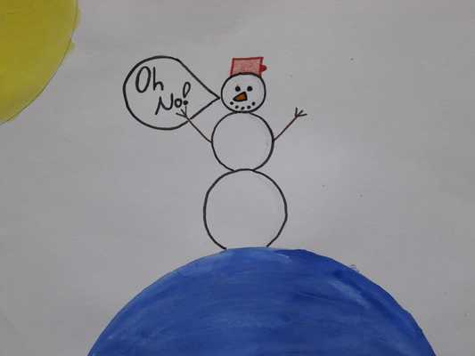
The snowman famillies staretd to panic because the didn´t know if this is the end of their peacefull lives.
Whole space is moving. When the snowmen thought that the end is here Neptune appoached that much that it was just next to the Uranus…
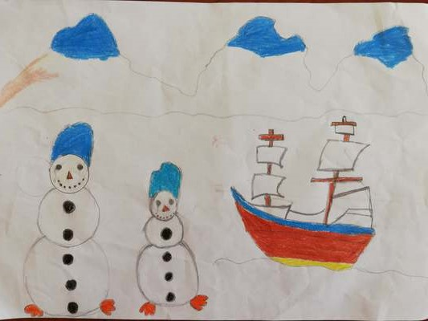
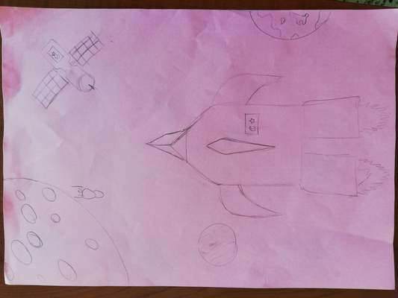
The snowman astronoms decided to move the snowman families to Antarctica by spacecraft. They all got on the spacecraft. The sun was almost here. They started to move. They were sorry and crying. Because they thought they lost their homes. Alice was afraid. She was hugging her mum. After a while, they came to Antarctica. They were afraid they were foreigners. But they were happy because they didn’t melt. They saw penguins. Alice became friends with penguens. At this moment, some scientists approached with a ship. The snowman families were angry with them.
The scientists said „we are sorry. We are trying to fix it“. „I missed my home. I am away from it because of you!“ answered Alice. The scientists said „ we are so sorry. You should be here until we solve the problem.“
Alice says:
- It’s your fault but we’ll help you. There are a lot of talented snowman scientists among us. Your scientists and our scientists can work together. We need a cold laboratory to work. Thus you can help us to survive.
Scientists say:
- We should build a cold lab in Antarctica immediately. Our scientists will do their best.
Alice says:
- I believe we can succeed it together.
Meantime snowman families begin to live in igloos. Snowman scientists and people scientists start working together. First they study on snowmen’s DNA to keep them alive on Earth.
Suddenly they discover that snowmen’s DNA can be transformed into human DNA. For this reason they create a medicine to transform snowmen into people.
And the big day comes…
…and the big day comes!
So the scientists prepared all the tools necessary to do the medical experiment. First, there were five human volunteers to test the implementation of the snowman DNA. And the snowman DNA was put inside of them!
Unfortunately, the first two volunteers started shaking right after the injection, fell on the ground and melted instantly. 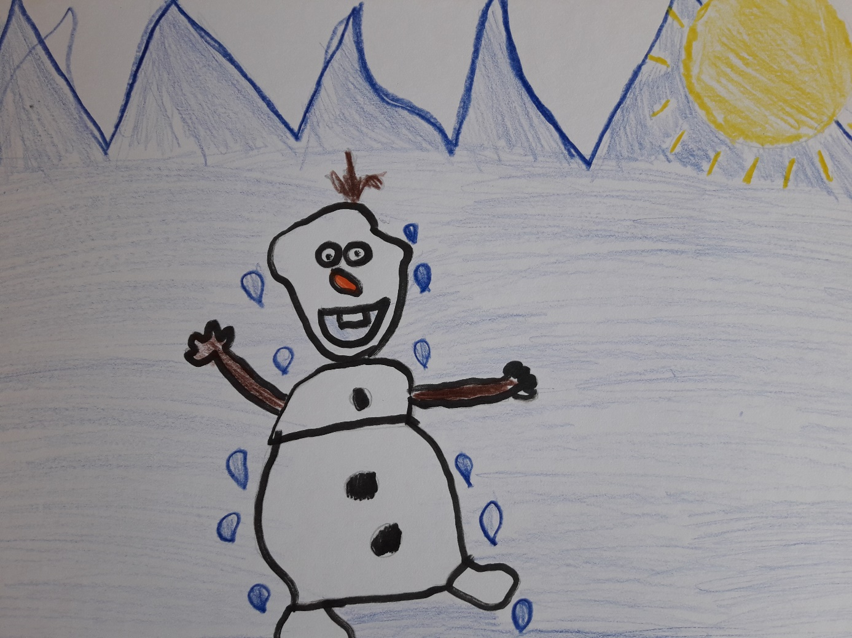
The third volunteer, turned into lettuce for some reason, it was strenge and nobody knew why. He was affraid of the colony of rabbits who live there. Thy wanted to eat him.
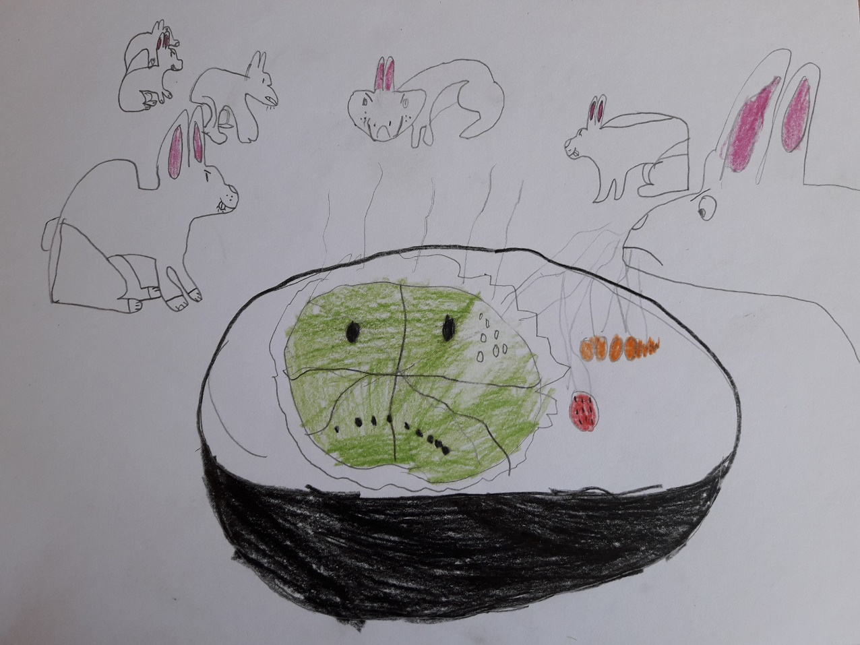
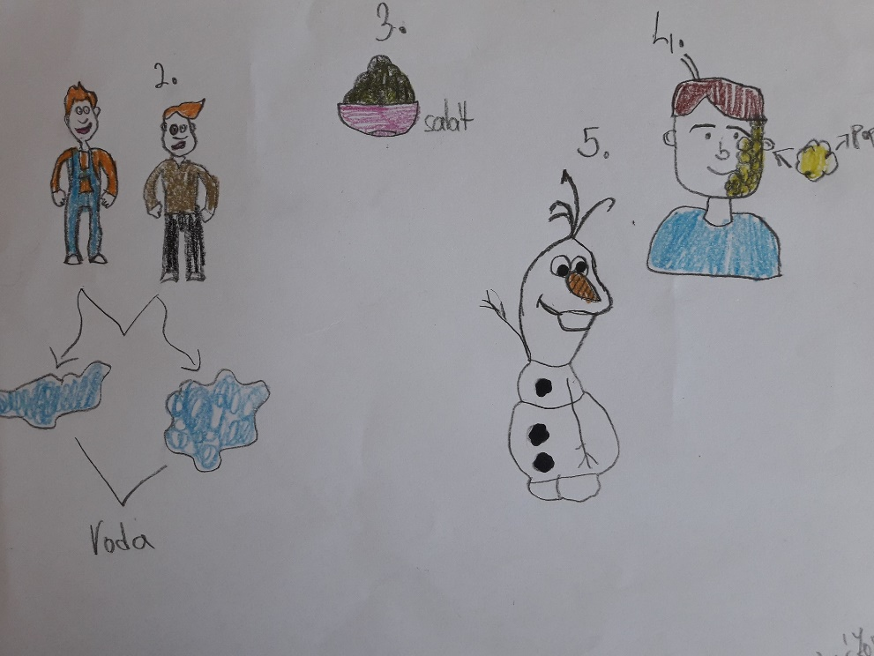
The fourth volunteer survived! Only nobody can tell that it was a human some time ago. One leg was missing, his face turned into corn. And it popped. Popcorn! But he was still alive and said he felt O.K. Others said that he also smelt really good!
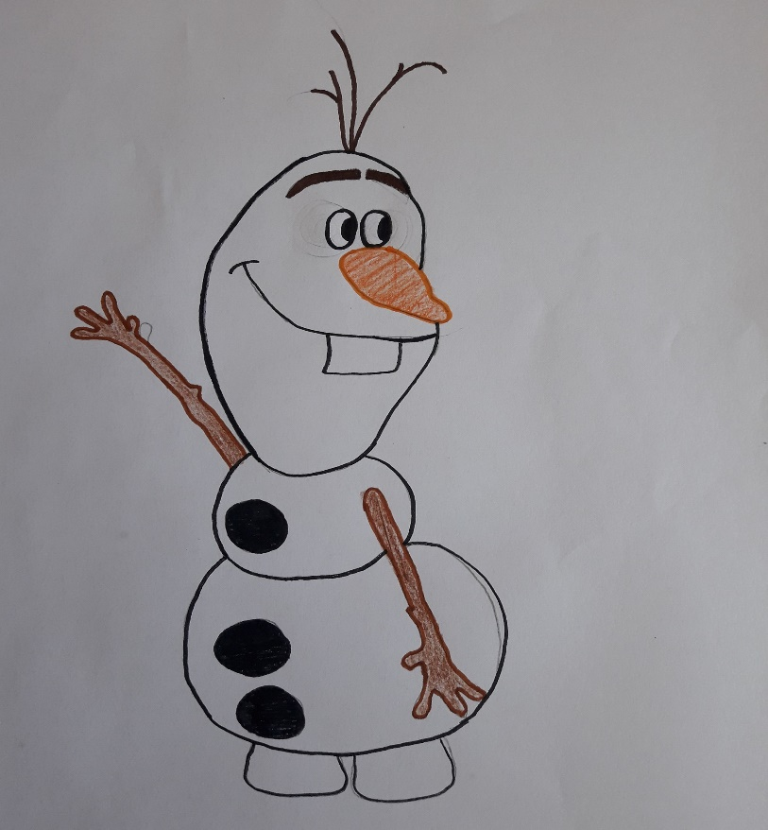
The fifth volunteer was the luckiest one! He was just fine! Only his nose turned into a really tasty-looking carrot and his hands turned into wooden sticks. He had a little a bit of trouble keeping the rabbits away but he was good at it. Everyone also called him „Olaf.“

In the end, the experiment was very successful!
After a couple of changes, the DNA injections were used for all the snowmen and the population was saved!
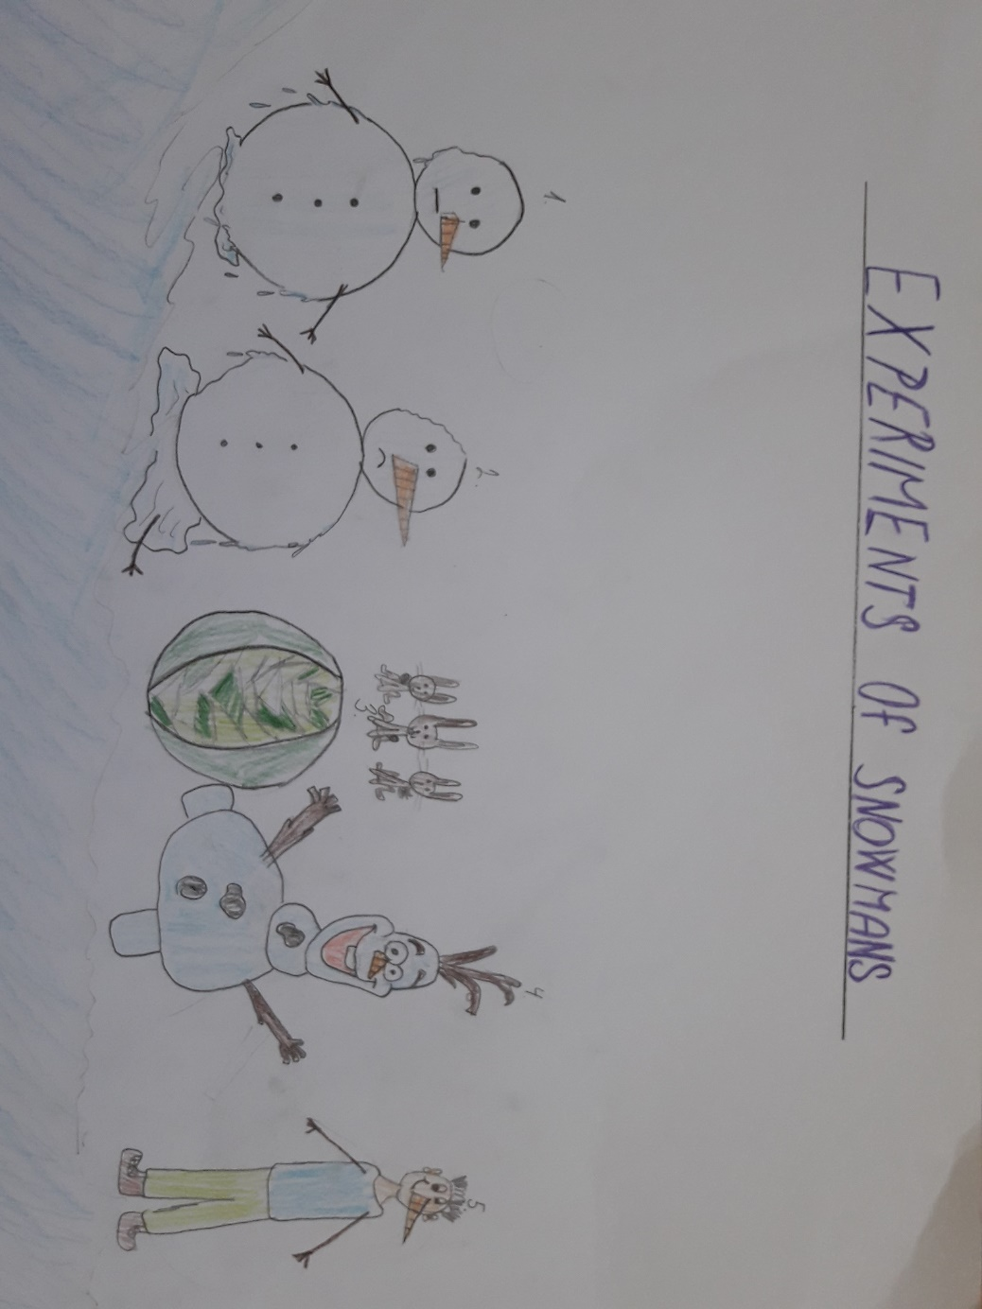
All the snowman and human newspapers wrote about this for years!

THE END

