33rd Authentic marathon of Athens (08/11/2015)

The Marathon of Athens , the ' original ' is not only a sporting event of international range, a difficult race for a few, a tough path of 42,195 meters
More than anything else the Athens Marathon is the bridge that unites the legend with history and shows off the power of human will and soul.
It constitutes of a tank of values, social awareness , environmental awareness , friendship and solidarity , now more relevant than ever .
Older, younger, Greeks and foreign people took the decision to participate in the race, to test the limits of their strength . Like every year marathon runners were those who caused the greatest moments of emotion . The moment of finishing the race for those who needed more than four and a half hours was full with appreciation and respect.
Most of them passed the finish line with teary eyes , while in the platforms their friends and relatives congratulated them in every way.

ROUTE: Av . Marathon - Marathonodromon - Marathon Tomb - Marathonodromon - L.Marathonos - Mesogeion - Michalakopoulou - Feidippidou - L.V.Sofias - Herodes Atticus - Panathinaiko Stadium.

I. WHILE THE SAME DAY:

1. held the race start Road 5 km.
2. held the race start Road 10 km.
3. Municipalities Marathon Course organized by 10.30 children races Municipalities "National Bank" the original marathon route.
4. Race Athletes Special Olympics Hellas 1200. starting Avenue Kings. Wisdom and end in Panathinaiko Stadium.
5. Child Race 1200. "National Bank" starting Avenue Kings. Wisdom House and end in Panathinaiko Stadium.
6. Afternoon Race 5 km. Starting on Amalias Avenue and end in Panathinaiko Stadium

Admirable is the number of requests for volunteers every year ! Schools , communities , companies and groups , whole families help in this great event with huge smiles !

Winner in the Original Athens Marathon: Christopher Merousis
Winner of the 33rd Marathon emerged Christopher Merousis. Actually Chiotis, who left far behind his opponents, scored the 5th best performance ever recorded by Greek in the original route.

The first 8 men :

Χριστόφορος Μερούσης 2:21:22
Δημήτρης Θεοδωρακάκος 2:27:03
Δήμος Ευαγγελίδης 2:27:28
Γιώργος Καραβίδας 2:30:41
Μιχάλης Καλομοίρης 2:31:39
Σιμιριώτης Κυριάκος 2:32:10
Γεράσιμος Γρίβας 2:32:39
Κώστας Ρήγας 2:33:10

PHOTO
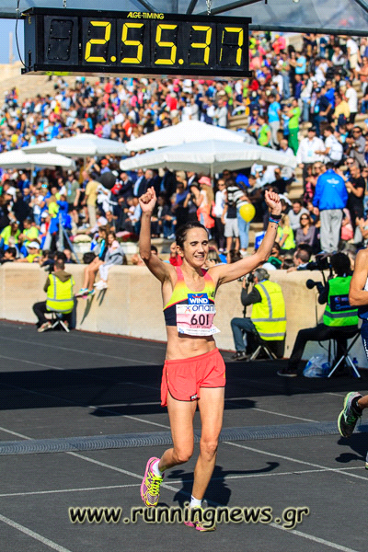
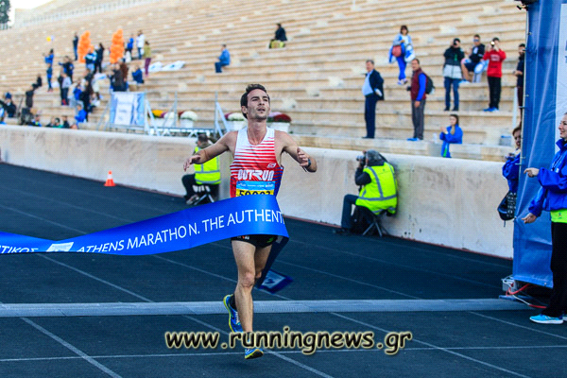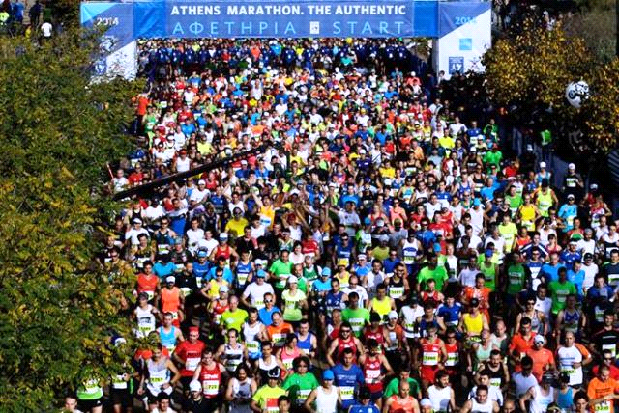

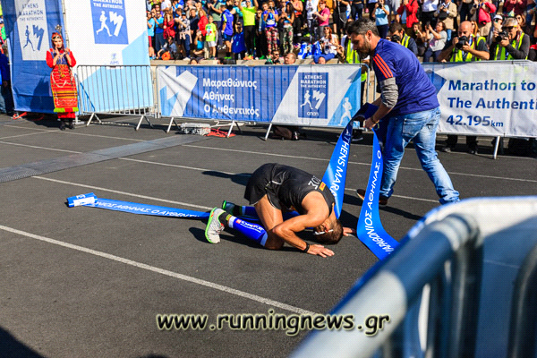

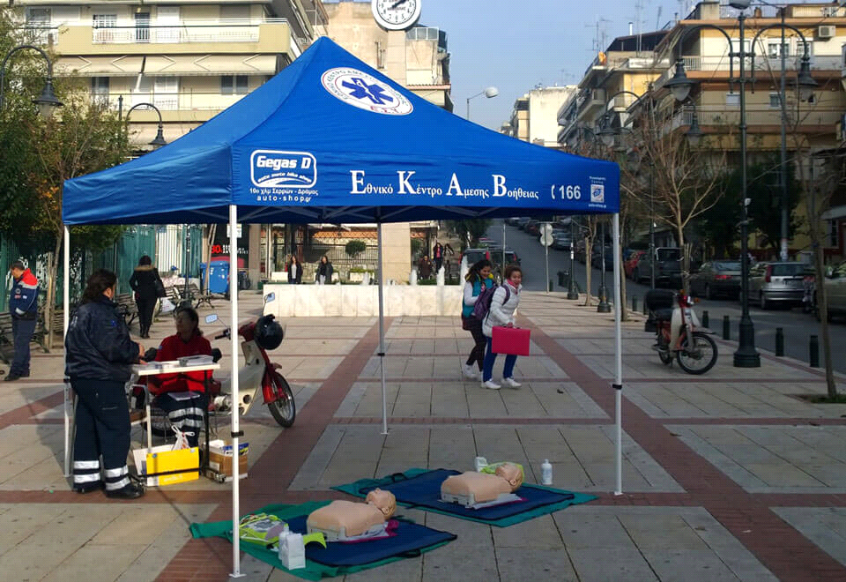
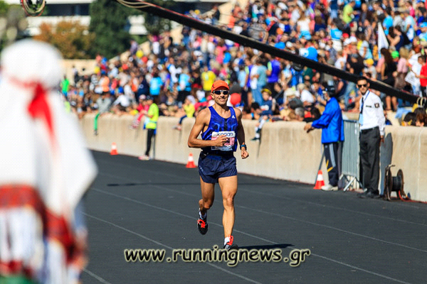
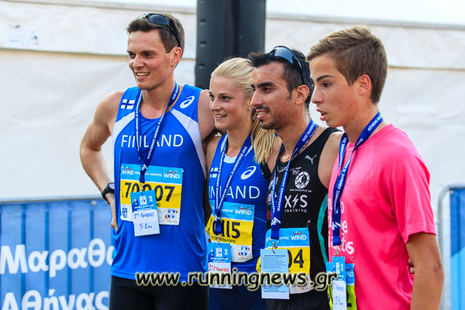
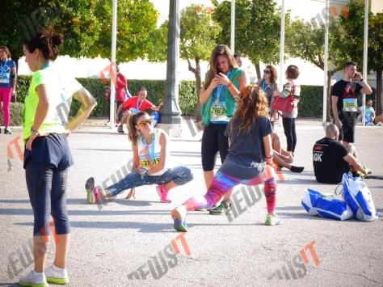
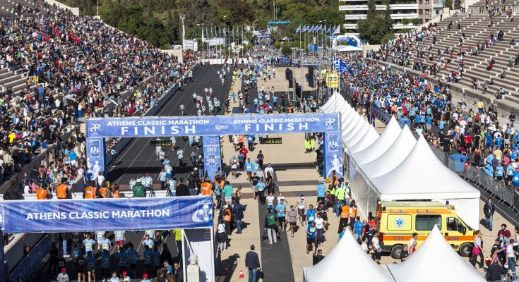

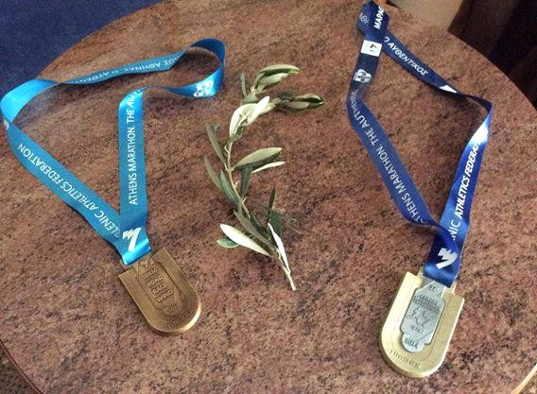

ΗISTORY OF MARATHON

The Marathon comes from the story of Pheidippides , a Greek messenger . According to this story, Miltiades immediately after the famous battle of Marathon in 490 BC sent Pheidippides, who was then considered the fastest runner of the Athenian army, from the field of Marathon to Athens to announce the victory over Persians .
It is said that he ran the entire distance without stopping and entered the House of Assembly , where he exclaimed " Nenikikamen " ( won ) before collapsing and dying .

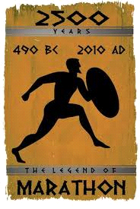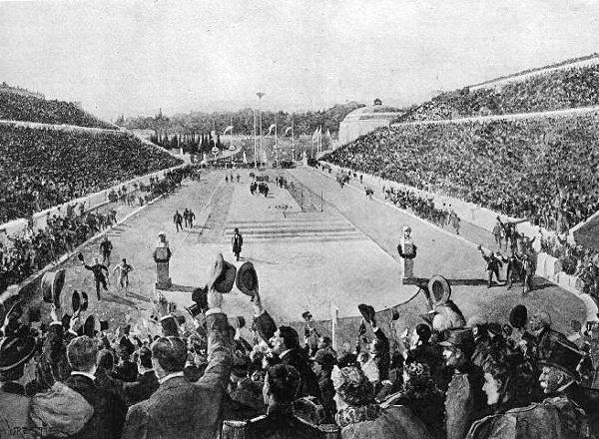

Training

Most coaches believe that the most important element in the preparation for a marathon is a long-distance running , but methodically .
Amateurs commonly try to reach a maximum of 32 km in a single race and on a weekly basis 64 km , but it varies from week to week.
Experts can run up to 200 miles per week . But such a long distance poses a greater risk of injury.
Several preparation programs last five or six months for beginners who do not run at all, with a gradual increase ( every two weeks) in the distance and finally a small reduction
( 1-3 weeks) for rest. Usually the athlete runs five times a week . The program generally increases the distance , reaching the upper range ( 32 km ), three weeks before the race.
Then weekly distance gradually decreases until the race. For a more skilled amateur , 3 months of preparation 5 times a week are generally sufficient for a duration of about 4 hours.
For a beginner six months are enough. However, intense training can also cause injuries.
Alexopoulou Rania- Athens, Greece
THE END THANK YOU

