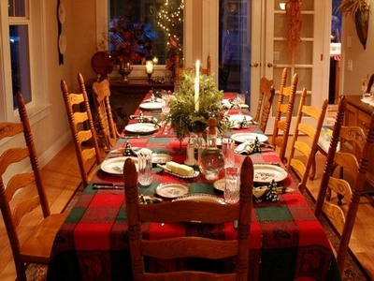

Christmas In Our Families
In Polish families Christmas Eve begins when the first star appears in the sky. On the table there is a lot of food: boiled wheat with poppy seeds and honey, the borsch with ravioli and the carp. In our families we always leave an empty plate for the unexpected guest. We also put hay under the tablecloth.

By Janek and Oskar
CHRISTMAS IN MY FAMILY
In my family we celebrate Christmas by having Christmas Eve, decorating Christmas tree, sharing wafer.
In others houses in Poland there are mostly 12 dishes but in my house we only choose our favorites like fish, red beetroot soup, small dumplings.
Me and my mom decorate Christmas tree.
While we celebrate Christmas Eve we share wafer. And after that we open presents.
Christmas in my family is a magic time full of happiness.

By Przemek

Christmas at my home
We usually spend Christmas Eve at my grandmum’s. This is the time, when everybody is at home. I help mum in the kitchen and I with my brother decorate Christmas tree. We have a special dinner. On the table there are such dishes as: small dumplings, dumplings with mushrooms, carp, kutia and red beet soup. My favourite dishes are small dumplings and red beet soup. We always share the Christmas wafer and we try all the dishes. The most I like the moment when everybody opens presents. We find presents under the Christmas tree and open them after the dinner.

By Wiktoria

