The tale was created by Aušra Rašytinienė

What can Kimochi characters teach us?
A tale of friendliness, sincerity and compassion

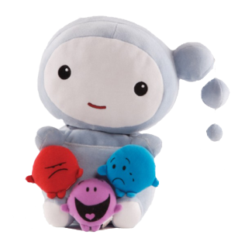
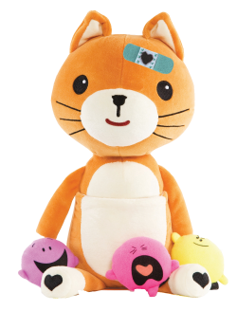
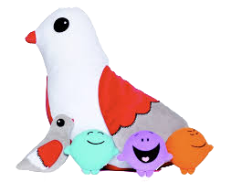
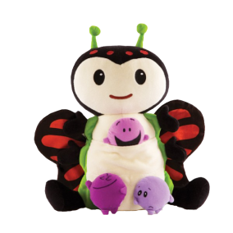

Characters: author, caterpillar-butterfly, kitten, cloud and pigeon

A caterpillar sits on the flower and cries. He feels miserable and ugly (emoticon - sad). A kitten passes by and gets surprised and angry when he sees the caterpillar (emoticon - surprised and angry).
-Why do you whine and spoil my mood! (emoticon - capricious) yells a kitten. The caterpillar becomes even more upset and starts crying.
The cloud in the sky is very upset when it sees the kitten's behaviour (emoticon-sad, angry) and begins to rain on the kitten saying:
-You should not behave like this, kitten. Don‘t you see the caterpillar is upset! You need to calm you voice down and gently ask:
-What happened to you, why are you so sad? (emoticon – curious, worried)
When caterpillar hears your calm voice, he will definitely tell you why he is sad. Ashamed kitten changed his face into calm and asks quietly:
-Hey, listen, caterpillar, I am really sorry for shouting at you, please tell me, why are you so sad? (emoticon – curious, sad). The caterpillar stopped crying and answers:
-How may I not cry, if I do not have any friends! I am ugly and nobody wants to be friends with me! Kitten is surprised and gets thoughtful (emoticon – surprised). Without knowing what to answer, he raises his head to the cloud:
-Listen cloud, how can I help the caterpillar? The cloud advises him to ask the pigeon for the answer. Everyone goes the pigeon, who is quietly sitting on the tree branch and cooing (emoticon – loving). The cat starts first:
-Pigeon, you are so loving and wise, can you please help us? The caterpillar is very unhappy and sad because he has no friends and I don't know how to help him. The pigeon smiles and says (emoticon – happy):
-He already has a friend! It’s you! If you want to help him, it means you care, and only true friends do that. Caterpillar, don't be sad, you already have a friend and soon you will become a really beautiful butterfly. From happiness, a caterpillar flaps its wings and becomes a beautiful butterfly!
Everyone, the pigeon, the kitten and the caterpillar-butterfly hug each other (emoticon-happy and loving). Up there in the sky, the cloud starts to rain, although it is the rain of joy this time. Everyone is having a good laugh!

