DANICA ZVER
VRTEC ŠENTVID
LJUBLJANA SLOVENIA
WHO IS AFRAID OF A BLACK MAN?
SLOVENIAN TRADITIONAL GAME

The space for this game is usually delimited by two lines: one for which the Black Man stands and one for which other children are located. The black man is the child we choose. It stands on one side of the meadow/playground and the other children on the other side. The black man calls out, "Who is afraid of the Black Man?" The children say, "No one!" Or "I'm not!" Black man asks: „But what if he comes?“ Oposite site : „Then we run away!“
Then the Black Man and the children are tied up against each other. That child, whom the Black Man seizes and drags to his field, helps him then to catch the other children.
The game lasts for as long as the Black Man and his helpers do not catch all the children. The last child to stay is in the next »Black Man«.
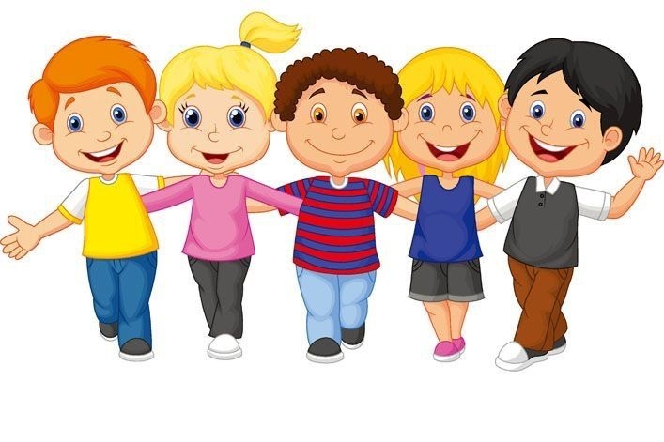

DANICA ZVER
VRTEC ŠENTVID

DANICA ZVER
VRTEC ŠENTVID

