Erasmus+ KA2 “Healthyland”
Sports’ Equipment Sudoku

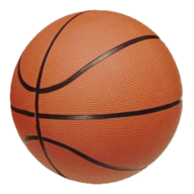 | 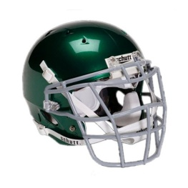 |  | 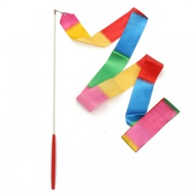
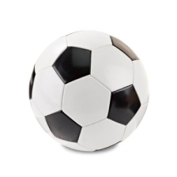

----------------------------------------------------------------------------------------------------------------
Kindergarten of Avlonari, Evia, Greece

