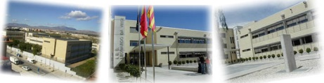
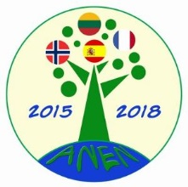

ACTIVE in NATURE, ENJOYING the NATURE!
Nr. 2015-1-NO01-KA219-013242_2
1st LEARNING/TEACHING/TRAINING ACTIVITY
ALICANTE - SPAIN
MAY 2016
EVALUATION OF THE LEARNING, TEACHING, TRAINING ACTIVITY

Student’s Name & Surname: ………………………………………………………
COUNTRY: …………………………………………………………………………………..
Did you like this activity? Yes / No
If no, why?

What went well and why?

How did you feel doing the tasks of activity?

What was the most difficult part of the activity?

What was the most interesting of the activity?

What did you learn from this activity?

What do you think your group gained / learned from this activity?

What suggestions can you make for improving the activity in future?

Please rate this activity:
Interesting 10 9 8 7 6 5 4 3 2 1 Boring

