Christmas cookies
  - A selection of Norwegian recipes
EBUS’ students have selected some of the most common Christmas cookies recipes to share with you

BROWN STICKS (BRUNE PINNER)
-Ann Kristin’s best recipe
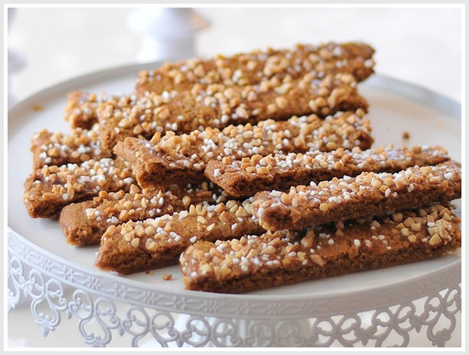
You need:
200 g Butter
200 g sugar
1 tablespoon light syrup
½ teaspoon cinnamon
1teaspoon vanilla sugar
1 teaspoon sodium
300 g flour
Sprinkle:
1 egg
Some almonds
And a little sugar

The procedure:
- Beet butter and sugar good together, then mix inn syrup and dry.
- Divide the dough in to 6 pieces, roll it out to sausages and press flat rods to a rectangular shape, Place it on a baking plate with baking paper. the rods should be about 4 cm wide.
- Brush with egg and sprinkle with chopped almonds and a little sugar. Bake at 170 ºC for 10- 12 minutes on the middle shelf of the oven.
- Cut the rods sideways while they're still hot, and let it cool.
Now you are ready to serve
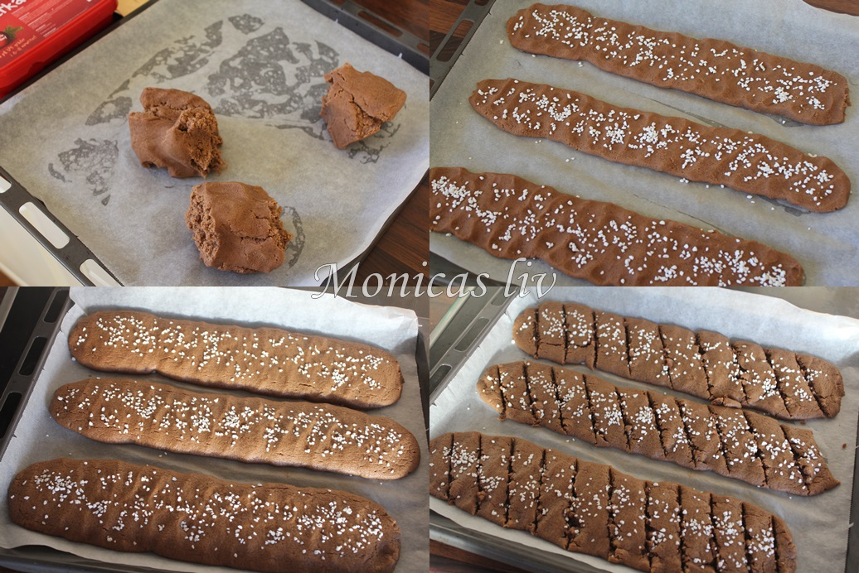
ENJOY!

Christmas Peanut Butter Blossoms

Ingredients
1 Pouch (1 lb 1.5 oz) Betty Crocker™ peanut butter cookie mix
3 Tablespoons vegetable oil

1 Tablespoon water

1 Egg

Sugar

36 Hershey's® Kisses® Brand milk chocolates, unwrapped

Betty Crocker™ white decorating gel
Betty Crocker™ holiday candy sprinkles
Betty Crocker™ red decorating icing

Directions
- 1 Heat oven to 375°F. In medium bowl, stir cookie mix, oil, water and egg until dough forms.
- 2 Shape dough into thirty-six 1-inch balls; roll in sugar. Place 2 inches apart on ungreased cookie sheets.
- 3 Bake 10 to 12 minutes or until light golden brown. Immediately press 1 chocolate in center of each cookie. Remove from cookie sheets. Cool completely, about 20 minutes. Decorate as desired using remaining ingredients.

Elise`s Christmas favourite Gingerbread
Ingredients:
2 eggs
2 ^{½} deciliter Sugar
250 gram dark syrup
125 gram butter
½ teaspoon ground cinnamon
½ teaspoon ground pepper
½ teaspoon ground ginger
½ teaspoon ground clove
½ teaspoon baking soda
600 gram flower

- Mix the eggs and the sugar to eggnog. Melt the syrup and the butter in a medium casserole. Cool the batter. Mix the dry ingredients and put it in the casserole. Let the batter cool until the next day.
- Set the oven on 200°C and find a baking sheet with greaseproof paper
- Roll out the dough and use forms to create different figures.
- Set the rack in the middle of the oven, for 10-12 minutes. Cool on a rack.
- You can decorate with frosting or whatever you have on hand.
- ENJOY

Madelen's Christmas favorite
Wafer Biscuits (In Norwegian it is called Krumkaker)
Ingredients:
4 egg white
200 g sugar
200 g melted butter
200 g flour
½ teaspoon ground cardamom

This is what you do:
1. Whisk eggs and sugar into a eggnog. Add the melted, cooled butter.
2. Gently fold in the flour and cardamom with a spatula. Let the batter swell for about 15 minutes.
3. Add a large teaspoon stir in the middle of a well heated wafer biscuits iron.
4. Bake curved cakes until golden brown
5. Roll curved cakes to cornet. Add curved cakes over a cup if you want to create wafer biscuits bowls.
Serve cones or wafer biscuits bowls filled with whipped cream and jam.
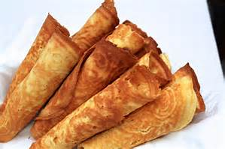
Good Luck :)

Malin's traditional Christmas cookie.
Berliner-wreaths
(Norwegian name: Berlinerkrans)
Berliner-wreaths is sweet and good cookies for Christmas. A favorite cookie for many people for Christmas.
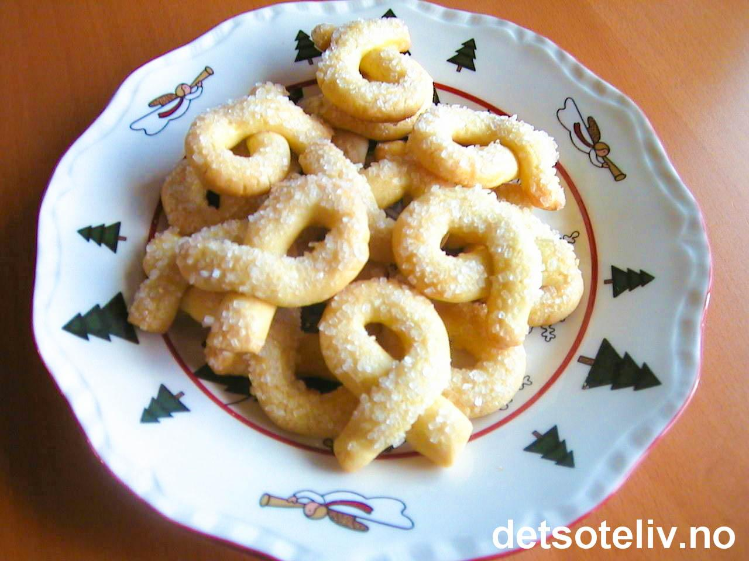
Difficulty: Advanced
Time: 60 min
This gives you ca. 60 Berliner-wreaths
Ingredients
2 hardboiled eggs
2 egg yolks
125 g sugar
250 g room tempered butter
300 g flour
1 egg white for glazing
3 table spoons pearl sugar

Procedure
- Rub the boiled egg yolks together and stir they together with the raw ones. Add the sugar and whip eggnog.

- Stir in the room tempered butter alternately with the flour. The crowd of the flour must be regulated in relative to the size of the egg yolks. Stir the dough even, but do not work with it so much. It can easily get short and hard to trill out. Cover the dough with a towel and let it be in the fridge for ca. 1 hour.

- Trill the dough into sausages as thin as your little finger, divide it into ca. 12 cm long bits and form it into small wreaths. Put it on a baking sheet on a baking plate. Glaze each wreath with well whipped egg whites and sprinkle it with pearl sugar.

- Fry the cookies on the middle groove in the oven by 175°C in ca. 10 minutes until they are lightyellow and well done. Take them carefully over to a grid when they are a little chilled. Be careful, the cookies can easily brake. Store the cookies in a dense box.

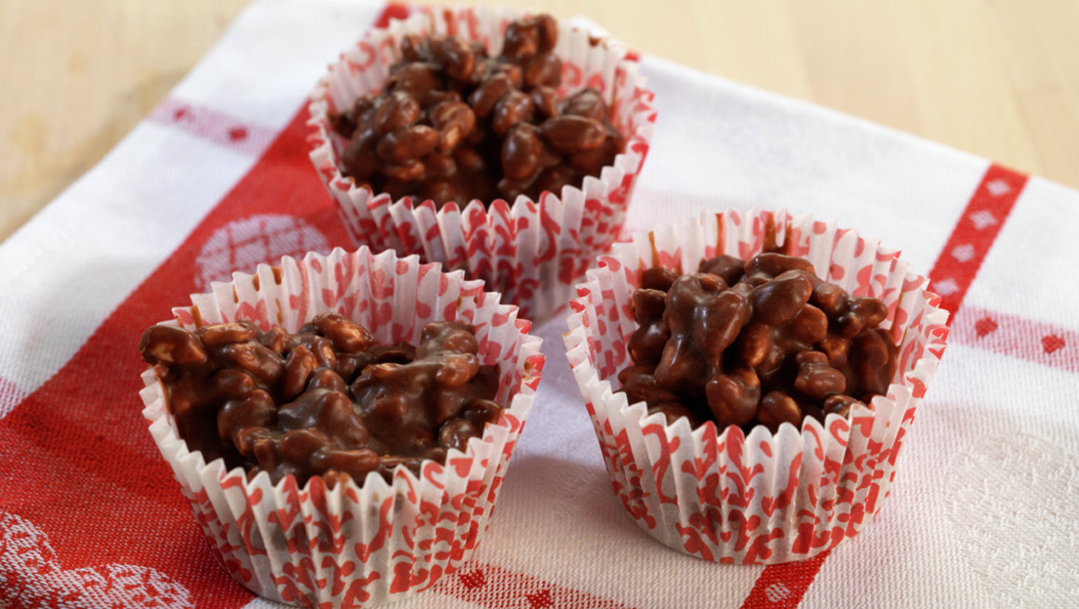
Marielle’s simple Christmas cookies:
Rice balls with chocolate
(Norwegian name: Risboller med sjokolade)
Difficulty: Medium
Time: 20 minutes
Rice balls with chocolate is popular among kids, but also a traditional Christmas cookie among adults.
This recipe is suitable for 25 servings.
Ingredients:
- 250 gram coconut fat
- 200 gram chocolate that you can melt
- 2 eggs
- 2 deciliter sugar
- 3 tablespoons coffee
- 100 gram puffed rice

Procedure:
- Melt the coconut fat and the chocolate together. Then let it cool of.
- Whip the eggs and the sugar to eggnog. Stir in coffee and the coconut fat/and the chocolate into the dough. Stir in the puffed rice.
- Make balls of the dough with a spoon, and then put it on a baking sheet. Then let it cool of, and put it in the fridge until serving.

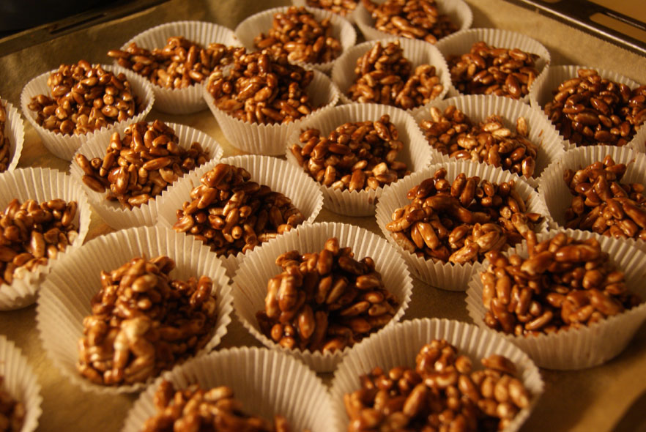
This recipe is written by Marielle S. Nordli.

Mathilde's favorite - Mint cookies

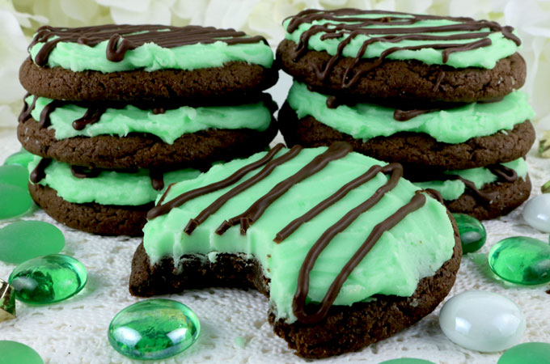

Here is what you need:
1 of an white egg
4 drips peppermint oil you find it in the drugstore
4 deciliter of icing sugar
100 g dark chocolate

It becomes ca. 20 stk. Of them
If you will have more you can double the recipe.

You whip the white of the egg till it is stiff. You drip the peppermint oil.
And then you bland the icing sugar to the pulp is firm and smooth, and then you sprinkles the icing sugar over the table top, take out the pulp and knead it till it is smooth. Then roll it out to it is ca. ½ cm. Tick.
Press out little circles, for example with a snap glass. Melt the chocolate in a water bath or low effect in the microwave. Dip the mint in the chocolate let them be cold on a shake.
We need to use more chocolate than what it stays over

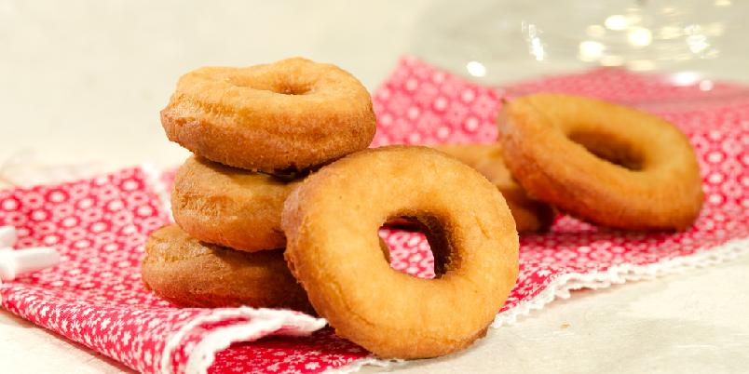
Nina’s faourite: Norwegian Donuts
Ingredients:
4 eggs
250 gr sugar
1 dl whipped cream
100 gr melted butter
1 ts ripped lemon peel
Around 500gr flour
¼ ts malt cardamom
1 ts baking powder
3 pk lard for baking

This is how you do it:
Mix the eggs and the sugar into eggnog. Then you add whipped cream and melted, cooled butter. Mix in lemon peel and flour with Cardamom and baking powder mixed in. Mix the batter together, and let it rest for a while in the fridge.
Roll out the batter to a suitable thickness. Stick out parts with a donut pier.
Cook the donuts in lard or cooking fat until they are properly brown and cooked all through.

I hope that you will try and enjoy this recipe.
Good luck!!

Tuva’s recipe:
Peppernuts
(Which is called peppernøtter in Norwegian)
Ingredients:
- 250 g black treacle
- 185 g sugar
- 65 g butter
- 0,5 deciliter of cream
- 500 g flour
- 1 tsp anise
- ½ tsp of pepper
- ¾ tsp of baking soda
How do you make the cakes?
- Turn on the oven, and warm it up to 180° C. Make one or two baking shelfs ready with a parchment paper.
- Boil the black treacle, sugar, butter and cream in a casserole, and cool down.
- Sift the dry ingredients through a sieve, and blend the dough together.
- Roll the dough to a sausage. Divide the dough into small pieces, and roll small round balls. Put the balls at the baking shelfs.
- Steak it in the oven in 10 minutes. Cool it down on a grate.

Portions: ca.40 cookies
- 250 g butter
- 150 g sugar
- 1 egg
- 500 g potato starch
- ca. 125 g flour
- 4 tsp vanilla-flavoured sugar
- 1 tsp baking soda

The procedure
1. Mix butter and sugar together until the mixture is light, creamy and white.
2. Add one mixed egg, and then sift the dry ingredients into the mixture.
3. Work the dough together, cover the bowl with plastic wrap and let it set for about an hour before you bake it.
4. Roll out «sausages» of the dough and part it into small pieces, which you roll out into little balls. Then you have to press the little balls down with a fork. 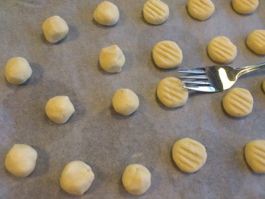
5. Put the little balls on a baking sheet and bake the cookies in the middle of the oven for ca. 10 minutes at 180°C.
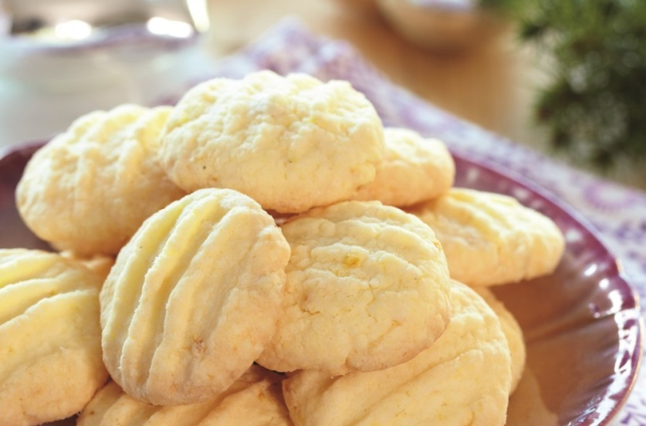

Ayan’s best:
Soft Christmas cookies/ Myke julekaker
- 3 ¾ cups all- purpose flour
- 1 teaspoon baking powder
- ½ teaspoon salt
- 1 cup margarine softened
- 1 ½ cups white sugar
- 2 eggs
- 2 teaspoons vanilla extract
- Sift flour, baking powder, and salt together, set aside. In a large bowl, cream together the margarine and sugar until light and fluffy. Beat in the eggs one at a time, then stir in the vanilla. Gradually blend in the sifted ingredients until fully absorbed. Cover dough, and chill for 2 hours.
- Preheat oven to 400 degrees F (200 degrees ). Grease cookie sheets. On a clean floured surface, roll out small portions of chilled dough to 1/4 inch thickness. Cut out shapes using cookie cutters.
- Bake 6 to 8 minutes in the preheated oven, or until edges are barely brown. Remove from cookie sheets to cool on wire racks.
This receipt is my favorite and I hope you like it the way I love it, and also Merry Christmas and happy New Year. Hope you like it.

