«ACTIVE in NATURE, ENJOYING the NATURE»
RESULTS
Result 1:
“Plant a tree – follow up its growing” - An outdoor activity as a symbol for the main focus we should have in our “ANEN” – project.
The International cooperation class has planted a red currant plant that is a symbol of the “Anen” project. Her name is Fiona - Green and she is planted at “Mellum”.
Some pupils in the International Cooperation project are working with an outside area where the plant is. In this area, everybody can enjoy the nature we are having around the schoo
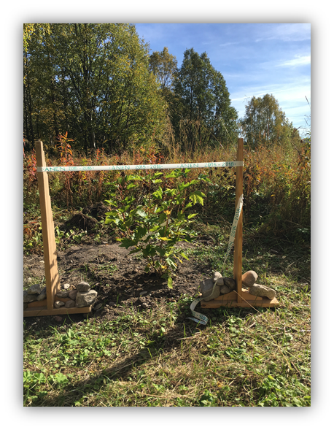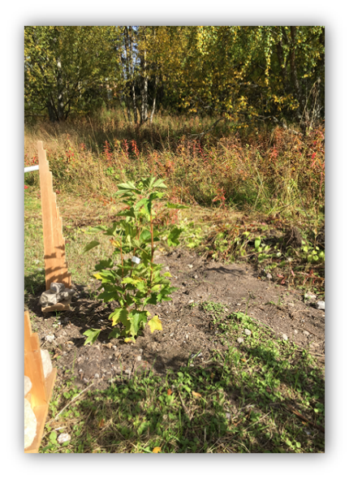
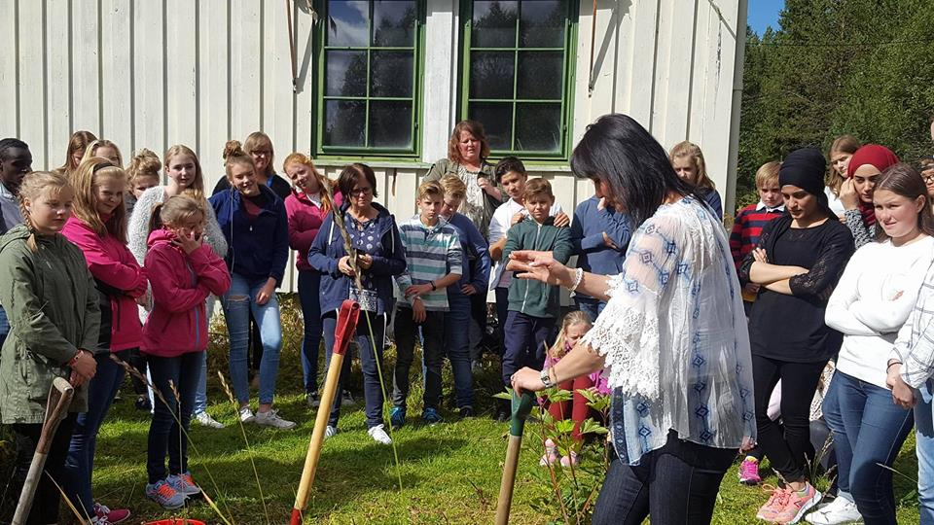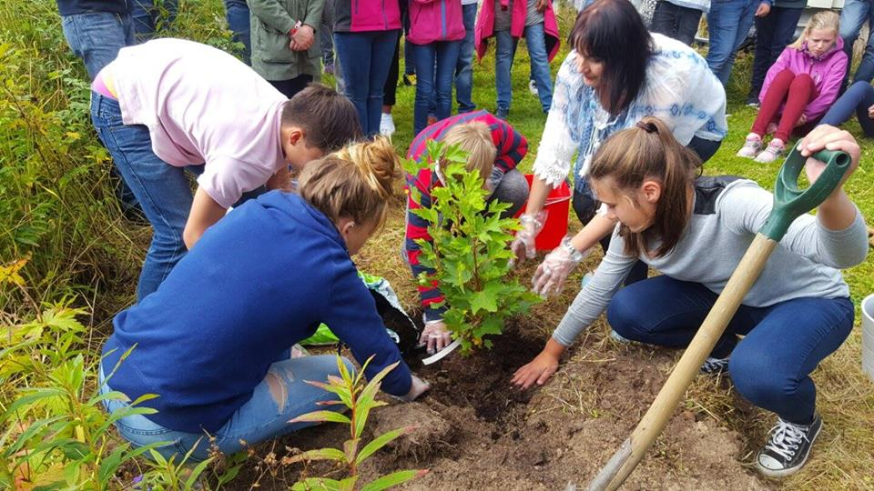

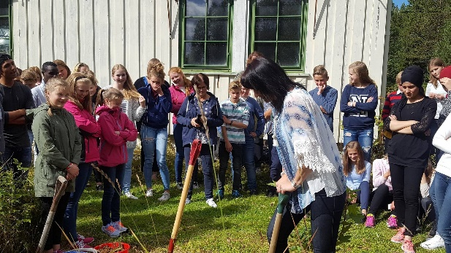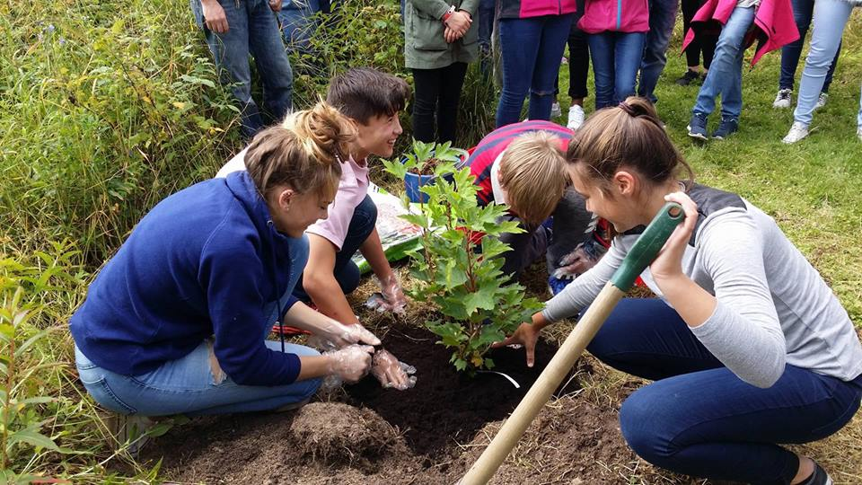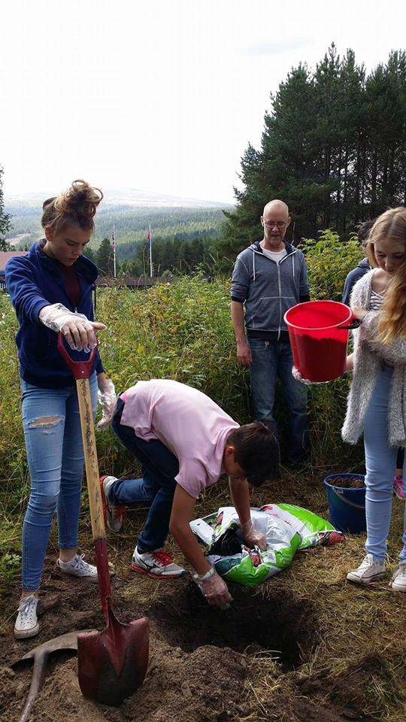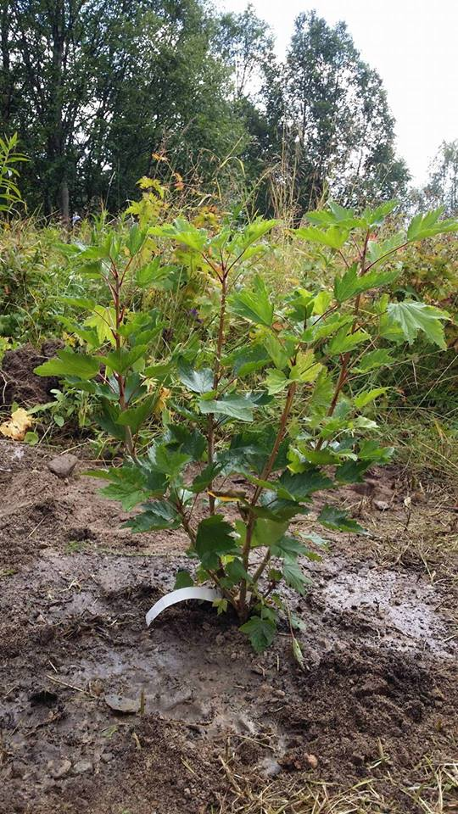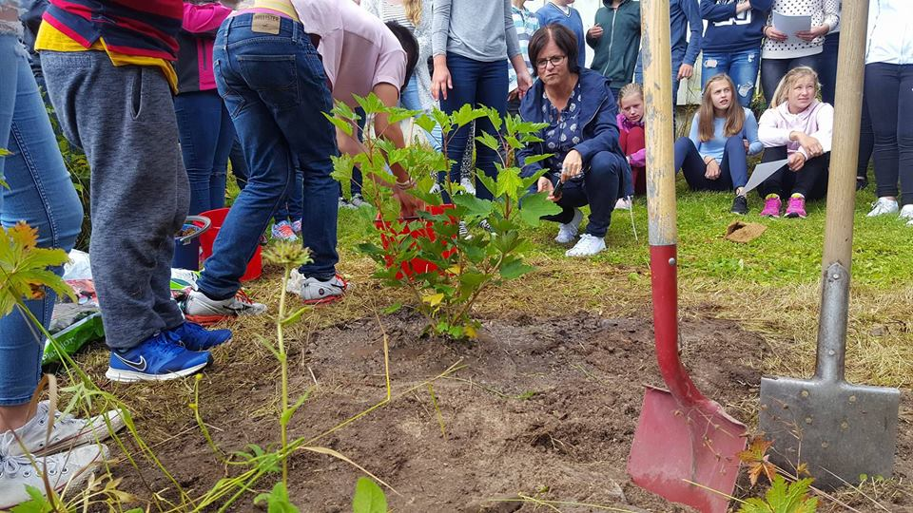
https://www.facebook.com/groups/957807974260248/permalink/1177825555591821/

Result 2
The project’s logo as a result of a logo-competition:
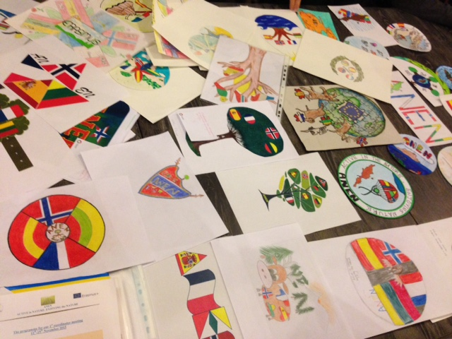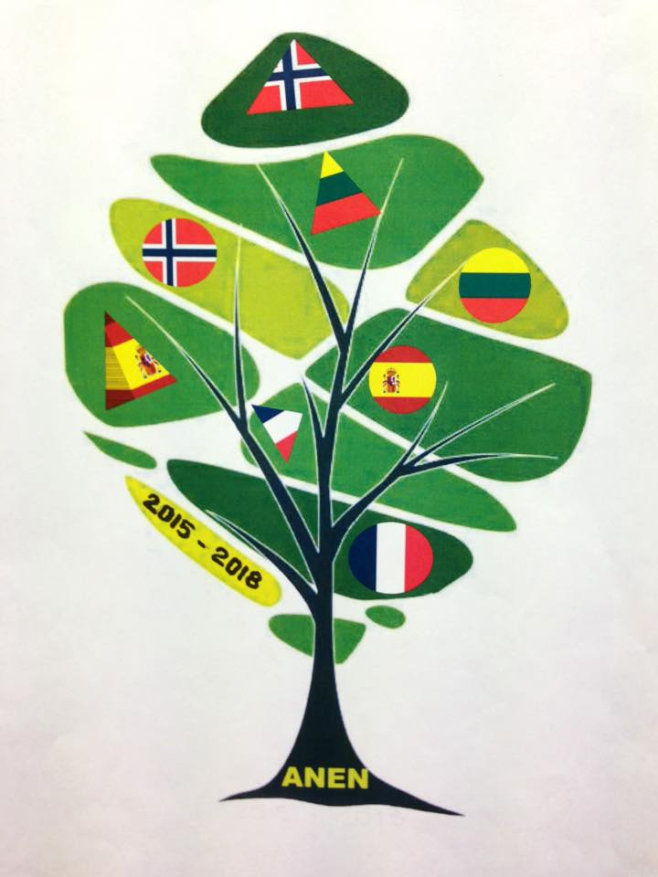 Logo - konkurranse Vinnerlogoen fra Norge

Utdrag fra vår webside: Our international logo contest is already over an here are the results:
1st place and winner – Deimantė Mickutė (Lithuania)
2nd place – Melanija Erciūtė (Lithuania)
3rd place – Maren Drevsjømoen (Norway)

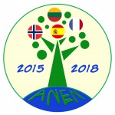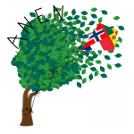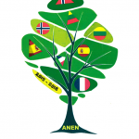
1st place and winner 2nd place 3rd place

Result 3
Dissemination corner:
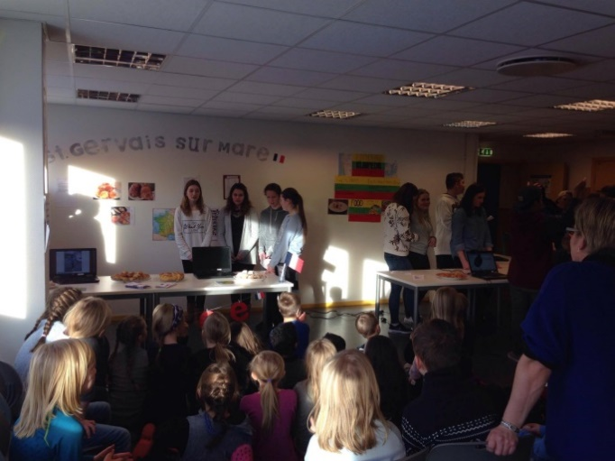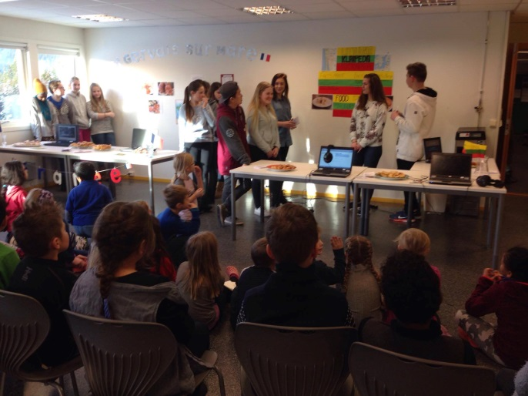 Presentasjon av Frankrike Presentasjon av Litauen
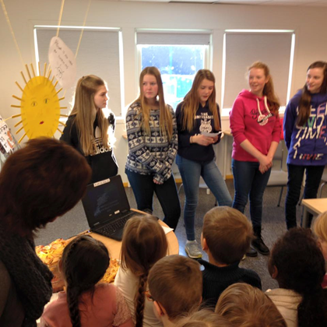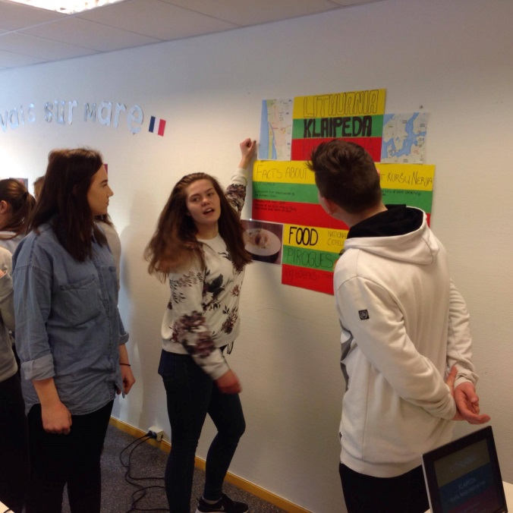
Presentasjon av Spania Presentasjon av Litauen
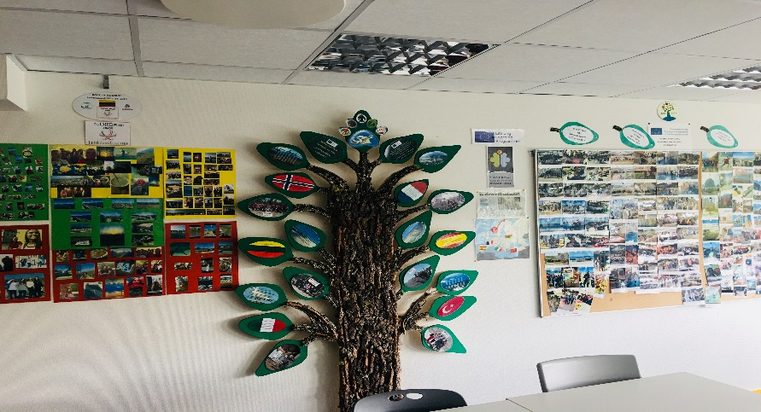

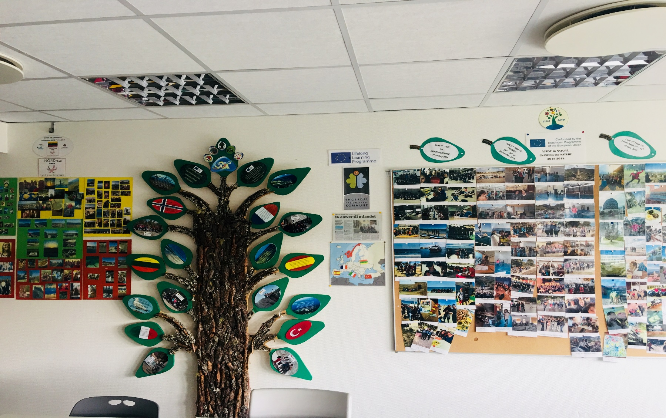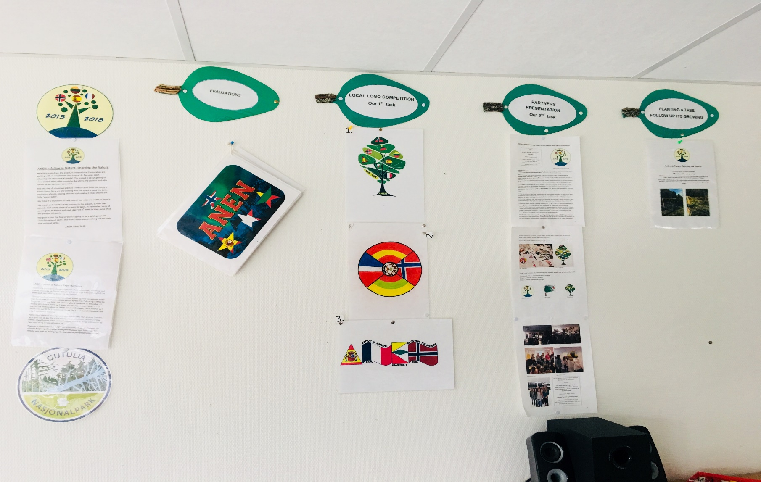

Result 4
The Project’s website:
www.anen.info

Result 5
The project’s calendar:
http://www.anen.info/calendar/

Result 6
The trip diary in Norway:
http://www.anen.info/wp-content/uploads/2017/08/Trip-Diary_NO.pdf

Result 7
Multilingual dictionary:
http://www.anen.info/wp-content/uploads/2017/04/ANEN-dictionary-Norway.pdf

Result 8
e-book with English lessons
https://issuu.com/mihaelanymoen/docs/ebookanen-last_version
http://www.anen.info/english-teaching-lessons/

Result 9
e-book with Outdoor activities – suggestions
https://issuu.com/mihaelanymoen/docs/outdooractivities1.doc.docx

Result 10
ICT tools collection, to be used in education:
http://www.anen.info/ict-tools-for-education/

Result 11
Students’ creative work in own language:
http://www.anen.info/students-book/

Result 12
The guiding app “Anen E+”:
https://www.youtube.com/watch?v=HMVeClghodk&t=64s

