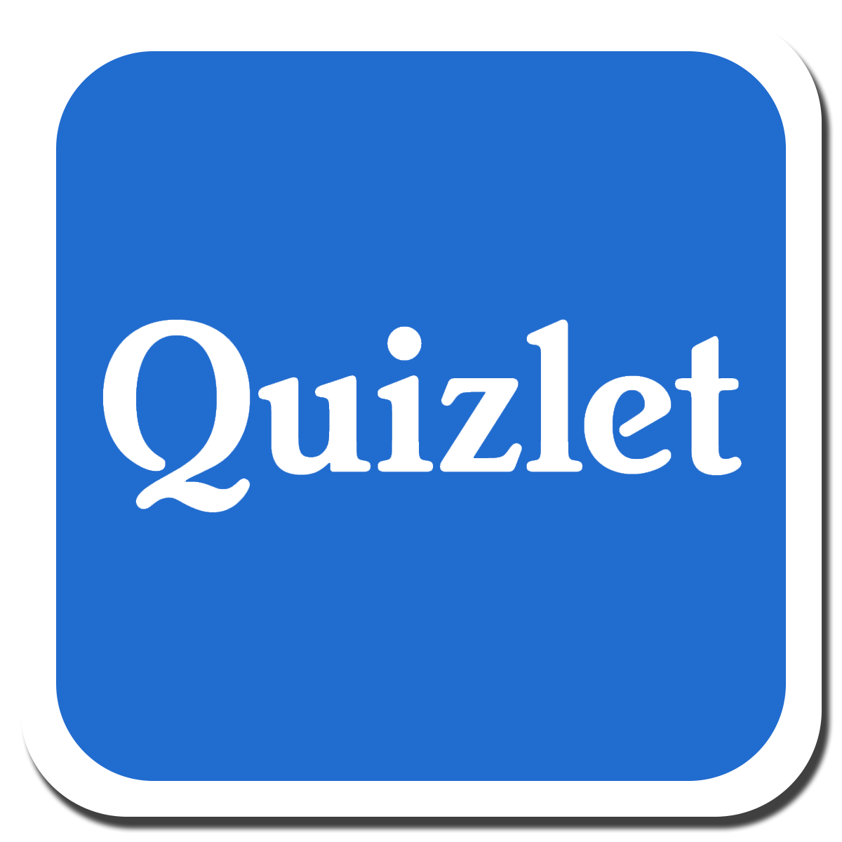 Quizlet provides free study tools for students, teachers, and learners of all ages that can be used in and out of the classroom, on your own or with friends, and on the go with our iOS and Android apps.
Kahoot! is a game-based learning platform, used as educational technology in classrooms and other learning environments. Its learning games ("kahoots") are multiple-choice quizzes that can be created by anyone and are not restricted as to age level or subject matter. Kahoot! can be played using any mobile device, desktop or laptop with an internet connection and web browser.
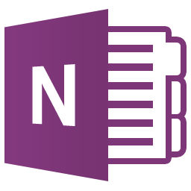OneNote is a digital notebook. Whether you’re at home, in school, or in the office, use OneNote to take notes wherever you go. And OneNote automatically saves and synchronizes your notes so you can focus on your thoughts and ideas.
Vimeo is a video-sharing website in which users can upload, share and view videos.
Photo Story is a great, easy-to-use program for creating picture slide shows that can be narrated or set to music.
Skype is a computer software program you can download for free. Skype is a VoIP phone service ( VoIP = Voice over IP) and it uses peer-to-peer technology that enables data to be sent directly between two computers. In short term – you can call other computers worldwide free of charge, if they have Skype installed. Skype is mainly used for telephony, but you can also use it for instant messenger, video calling, texting, file transfer etc
Mindmap can be used as a simplified content management system (CMS). It allows you to store all your data in a centralized location to stay organized.
Animoto is a very cool way for students to create good-looking videos. It lets you quickly and easily combine text, images, and videos into beautiful videos. The videos really do look good.
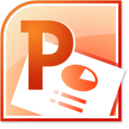 Microsoft PowerPoint is an excellent presentation software program, which is used for slide presentations in classrooms and business and many industry areas.
Prezi is a web-based tool for creating presentations. It's similar to other presentation software like Microsoft PowerPoint, but it offers some unique features that make it a good alternative. In recent years, it has become popular in schools and businesses.
Salaby is an educative software adjusted to the Norwegian school subjects
Creaza is a digital learning tool that enables students to work with different subjects and topics by creating mind maps, presentations, cartoons, movies and sounds productions, i en faglig in a pedagogical context..
Kikora is a learning tool for mathematics instruction. It enables students to learn and teachers to teach math more efficiently. No installation is required; the tool is loaded directly in the browser.
Microsoft has enabled SharePoint Online in Office 365 since 2010, which is a long time in the world of corporate intranets. This SharePoint Online is the latest iteration of Microsoft SharePoint Server, where teachers and students can produce, edit and share their files with each other without worrying of storing the files. They get automatically stored in the server.
SMART Board is one brand of interactive whiteboard. It allows you to project an image and 'interact' with it by writing on it or moving it around. The SMART Board is connected to a computer and works with a projector. The projector displays what is open on the computer and, rather than using a mouse or keyboard (although you can use those also), the SMART Board is a touch screen, which allows you to manipulate anything on the screen using your fingers. It is similar to how you would use a tablet or iPad. Special pens are included in a SMART Board to make writing in different colors quick and easy.
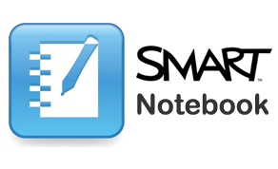 SMART Notebook is a part of the SMART Learning Suite. The suite combines Notebook with assessment, student collaboration and game-based learning software, to create enriching learning experiences. It's available on one simple licensing plan.
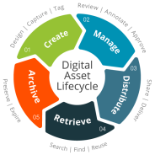MultiSMART enables all individuals possess key multiple ‘intelligences’, in various degrees of aptitude, to learn, remember, perform and understand. These are Logic (& Math) Smart, Language (& Linguistic) Smart, Visual (& Spatial) Smart, Body (& Kinaesthetic) Smart, Music Smart, Self (& Intrapersonal) Smart.
Tempolex is a drilling programme that helps some students in getting better readers.
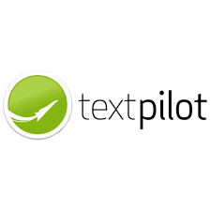 Textpilot is an intelligent support-programme that helps students in writing correctly in any kind of texts and in several languages.
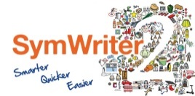 SymWriter2 can be used to create symbol-supported documents like SymWriter Online and has the addition of assisted writing with grids and switch support.

