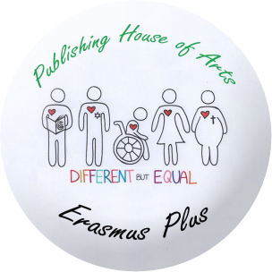
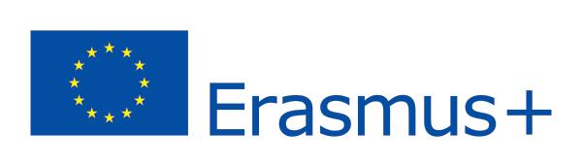

REPORT ON MOBILITY MEETING IN KELMĖ, LITHUANIA, APRIL 25-29
REFLECTION-EVALUATION OF ACTIVITIES
Student/activity | Jorge Juan Méndez Lorenzo | Andrea García Vázquez | Carlos Gondell Muíno
Music writing workshop | I didn’t work in this workshop. | We were choosed by each lithuanian musician and two of us made a rithym for our song. Then, we finished it and we recorded the song. I enjoyed playing the drums. | Andrea and I worked in the same workshop, but I have to say that rapping for me was a very especial experience.
CD Cover and label workshop | I worked with a lithuanian student called Rimvidas in this workshop. All of the pupils who worked on this subdivided into 4 groups, and Rimva gand I worked on the CD design itself. | I didn’t work in this workshop. | I didn’t work in this workshop.
Workshop on Lithuanian folklore instruments in Folklore Centre | We first watched an old Lithuanian musician playing antique folklore instruments, and after he finished doing it, we danced with Lithuanian folklore dance apprentices. I think it was very fun, even though I don’t like to dance. | Listening to the typical Lithuanian music made me learn a bit about their culture and dancing with them was really nice and I enjoyed it. | At first I was really shy and I didn’t want to dance but then I decided to try it and I really liked it. Since that moment, I can’t resist dancing at all the time.
Presentation of final products: CD and songs | I didn’t present the song, nor the CD work we did. Andrea and Carlos presented the song, which they did great and the Lithuanian students presented the CD. | I liked a lot playing the drums in front of all the people and I think they enjoyed our song a lot because it was the best one. | I had some mistakes when I was rapping but the playback worked well for me. I loved the experience of changing myself, and act infront of all that people.
Workshop in European Information Centre in Vilnius | We learnt about the opportunities related to jobs we have when being part of the European Union; such as doing projects in which we can travel around the world. | There we learnt about a lot of european chances of having different jobs in each country due to the scholarchips. | We heart a speech about the opportunities and benefits European Union gives to us
Cultural activities:  Hill of Crosses  Vilnius  Plokštinė Cold War Museum  Amber Museum  Palanga and seaside | We had a chance to learn about Lithuanian history and culture, and to see beautiful places we normally couldn’t see. | This activities helped us to know more things about this country and its history. We learnt a lot and we had the chance of buying | It showed us the history of Lithunia and how it changed to what it is today

SKILLS AND COMPETENCES DEVELOPED
Skills/competences
Computer skills: | I was already good at this field, but I learnt something new to me, which could be useful in the future. | I didn´t work too much with the computer. | I didn´t work with the computer
Creative skills: music composing | I didn’t work at this field. | We also learnt how to be creative without feeling embarassed. | They showed us how to compose a song with basic singing skills
Introduction to Music Record Studio | I didn’t work at this field. | We learnt how to record a song and how to play it in front of everybody. | We learned the basics os recording music.
English language:  Speaking  Writing  Reading  Listening | We literally used English everyday so I guess we improved it more, because practice makes things better. | We were speaking english everyday, we also wrote a lot in english to talk by phone with our lithuanians. | The only way to communicate with each other was using english, speaking or writing, but mostly in english
Awarenes of multilingualism | We are aware of the importance of knowing different languages, so you have opportunities to travel abroad. | We understood the importance of knowing a lot of languages to talk with different people. | We are now awared of the importance of knowing diffrent languages when you are abroad
Awareness of national identity | We were aware of how interesteing is it to know about other cultures, and learning their habits. | We enjoyed a lot talking about our culture with others and sharing our habits. | It was fun talking about each culture and the differences between our lifestyles
Awareness of European identity | We are now aware of how the European Union works exactly and how many opportunities it gives to young people like us. | Being in the european union gives us a lot of chances and that makes us be proud of our situation. | We now know everything the European Union does for us and for the world.
Team work | Foreign people were really nice to meet, they were all friendly and always prepared to talk with everyone. They also helped us in anything they coul. | Working with this people was fantastic i enjoyed each moment. | Working with foreign people was really fun and I learned a lot

HOST FAMILIES
 | Matas Urbelis | Jörune Antanaityte | Rokas Andrulis
 | He was so good with me. We are still in touch and i will never forget everything that he did for me that week. | Awesome family, nobody could have treated me better. She and her parents are the best. | He is such a great guy! He looked after me in each moment, i would like to enjoy some more days with him.

