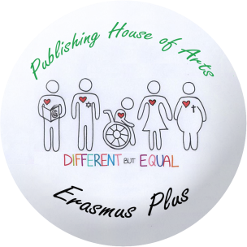
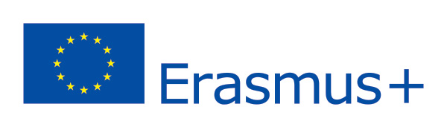

REPORT ON MOBILITY MEETING IN KELMĖ, LITHUANIA, APRIL 25-29
REFLECTION-EVALUATION OF ACTIVITIES
Student/activity | Nadine Heinzelmann | Marie Scheffel
Music writing workshop | - | It was hard to write the lyrics and a good melody, but the Lithuanian boys helped us a lot.
CD Cover and label workshop | I enjoyed it and the team work was pretty good. | -
Workshop on Lithuanian folklore instruments in Folklore Centre | It was great and a lot of fun to learn different Lithuanian dances. | In my opinion, the several sounds of the old instruments were presented well.
Presentation of final products: CD and songs | For me, it was interesting to see the work of the other group. | I liked to hear the songs of the other countries and to see the final CD cover.
Workshop in European Information Centre in Vilnius | I did not know that there is such a center in Lithuania. | There was no workshop, but the woman did a good presentation.
Cultural activities:  Hill of Crosses  Vilnius  Plokštinė Cold War Museum  Amber Museum  Palanga and seaside | It was great to get to know more about the Lithuanian culture and learn typical things about the region itself. | The severe cultural activities were varied and it was a good way to spend our freetime in a foreign country.

SKILLS AND COMPETENCES DEVELOPED
Skills/competences | Better communications skills in foreign languages. | I improved my Lithuanian vocabularies.
Computer skills: | Now I can design a CD cover. | -
Creative skills: music composing | - | I know how to write a song and find the fitting lyrics to it.
Introduction to Music Record Studio |  | I learned how to record a song, but I´m still not able to sing.
English language:  Speaking  Writing  Reading  Listening | I improved all facettes of my English. | I have better competences right now.
Awarenes of multilingualism | I got better in switching between several languages. | I learned to think in different languages.
Awareness of national identity | I learned that actually we are all the same, no matter what country we´re from. | It is important to not forget about your national identity and be open-minded towards others.
Awareness of European identity | I experienced a feeling of unity. | We should not forget thst we are one Europe no matter which country we are from.
Team work | All students cooperated in an amazing way. | It is something great which helps you to achieve more in life.

HOST FAMILIES
Gabriel Surna | Mantas Ralovecas
It was okay. | It was really amazing! He was the best host partner I have ever had and his family was awesome too. They cared about me and made sure that I had a great time there. Moreover, I will never ever forget that. I cannot wait to see them either in Germany or Lithuania again! <3 :D

