PUBLISHING HOUSE OF ARTS 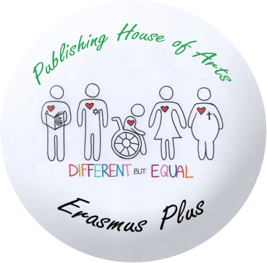
2014-1-LT01-KA201-000505
TEACHERS‘ REPORT

2016-05-03

- Please give the students evaluation reports and send them by May 22. Upload them in etwining too on your own. I will create a Page for it
- At least two articles for DEFRIT : one should be about Erasmus+ activities, another topic is free. Also photoes. Everything in Word format. Don‘t forget to add authors‘ names. Deadline May 22.
- Mechtild, Michael and Lucia: what is the number of DEFRIT issue? I got mixed, I am afraid.
- Please share your photos with other members via Dropbox or We Transfer. Also upload some in etwining;
- Please do as much dissemination activities as possible: Clelia is planning a big meeting with parents, teachers, etc. This is a great idea. We have an Open Door Week where we will present our project. Write articles to your school websites and local newspapers. Whatever you do, please upload info in etwining;
- https://www.kmk-pad.org/praxis/pdm.html this is the link to our project being selected the Project of April month. It‘s a great recognition. It would be great if you could ask your school website to have a direct link (I hope you understand). Please publicize this news as wide as possible – it‘s a great achievement.
- Mechtild and Michael, when you receive this award, take as many photos as possible and make a copy of the certificate to all countries, please
- I‘ll send you a table for you to fill in with your summer vacation dates – when you are certainly unavailable. This is necessary for me when I start Final Report.
- Please check the dates of Final Report in your financial agreements and let me know if they are all the same for everyone.

GOOD LUCK

