… and Marko grabbed the gem.
Leaving the cave, Marko thought that he couldn’t do this on his own and realized that he’s going to need help from his friend Laura, he quickly flew home and wrote a letter to Laura.
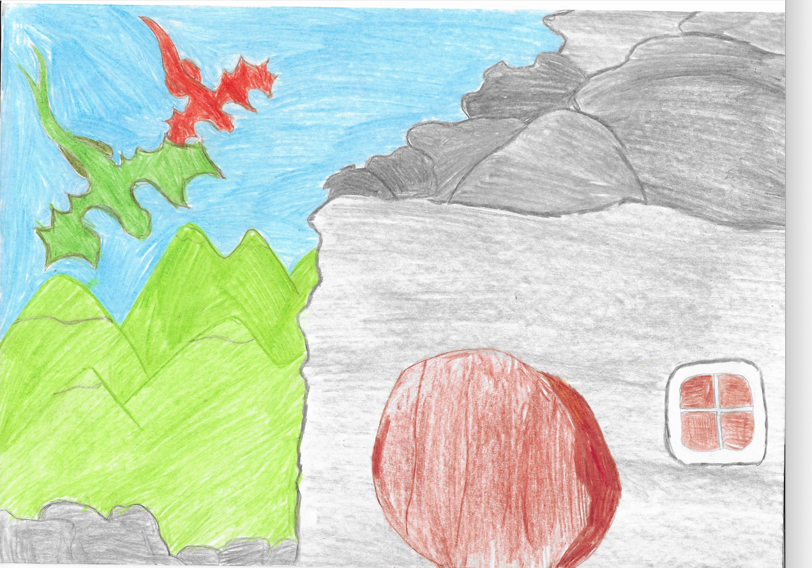

Dear Laura,
I’ve already found the gem. However, I can’t continue this mission alone. I’m going to need your help. I understand if you don’t want to help me, but I’d really appreciate your help and your companionship. Master Dragon gave me several things to think about and I need your advice.
From your great friend,
Marko

Several days passed without an answer…. Marko started to believe that Laura would never reply. He needed a plan if he wanted to help the humans, so he started thinking about a way to fix this.
The days became weeks and the weeks became months and he still didn’t have an answer from Laura and without what seemed to be a reaction from the precious gem that Master Dragon gave him, he started to get worried because nothing was happening. He feared that the gem wouldn’t work.
He realized that the longer he would wait, the least probable would be Laura’s reply and that the gem wouldn’t transform into the new owner’s face. Marko was afraid that he would never be able to help the humans.
Hopelessly, Marko looked at the sky as if to ask for help, when, unexpectedly, he saw an orange dot getting closer. Yes, it was Laura….
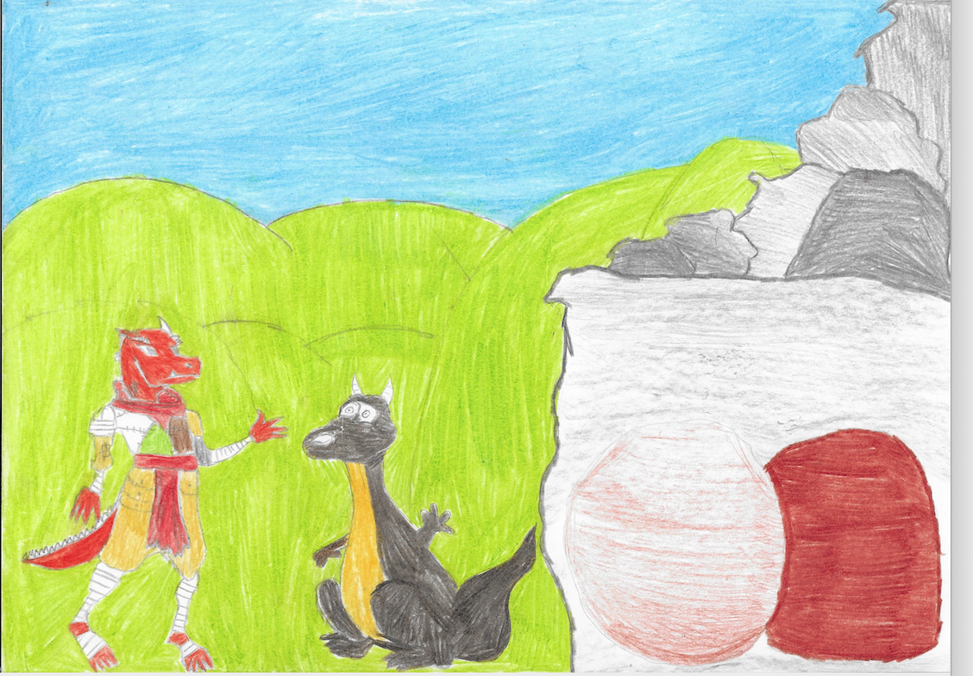
Laura had read his letter and was arriving, ready to help Marko. Full of joy, Marko couldn’t help but to jump around like a child!
Laura and Marko talked for hours and tried to understand how the gem worked.
(Laura) – Should we say some magical words?
(Marko) – I don’t think so.
(Laura) – Then what might it be?
(Marko) – I don’t know, but we’ll figure it out.
The days passed by and they were going crazy, how was a simple gem taking so much time of their lives. They needed a solution and fast…
(Laura) – Wait, the gem still has the Master Dragon’s face.
(Marko) – Does that have anything to do with it?
(Laura) – Of course it has! Don’t you think that by this time the gem should’ve had your face?
(Marko) – Well, that’s a hypothesis.
(Laura) – Let’s talk to the Master Dragon then!

They flew as fast they could and when they arrived at the Master Dragon’s cave, they knocked on the door and the Master asked:
- Who’s there?
(Marko) – Master, open the door, it’s important!
(Master Dragon) – Marko, is that you? What are you doing here?
The door opened slowly, and Master Dragon invited them in.
(Master Dragon) – You shouldn’t be here, and… First of all: Who are you, “Orange”?
The Master was pointing towards Laura...
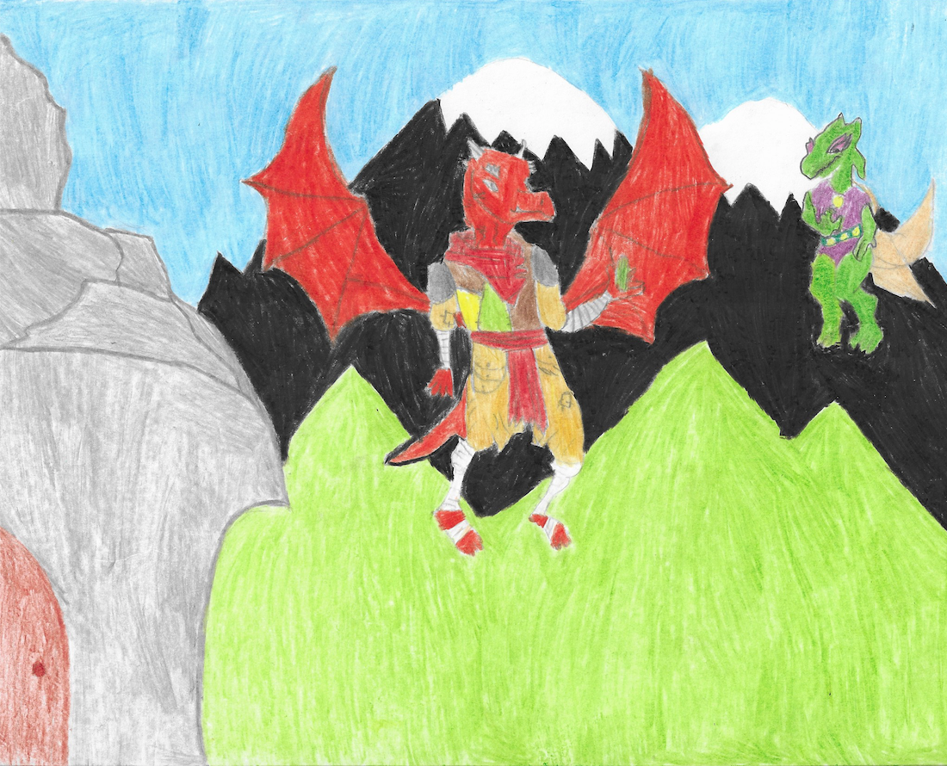
(Laura) – I’m Laura and I came to help my friend, to convince you…
(Master Dragon) - …Convince me to do what?
(Marko) – Helping the humans…
(Master Dragon) – Don’t even think about that! I gave you the gem for a reason… Don’t get me into your problems…
(Laura) – But the gem still has your face…
(Master Dragon) - That’s not my problem!
(Laura) – Of course it is!
Laura screamed so high that even the ones that were passing outside heard it clearly… Marko and the Master made very surprised expressions, looking at Laura, who continued:
- Your selfishness is damaging my friend’s mission!!! So, if you have got at least one bit of kindness in your heart, you are going to help him and…
– Laura! – screamed Marko – It’s enough. If he doesn’t want to help, then we’re not going to force him.
(Master Dragon) – You have the courage to come to my house and scream at me, thinking that would make me help you? You are even worse than the humans…
(Laura) – Look, I’m sorry for screaming at you, but we just wanted your help…
(Marko) – I understand if you want to kick us out, but please reconsider. We are begging for help. We don’t know what to do anymore…
(Master Dragon) – You kids are all the same… You think that a simple apology is going to make me change my mind?
(There’s was pause)
(Master Dragon) – And how would you prove that the humans are worthy of my help?

To be continued…

