Schools work together for our collaborative online Wheel game
https://wheelofnames.com/view/el/tzp-pjx/
Dear partners, let each school take the picture, paint it and send it to Mrs Anna Fanourgiaki by Saturday 5th of December afternoon

school name

1. Predškolska ustanova „Naša radost”
Edina Đorović

2. Daniela Virágová

3. 12th Kindergarten of Karditsa | 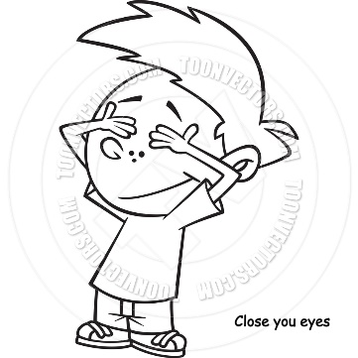
4. Σταθούλη Μαίρη | 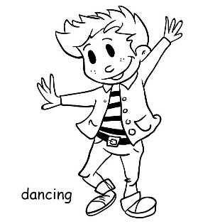
5. Kindergarten of Sternes Chania Crete | 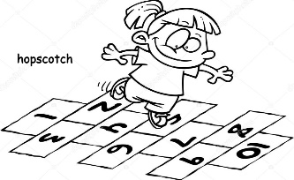
6. Uzunköprü Demokrasi İlkokulu
Neriman Temizel
7.  1th Kindergarten of Anogia | 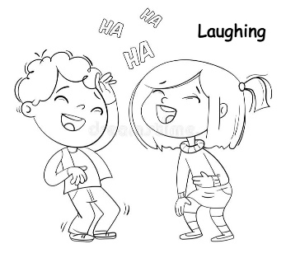
8. 2nd Kindergarten of Plagiari
9. Przedszkole nr 16 w Żorach  Place  Żory, Poland | 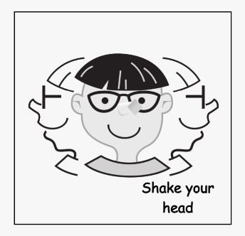
10. 13th Kindergarten
of Rethymno
11. 5th Kindergarten of Veria | 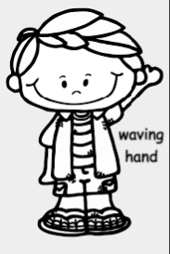
12. 2nd Kindergarten of Almyros | 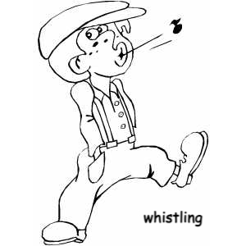
13. Kindergarten of Paralia Ofryniou

