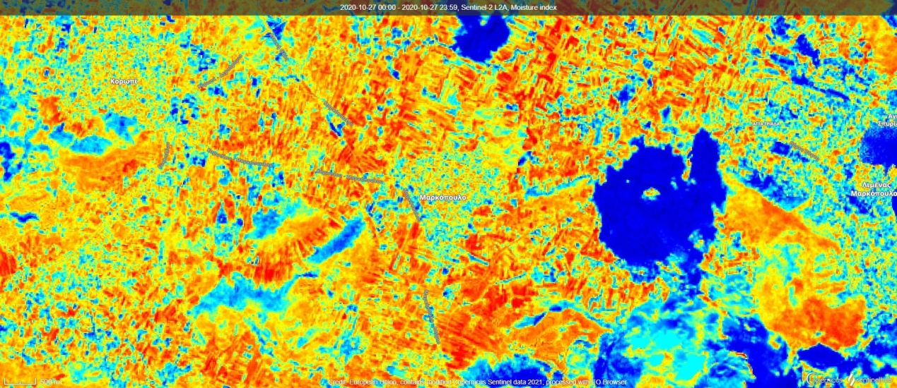
Picture 1 - 27.10.20 - Markopoulo Greece (Autumn)

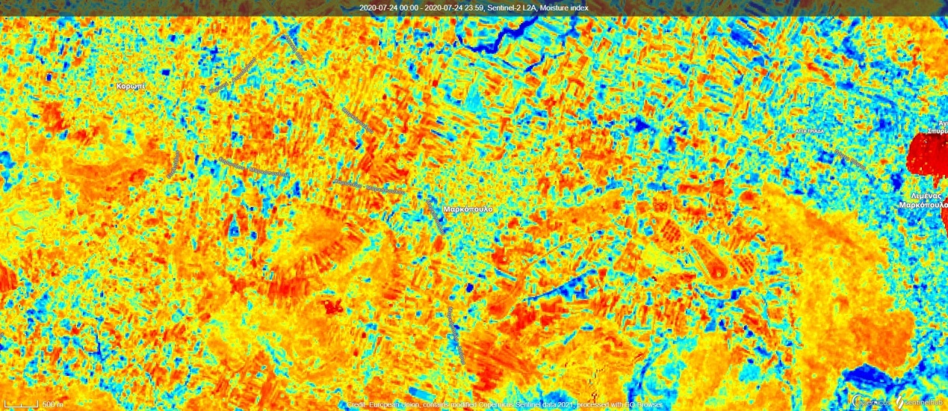
Picture 2 - 24-07-2020 Markopoulo Greece (Summer)

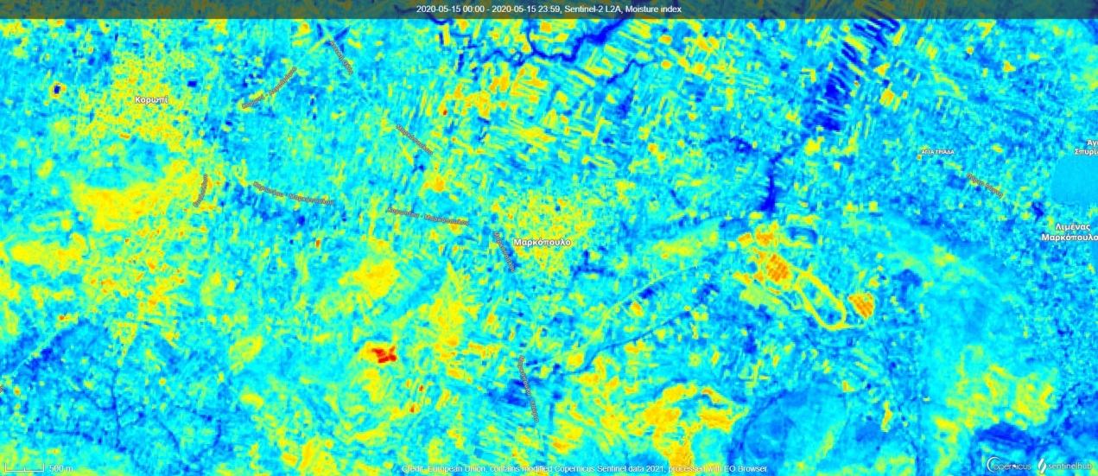
Picture 3 - 15-05-2020 Markopoulo Greece (Spring)

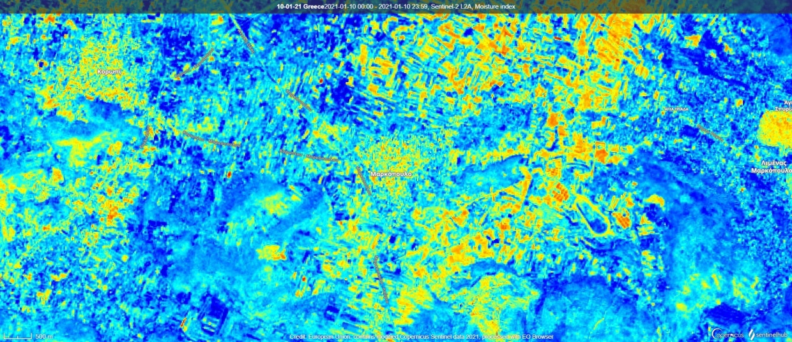
Picture 4 - 10-01-2020 Markopoulo Greece(Winter)

We can tell the moisture difference between different seasons when looking at the colors of the picture.
We observe that in the winter months there is lots of blue and as we go into spring less blue and more yellow and then in the summer lots of yellow, orange and red and finally in autumn lots of yellow, orange and red and some bluish areas.
As the color turns from Blue Yellow OrangeRed this means from
High canopy No water stress Water stressDroughts

