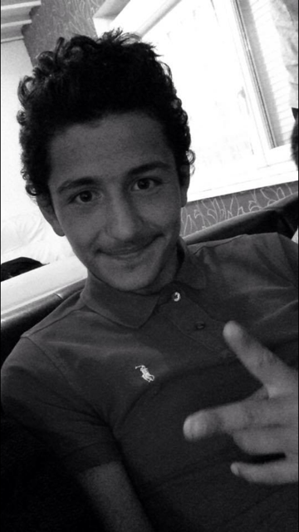
Oktay Akman

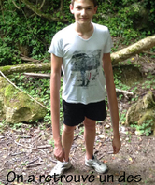
Enzo Deza : YOU LIKE FOOTBALL. YOU LIKE WATCHING FOOTBALL MATCHES ON TV . YOU DON’T LIKE FRENCH TEAMS, DO YOU? YOU HAVE GOT BLUE AND GREEN EYES. NO , I DON’T , TRY AGAIN !!!

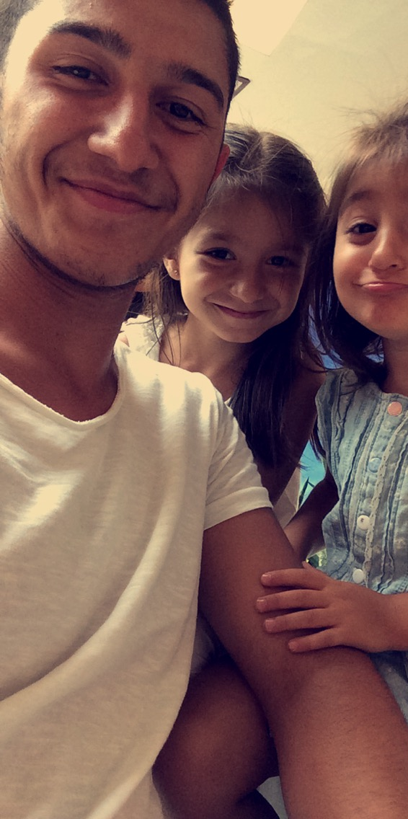
Fatih Ayrangol



Quentin Lavens : YOU PLAY VIDEOGAMES TWO HOURS A DAY. YOU LIKE CREATING CHARACTERS IN VIDEO GAMES, DON’T YOU? Yes, I do, congratulations!


Osman Kuzu : YOU WEAR A BLACK AND BLUE TSHIRT. YOU LIKE PLAYING A SPORT (we didn’t understand which one?!) WITH YOUR DAD. YOU LIKE BADMINGTON TOO. No, I don’t ,try again. I don’t like badmington .


Quentin Heinimann : YOU WEAR A BROWN PULLOVER AND YOU PLAY BADMINGTON. Yes, I do, congratulations !

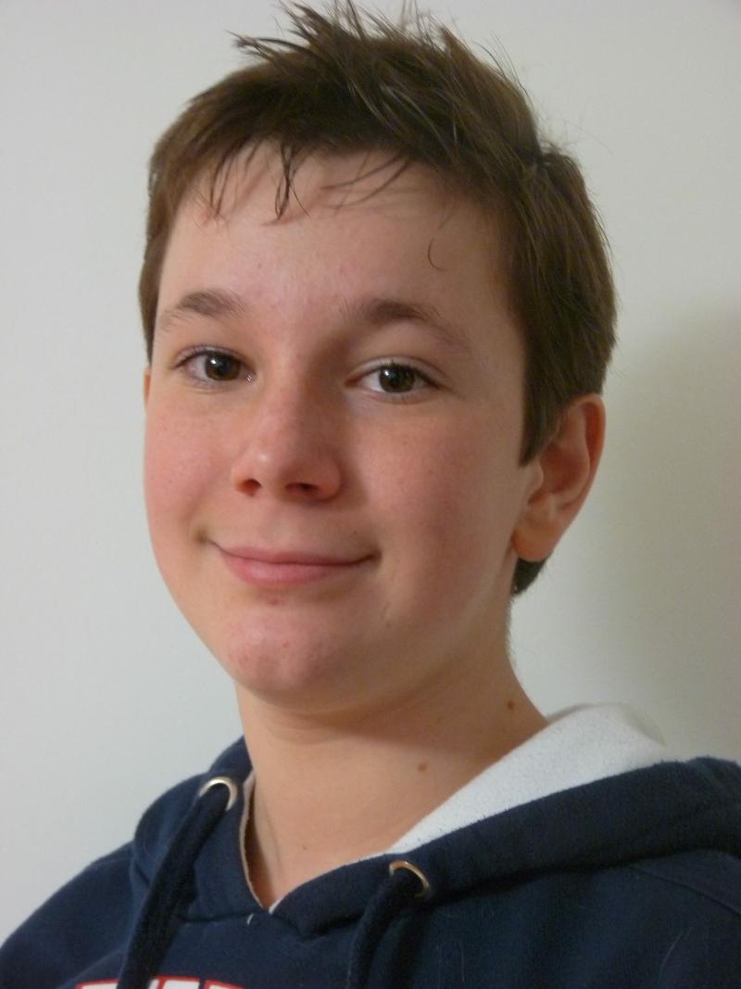

Pierre-Amand : YOU PLAY HANDBALL, YOUR FAMILY TOO. YOU HAVE GOT BLOND HAIR. No, I don’t, try again !

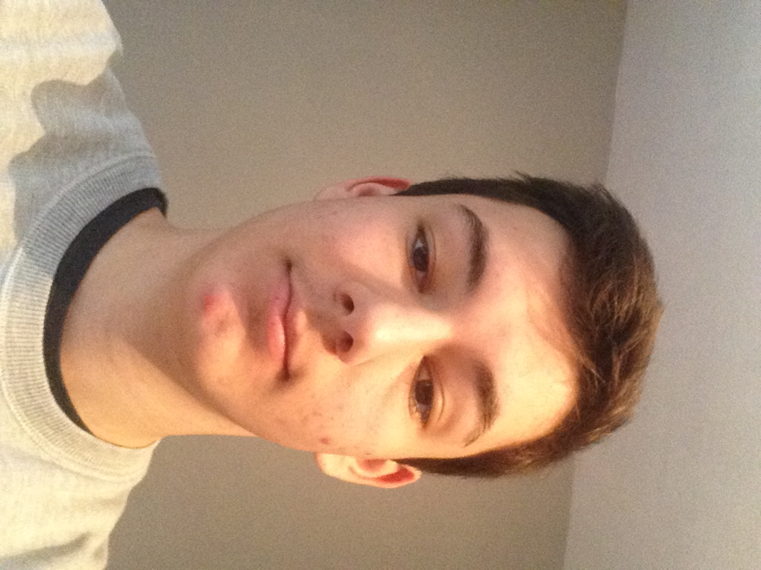

Lilian : YOU PLAY THE GUITAR TWICE A WEEK, DON’T YOU ? (You wear a grey sweatshirt) No I don’t, try again!



Clément

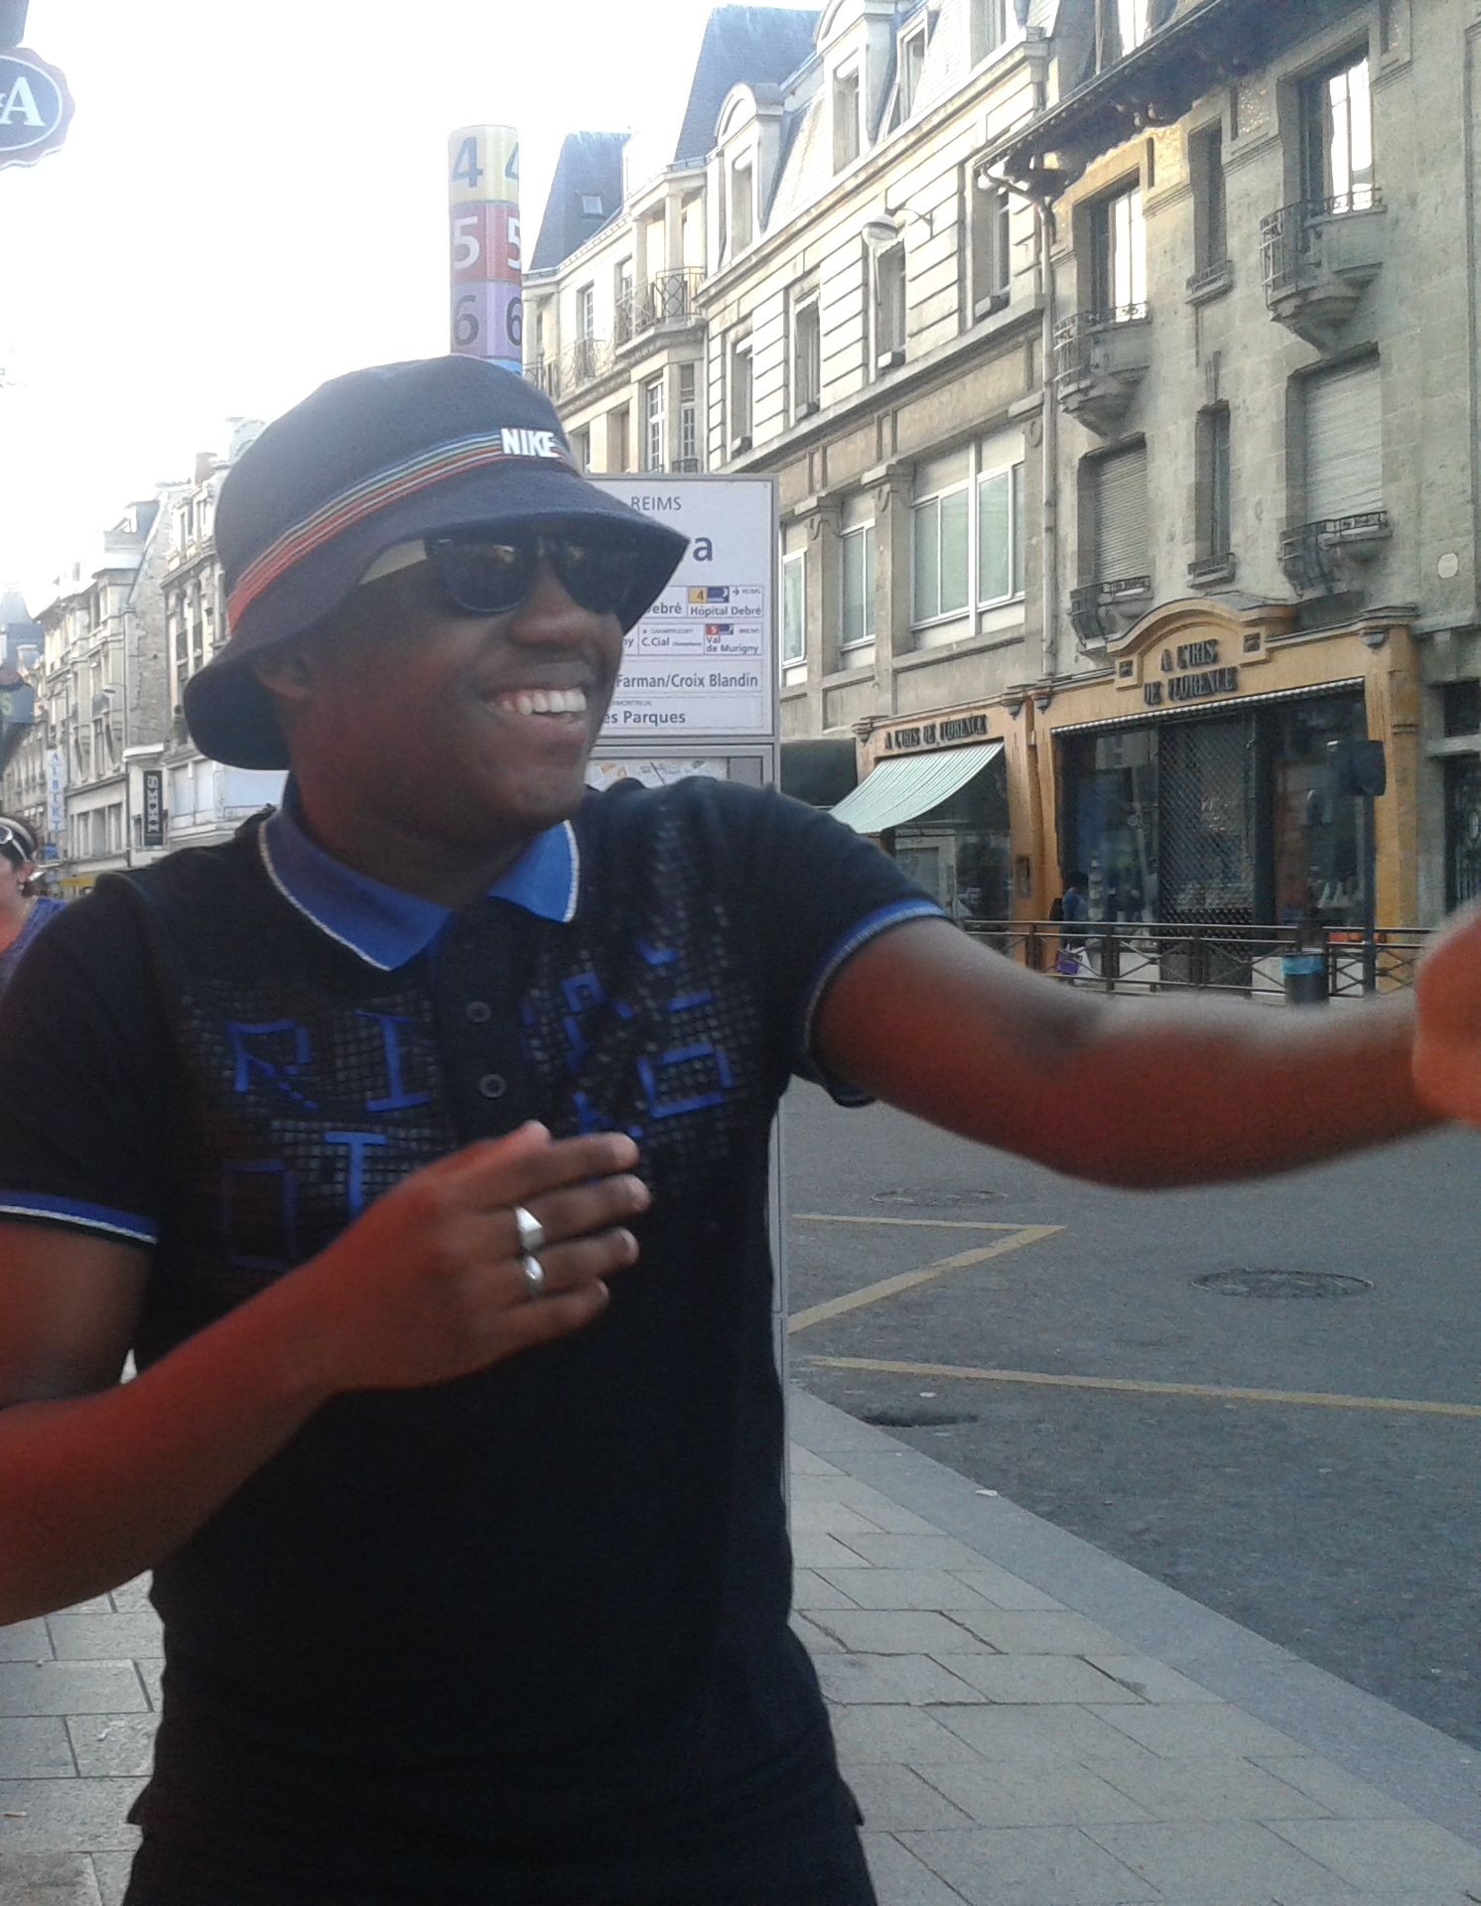

Christopher : YOU PLAY FOOTBALL. YOU LIKE LAUGHING !!! No I don’t try again but yes I like laughing.

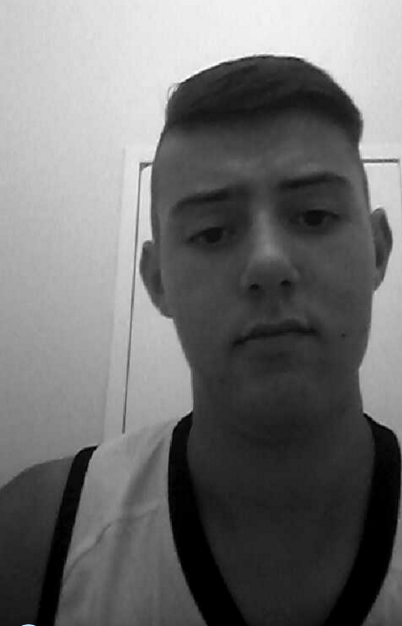

Joris

N°3 : YOU LIKE MOTOCROSS AND YOU PLAY FOOTBALL AT VAL DE MURIGNY. YOU LIKE LISTENING TO MUSIC : JUL / ALONZO. YOU DIDN’T DESCRIBE YOURSELF PHYSICALLY SO THIS IS DIFFICULT TO FIND YOU!!!! No,I don’t, try again!

Here are some elements to correct your answers:

N°8: my picture is black and white.

N:11 on the picture I am with 2 little girls

N° : 10 I have got brown hair and brown eyes

N’4 : I don’t play football
I prefer smaller grounds and play indoor to be in the warm.

N°: 3 I have long brown hair and I am wearing a polo.

N°2 : Hello my friends ! I have brown hair and I am white. Good luck ! :p

N°9: I am wearing sun glasses and a sun hat.

N°1) Oh, Sorry, I have got a navy blue and not a grey sweat shirt, I have got brown hair and not blond.

N°10: I have short brown hair.

