: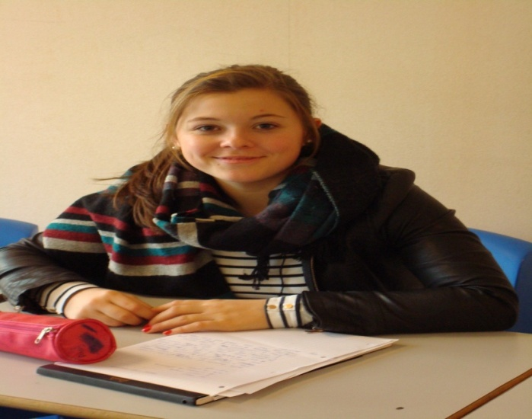
Anais : YOU ARE A JUDO CHAMPION, YOU PRACTISE SPORT EVERYDAY, YOU LIVE IN PICARDIE AND YOU WEAR A GREY TSHIRT. YOU ARE A NEW STUDENT IN THE ENGLISH CLASS. (recording number 2)

Gamze

Gamze : YOU LIKE SHOOTING (it’s relaxing) / YOU WEAR A JEANS JACKET. (recording number 6)

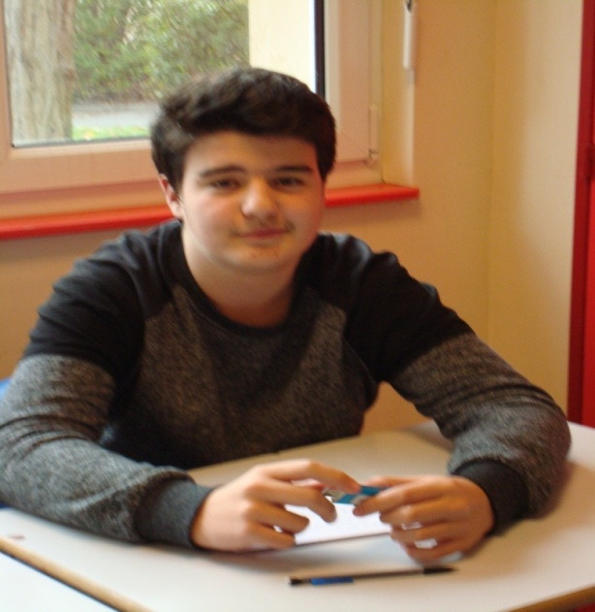

Théo A. ???????????????

Lucas C ???????????????
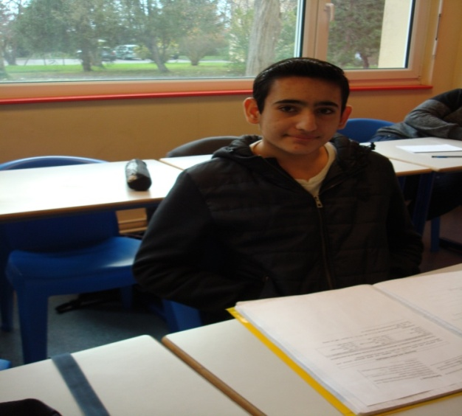

Bachir : YOU PLAY FOOTBALL AND YOU WEAR A WHITE TSHIRT ( recording number 7) (number 13 is the same as number 7 !!!!!!)

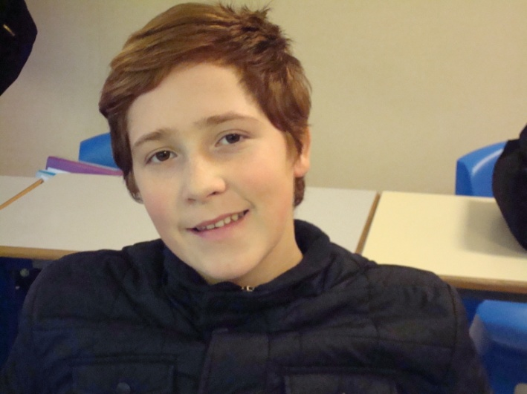

Romain : YOU LIKE PLAYSTATION / MMA ( free fights) / you practise boxing every day. You have blond and red hair. (recording number 11)

Mickael : YOU LIKE BOXING AND VIDEO GAMES. YOU HATE JUSTIN BIEBER. YOU DON’T LIKE SCHOOL. ( recording n°15) You have black curly hair. YOU HAVE A MUSTACHE.

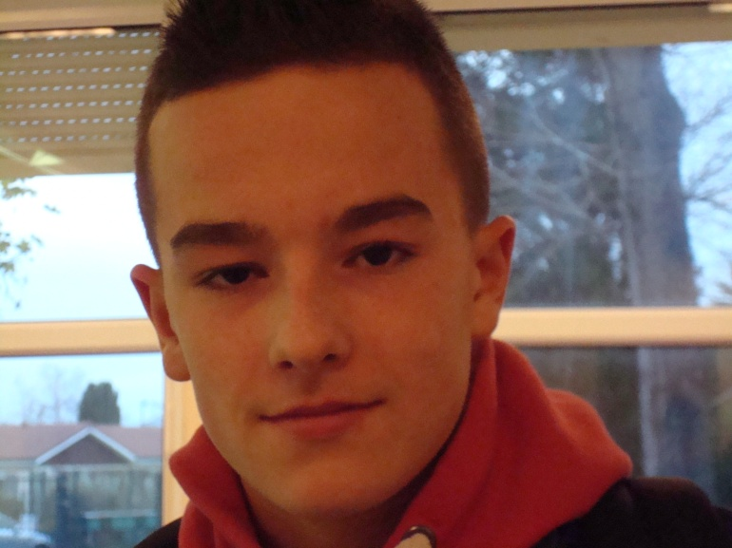
Thomas : YOU TOOK A PICTURE A PICTURE OF YOURSELF. YOU PLAY FOOTBALL. YOU LIVED IN LYON ( recording number 12)

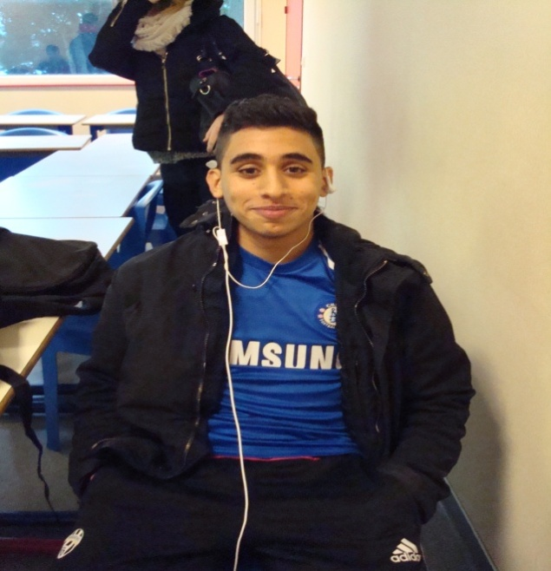 Alyes : YOU LOVE FOOTBALL (you think it’s good and funny) WITH A BLUE TRACKSUIT.(recording n°5)
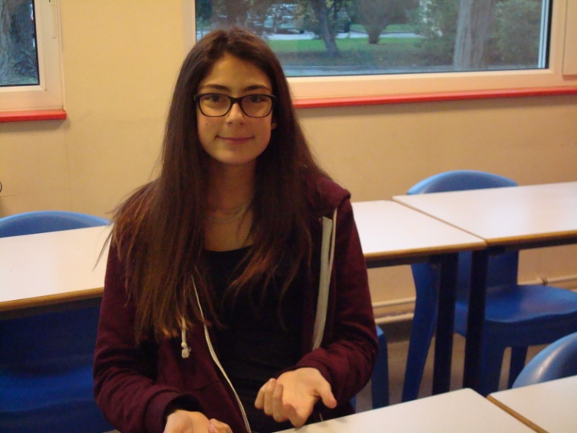
Chloe : YOU HAVE LONG HAIR (recording number 14). YOU HATE DOING THE WASHING UP. YOU WEAR GLASSES. YOU LOVE NUTELLA.

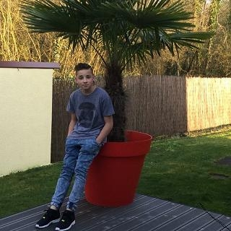Lucas P : YOU PLAY TABLE TENNIS AND YOU WEAR A BLUE SHIRT AND BLACK SHOES. YOU HAVE SHORT BLACK HAIR. (recording NUMBER 1)

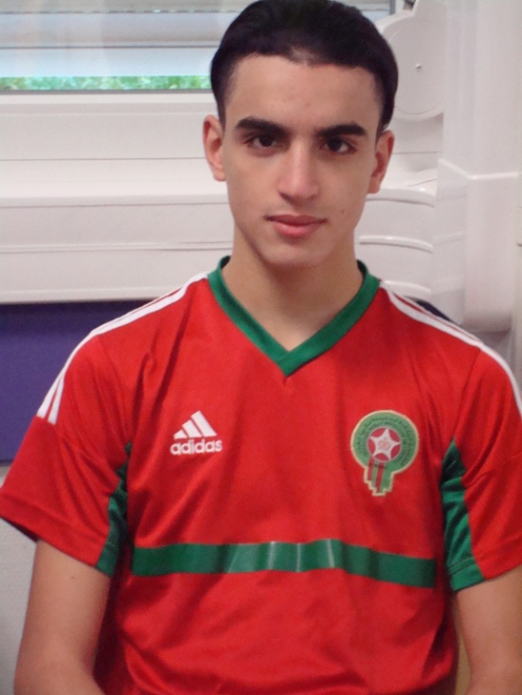

Amine : YOU PLAY FOOTBALL ( recording number 10) : it’s an interesting and collective sport. YOU’RE TALL. YOU ALWAYS PLAY FOOTBALL.

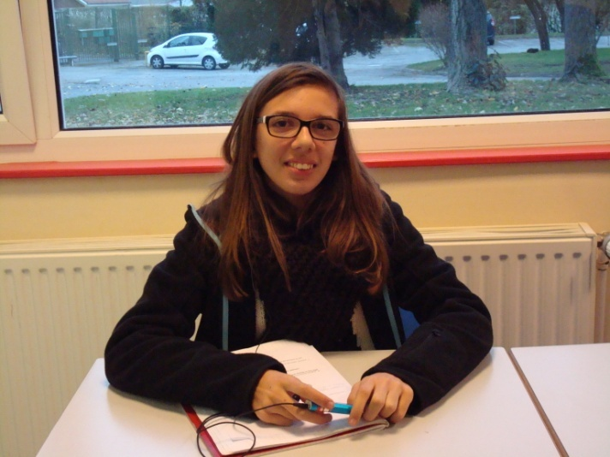
Gaelle : YOU LIKE WATCHING TV AND YOU PLAY BASKET BALL. YOU WEAR A BLACK COAT AND A WHITE PULLOVER ( RECORDING NUMBER 4 ). SCHOOL IS PRONOUNCED /skul/ !!!!!
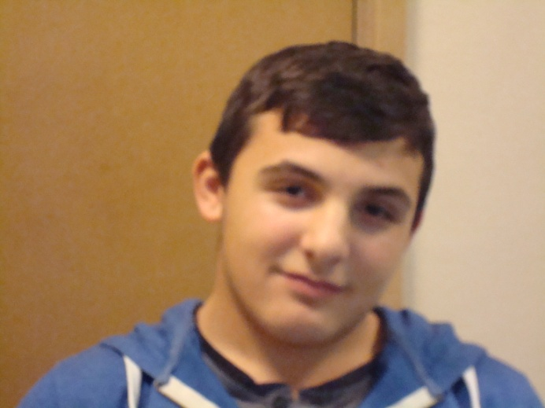

Pierre : ????????????

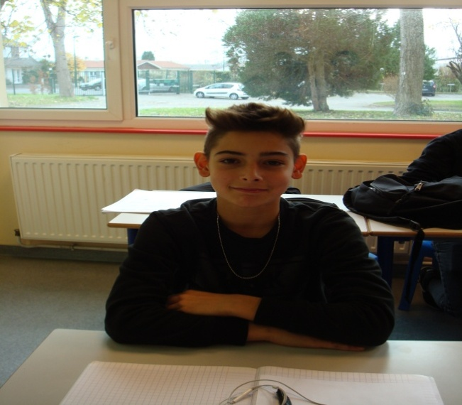

Paul : YOU HAVE GOT BLOND HAIR, YOU LOVE BIKES, YOU PRACTISE IT A LOT, BABY is the nickname of your motorbike. YOU WEAR A GREY TSHIRT. (RECORDING NUMBER 3).

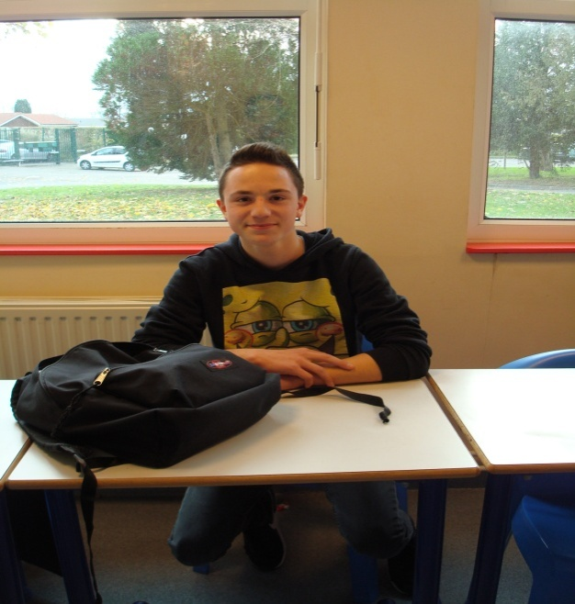

Lucas C. : recording number 17 : YOU LIKE SKATEBOARDING. YOU LIKE VIDEO GAMES. YOU’RE SMALL. YOU’RE 15 YEARS OLD .

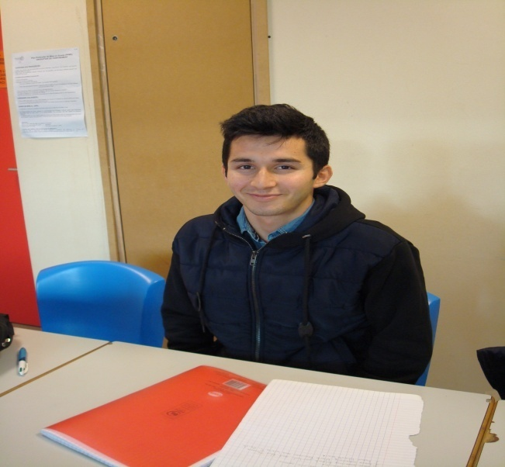
Bachir???????

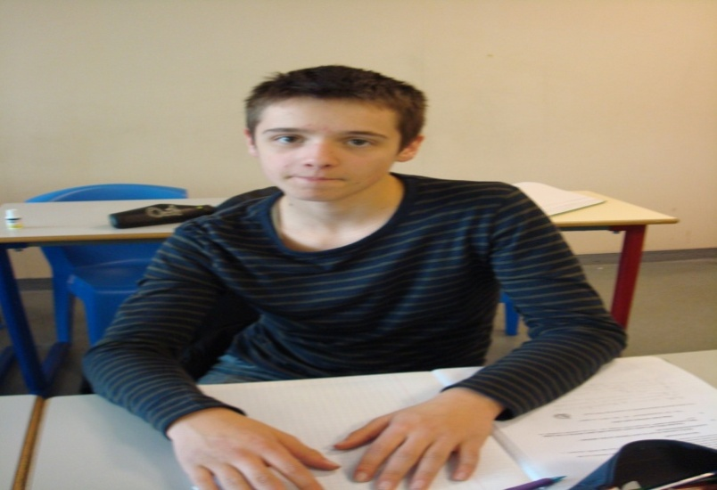

Alban : YOU’RE DOING MOTORBIKE ( recording number 8) during weekends with a lot of sensations. You have brown eyes.

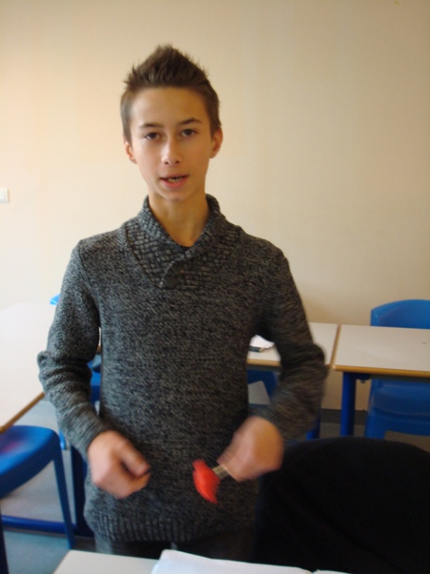
Lucas J. : YOU HAVE SHORT BROWN HAIR. YOU LIKE SKATEBOARDING AND JUMPING WITH YOUR BIKE. YOU LIKE EXTREME SPORTS ( recording number 9)

RECORDING NUMBER 16 is a girl who likes Harry Potter. She wears glasses too. SHE LIKES DRAWING AND WATCHING TV AND PLAYING VIDEO GAMES.
BUT NO PICTURE CORRESPONDS TO THIS RECORDING.

