Day 1
Dear dairy,
I woke up at 7:30 am, I ate breakfast at 8 `clock. Vat 9:30 I drove with my dad to malls. There waited the other people and our teachers. At 10 am we started from Mals to Bergamo, it was a long trip, it took 4 hours to go to Bergamo, we arrived at 2 pm. We checked in at the airport. We were too early and so we went to the shopping centre. After 1 hour we went back to the airport. There we had the security check. There were many people. At 5 pm we flew to Spain (Seville). It was my first flight, it was really funny and at first I was really screed. After 2h15min we arrived in Spain. There we drove with a taxi to the hotel of the teachers. There the host family picked as up and we went to their homes. At 8:30 pm we went to a restaurant and there it was a bit strange for me because I was the only Italian student but all the other Erasmus + project students. At 10 I was at the home from Miguel, the family of him welcomed me and I went to bed. Leon Klotz – Team Italy
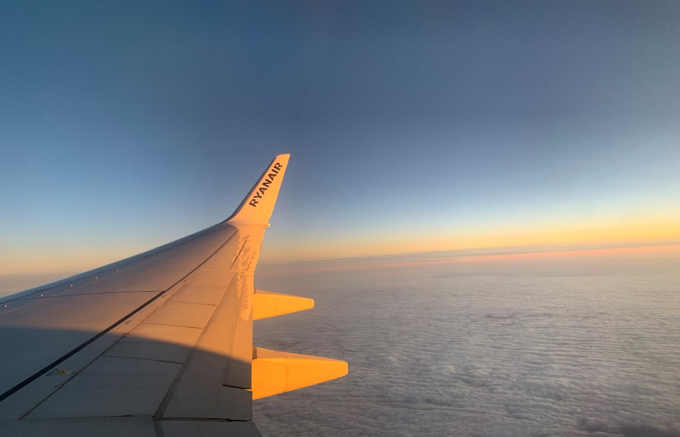
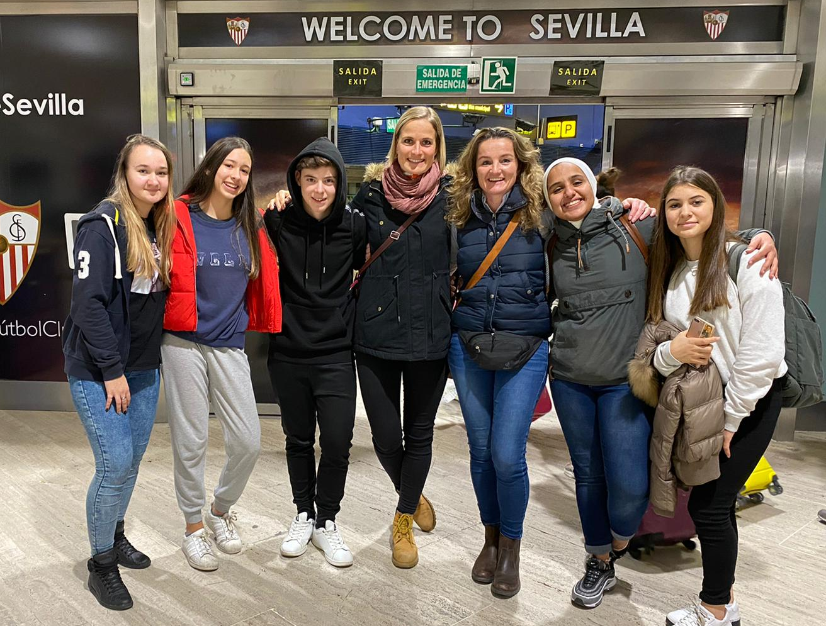
Day 2
26.11.2019, Seville
Dear diary, today I got up at 7:00am, and then I had breakfast, got dressed and brushed my teeth.
After that my exchange student`s dad drove us to school by car, at school we met my friends and the other exchange students.
The school began at 08:15am; at first we had a lesson of English, then we had a workshop called “The power of storytelling” by Audrey Rajah, after that we had a coffee break for half an hour.
After the coffee break, we had an Informatics lesson where we had to write a story. In the beginning, I thought it would be difficult, but in the end, my story turned out pretty well.
At 13:45 we had another workshop called ”Digital story telling: Apps used to create stories” by a teacher of the school.
Then the school ended and we finally could drive home to eat something, I actually was so hungry because they eat lunch a few hours later than we normally do in Italy. I fortunately liked the food very much, I ate a typical Spanish meal called “Paella“.
After lunch we went to a big shopping mall with all the other exchange students, we had a lot of fun but we also spent lots of money, but I really enjoyed it!
Then we all went to McDonald´s in the evening and then we drove back home.
At home, I took a shower, talked a bit to my host student, called my boyfriend and family and now I´m lying in my bed and I will probably go to sleep soon, it was a great day!
Noemi Theiner – Team Italy

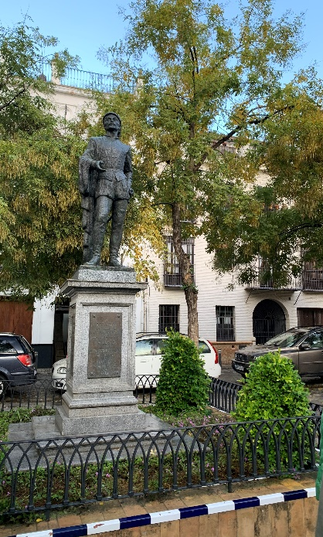
Day 3
Wednesday, November 27th
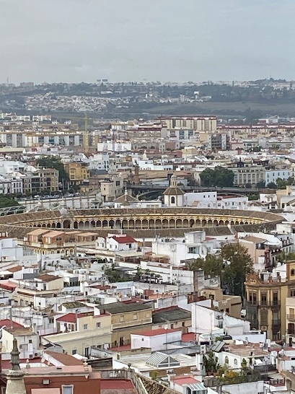
On Wednesday, I woke up at 7.30am and had breakfast with my host family. Afterwards we went by car to school. At 8.15am, we started our excursion to the town centre by bus. Then, at the time we arrived, we took a walk to the Barrio Santa Cruz. We saw a very famous monument called DON JUAN TENORIO. This man was a seducer at the time and had married many women. Afterwards we visited ALCAZAR, which is very famous for the movie Game of Thrones because they made many scenes there. Real Alcázar de Sevilla is the royal palace of Seville. The name 'Alcazar' means castle in Spanish. The complex of the palaces was built in the Mudejar style; a building style with many influences from the Moorish and Christian culture. It is probably the oldest palace in Europe still in use.
After that, we had coffee and a second breakfast at Starbucks. Afterwards we went to see the Cathedral of Seville. For me that was the most interesting part of this day because I learned things from the teachers that I would not know without anyone telling me. We also went on top of the cathedral; this tower is named the Giralda, from where we enjoyed a wonderful view over the city.
In the afternoon, we had the opportunity to grab something to eat, so we decided to try tapas, a typical dish in Spain. They were very tasty and we all enjoyed them.
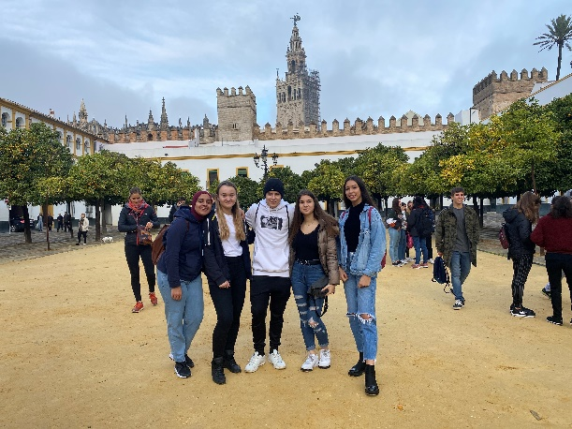
After lunch, we returned to school, where we worked on our storytelling projects. I was in a group of three boys from Spain and one girl from the Netherlands.
School finished at 5.30pm, we all went to a shopping centre nearby called Lago to check out the many different stores.
At night, I was very tired from all the sightseeing, new impressions and shopping. I had dinner with my host family, and afterwards I went straight to bed.
For me this day was one of the most exciting. Yasmin Sophia Vale – Team Italy
Day 4
28.11.2019
A day in Seville!
Like all the other days I woke up at 7:15 am. I did my routine and got dressed. After that, I went into the kitchen and drank my warm milk with chocolate that her parents made for me. At 7:45 am we left the house and went to their car to go to school.
Spain was much different than Italy. For example, breakfast, lunch and dinner. They eat very late. Breakfast is at 11 am, lunch at 3 pm and dinner mostly at 10:30 pm.
In school we listened to the presentations we had done and after all the presentations we left the school and went to Plaza España. There we got divided into groups. I liked my group and the teacher we had was really cool and motivating. We had 30 minutes to answer the questions and we also finished in time. Later after we were done, we listened to some poems. After the poems we walked to a restaurant and ate a lot of things. I also met new people what was really funny. I did not like the food because I didn’t know most of the dishes but I tried most of the food. Later in the evening, I went to another shopping centre. It was a smaller one but also there were interesting shops. With my group I explored the shops. After we explored the shops, we went to eat something at McDonald’s. They had a lot of fast food restaurants. One hour later, I had to go back to my host family. Her father picked us up from the mall and then he drove us back to the house. I showered, packed my suitcase and ate the food her mother made. And with that, the warm and nice day ended.
Amira Ghazali – Team Italy
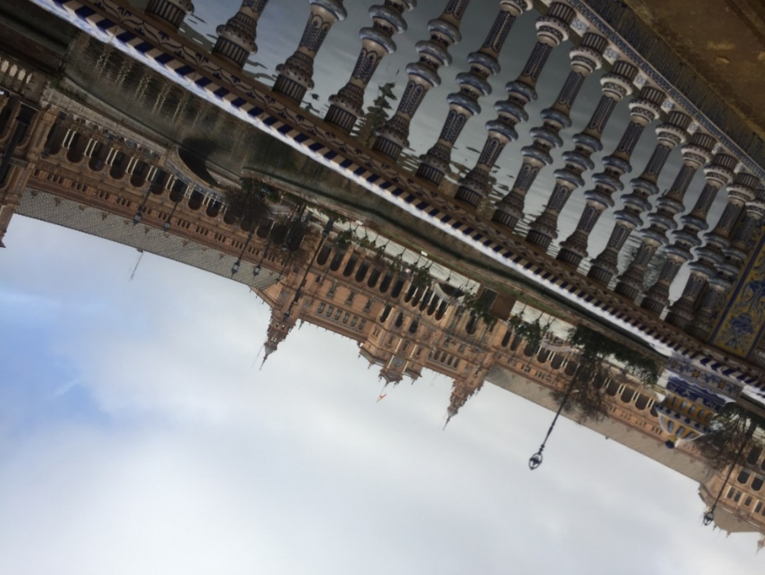

Day 5
29.11.2019
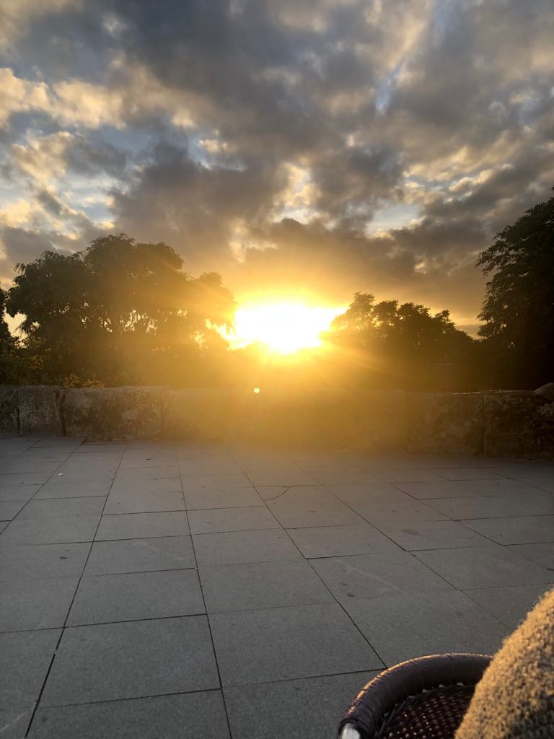
Dear diary I woke up at 7 am like every other day. We had breakfast at home. After breakfast I packed my suitcase because we had to take our suitcases with us. When we were leaving the house, they gave me a present. It was a small backpack. It was very kind of them, and I was very happy. Then at 8 am we drove to the high school. We had 3 hours at school. The first was History. We had a little presentation about Italy. The second hour was PE. We went to a park next to the high school and we played Frisbee. Then we went back to school and we had Drama. We watched a movie. Then we took our suitcases to the hotel. We stayed there about 2 hours. Then the driver took us to the airport. When we were at airport, we went to eat lunch. We went to Burger King. After we ate, we went to the plane. The flight took about 2 and a half hours. And it was amazing, and we took many pictures. After we landed, we went to take our suitcases. Then the driver waited in front of the airport. He took us back home. It took us about 3 and a half hours. My mom already waited for me at the parking lot and I was very happy to see her again after a week. It was great to be home again, but I really miss the time and the people in Seville. Timea Lisivkova – Team Italy

