KA 229 Erasmus+ mobility
the Netherlands
Digital project assignment

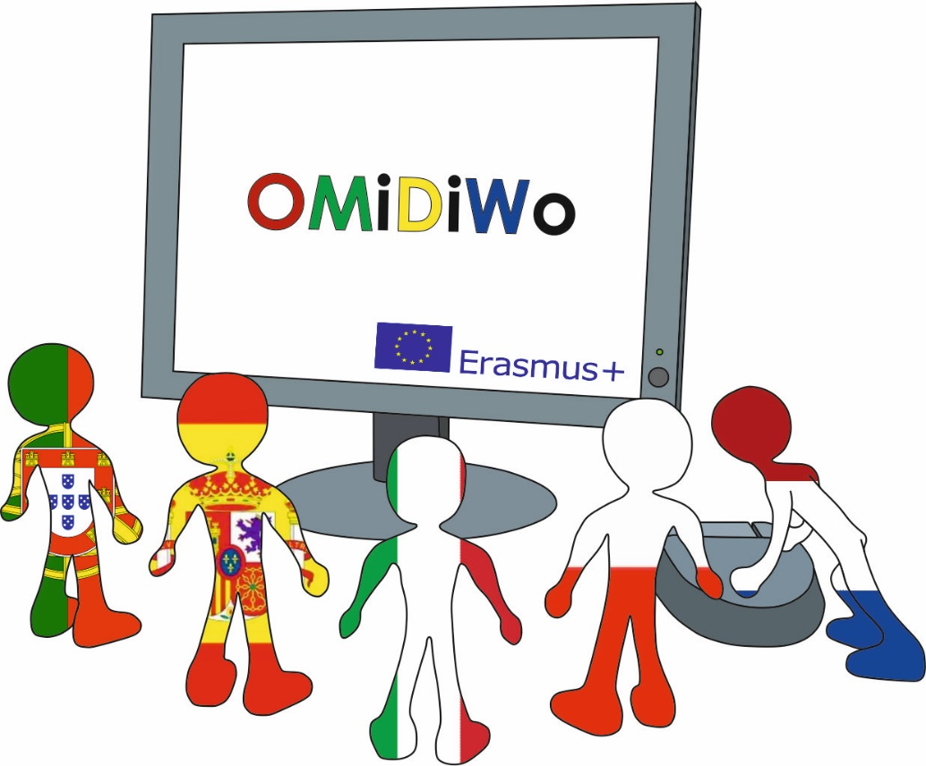

29 March 2022
to
31 March 2022

INSTRUCTIONS
Project description:
Together with your group, you are going to create one videoclip which answers the question:
“What is the European identity?”

In order to answer this question, you can:
Do (online) research, carry out interviews with locals, peers and teachers, make a survey, contact international institutions and NGOs for information, etc.

You will finalize the product using an iPad / smartphone / computer.

Finishing the project in 10 steps:
Follow this step-by-step plan when making your clip:
Stap | Actie
1 | READ ALL THE INFORMATION IN THIS DOCUMENT BEFORE YOU BEGIN!
2 | Brainstorm the question: “What is the European identity?” with your group members.
3 | Determine which information is still needed.
4 | Research the missing information (internet, interviews, surveys, etc.)
5 | Gather ideas on how to present your findings
6 | Assign tasks (camera, speaker, script, sound, design, etc.)
7 | Carry out tasks.
8 | Merge everything into one videoclip (see Do’s and Don’ts overview).
9 | Present the clip to the other groups.
10 | Send the clip to your teacher(s).

Finished?
1). Present it to your group (end of project).
2). Send it to your teacher / project coordinator and upload it to the Twinspace via one of the following websites:
- www.wetransfer.com
- www.sendspace.com
- www.dropbox.com
TIP: upload your clip onto Youtube for easy access.
Need inspiration?
- European Identity and mobility programmes
https://www.youtube.com/watch?v=8lVUlN3gffY
- European Identity & National Identity: Constructing a 'We'
https://www.youtube.com/watch?v=p9hhXLho_94
- The History of the EU with David Mitchell
https://www.youtube.com/watch?v=GfN05WB_rYw
SOURCE LIST
Recommended programs:
- iMovie
- Windows Movie Maker
- Stupefix (https://studio.stupeflix.com/en/)

Need help?
How to work with iMovie (Apple)?
https://www.youtube.com/watch?v=rDHYedh_BKY
https://www.youtube.com/watch?v=2gkxlgalgDY
https://www.youtube.com/watch?v=mXW2jQZwAng
How to work with Windows Movie Maker (Windows)?
https://www.youtube.com/watch?v=l3E_btYn8sQ
https://www.youtube.com/watch?v=9UgDq8fpbw0
https://www.youtube.com/watch?v=VcUApeCX4Gs

Need sources?
Pictures
- Google Images (https://images.google.com/).
- Creative Commons (http://ww3.creativcommons.org/)
- Wikimedia Commons (https://commons.wikimedia.org/wiki/Main_Page)
- Pics4Learning (http://pics4learning.com/)
- Flickr (https://www.flickr.com/)
Music / Sound
- 7 Sources of Free Sounds for Multimedia Projects (http://www.freetech4teachers.com/2010/08/7-sources-of-free-sounds-for-multimedia.html#.Ve3v9fntmko)
- Free Play Music (http://freeplaymusic.com/)
- WavSource (http://www.wavsource.com/sfx/sfx.htm)
- Royalty Free Music (http://incompetech.com/music/royalty-free/)
- Youtube to mp3 converter (http://www.youtube-mp3.org/nl)
Montage
- Youtube clip converter (http://www.clipconverter.cc/nl/)
- Online video cutter (http://online-video-cutter.com/)

KEY
Do’s and Don’ts:
 | DO | DO NOT
Build-up  (introduction, main body, conclusion) | The video has a good and clear structure. There is a clear beginning, middle and end. All parts are well announced in the video. | The video shows NO OR an unclear build-up. There is no clear beginning AND/OR middle AND/OR end.
Clips / Images  (images and video fragments) | The clips/images used are clearly visible and clearly fit the different parts of the story. The clips/images are (in part) symbolically AND/OR metaphorically used to represent what is being said in the film. The choice of clips/images is logical. | No images AND/OR clips were used in the video AND/OR an attempt was made to create an image but without success. The choice of clips/images is (often) not logical.
Sound / Audio (background music and narration) | Different types of audio fragments are used. The sound/audio/music used clearly matches the different parts of the clip. The sound/audio used really adds something and is not too loud OR too soft. The speaker(s) is/are clearly intelligible. | No sound/audio has been used OR an attempt has been made to fit sound/audio to the different parts of the story but without success AND/OR The speaker(s) is/are not clearly intelligible (due to the chosen sound) .
Merge  (the layout as a whole) | The video is not too long nor too short and consists of the right amount of fragments and information to keep the viewer interested. | The video is too long or too short to engage the viewer.
Originality  (what makes your clip unique and interesting) | The video shows considerable originality and ingenuity. The content and ideas are presented in a unique and interesting way. | The video does not show OR just a small attempt to be original AND/OR imaginative in just a few parts of the presentation.
Information  (the information that is conveyed) | The information given in the clip is correct. The information is (for the most part) done from memory. The information is explained on the basis of examples. | The information given in the clip contains many errors AND/OR the information is (for the most part) read out loud AND/OR the information is not explained by means of examples.
Effectiveness  (how to keep your audience entertained / interested) | The video has a clear purpose from start to finish and keeps a clear focus throughout the presentation. The different video fragments make the audience want to keep watching the clip. | It is not very clear what the purpose of the video is AND/OR the focus is missing throughout the presentation. The video does not entice the audience to keep watching the clip.

