CATHEDRAL of SEVILLE

The inmense Seville Cathedral is the biggest Gothic cathedral in the world and also the 3rd biggest one, after Saint Peter, in the Vatican, and Saint Paul in London, UK. In 1401 started its construction, after the Christians reconquered Seville, and it ended in 1506. It was built over the remains of the city’s main mosque.

Highlights include the Giralda, the great bell tower, which incorporates the mosque’s original minaret, the monumental tomb of Christopher Columbus, and the Capilla Mayor with an astonishing gold altarpiece.

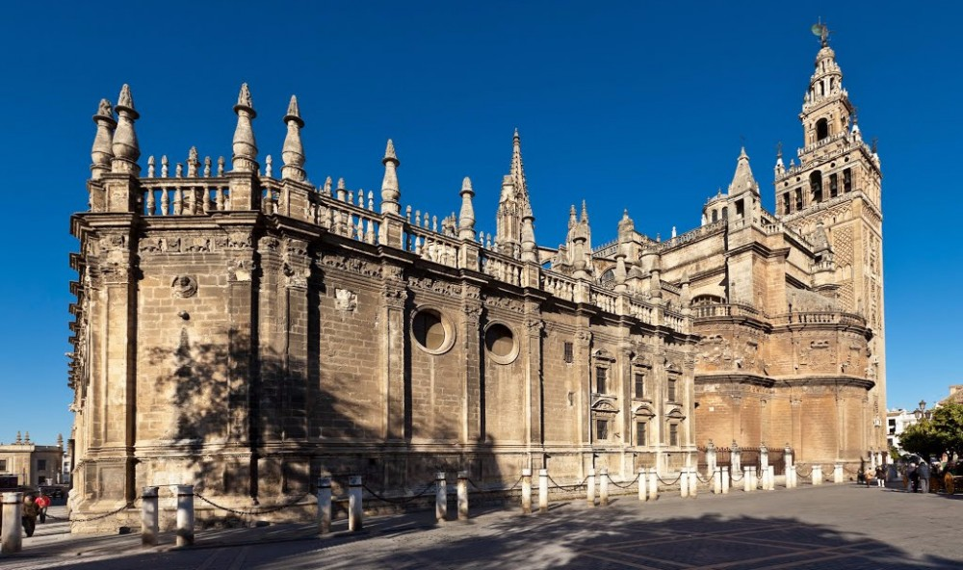

In 1248, the Castilian King Fernando III rescued Seville from its Almohad rulers and transformed their great mosque into a church. The Seville Cathedral has got 5 naves and 25 chapels, which contains works of art by some of the most famous Spanish painters.

