La plaza de toros
This famous monument is “La plaza de toros” (in English, the bullring). It was built in the 18th century by Vicente San Martin, related with Baroque. The main artistical and typical ideas of this movement: The Baroque are an exaggerated and realistic art, they don´t have a central point, and its purpose was to represent the internal emotions.
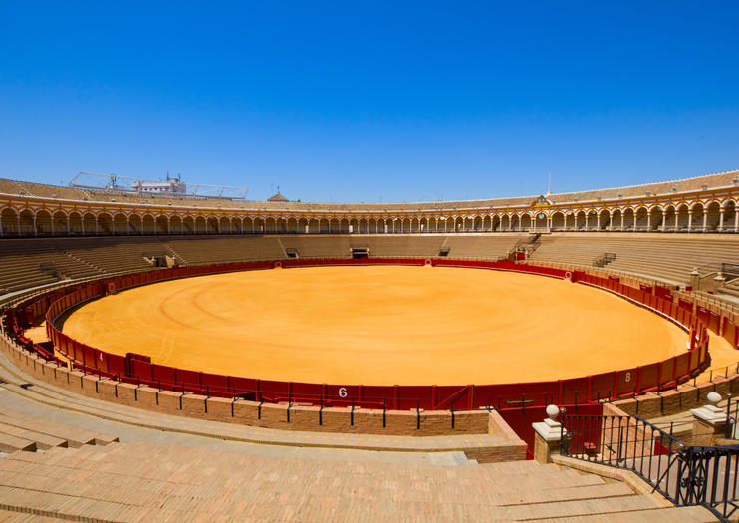
The front of the building is typical Baroque façade. Its main façade is located on the Paseo Colón, next to the Guadalquivir river. The main entrance is the Puerta del Príncipe. This door has two columns and it is decorated with marbles and a beautiful iron fence (dated in the 17th century), from a disappeared convent.
Inside, you can find a large oval that has an enclosure in the higher part, with a gallery of semicircular arches, and a series of corridors.

