ESCULTURAS SILENOS ( BAELO CLAUDIA)
Figures of the sileni appear bearded, naked, leaning each to one side on a pet's skin and supported at the elbow with semi-flexionadas legs. They are embracing a wineskin, which threw water by way of sources on two sinks attached to the wall of the scaena. The water game combined with the beauty of the sculptural group and liners made of that place a point of aesthetic reference inside the theater.
Marble. 50 x 55 x 190 cm and 45 x 55 x 190 cm end of the 1st century AD.
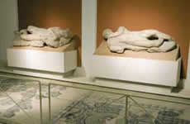

FORUM OF BAELO CLAUDIA
The Forum of Baelo Claudia was the big square of the city, Centre of legal, administrative, commercial, and religious life. It had dimensions of 115 by 87 meters. Around the large central square, the official buildings in the city were distributed.

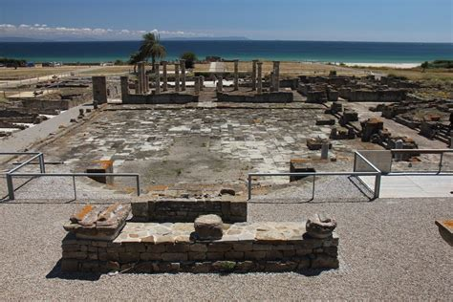

FACTORÍA SALAZÓN BAELO CLAUDIA
In Roman times it was called "cetaria" to this type of factories engaged in the processing of fish.
Have they been excavated a dozen factories of salting in Baelo Claudia, and all of them share a few common characteristics of this type of buildings.

