Fine arts museum.
It used to be a Convent, but in 1835 turned into an art museum. It has been changed several times, for example in 1942 the front of the building was removed. Most of the parts came from different Convents, so it has a baroque style.
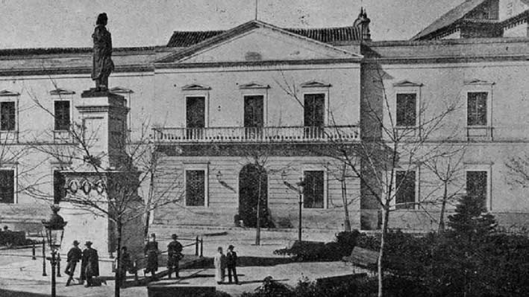
This was the first front of the museum. But it was changed for this one, that was taken from the other part of the Convent.
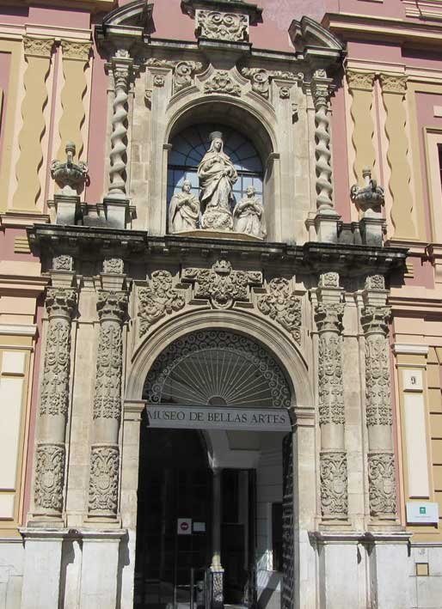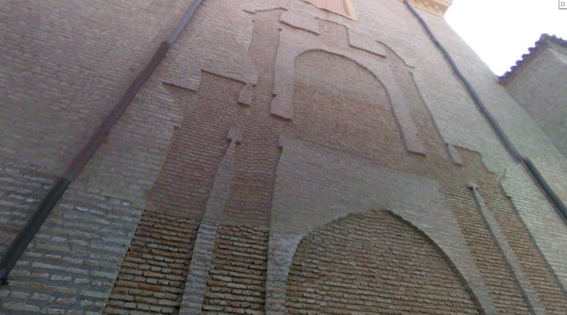
Moving on, the sculpture that we can see in the first picture represents Murillo, one of the biggest painters that we can see in this museum.

The museum has 3 patios, the Big cloisters, that has two parts, the upper and the lower, the Aljibe patio and the Bojes patio or Small cloisters.

This was the church, so we can see that it has latin cross shape. Here you will have to look for the painting called Virgen de la Servilleta. (Sala V)
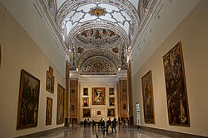
The parts that concern to the baroque are in the rooms V, VI (Sevillian baroque), VII (Murillo), VIII (Juan de Valdés), IX ( European baroque) and X (Zurbarán).

