EL SALVADOR CHURCH
The Salvador is a religious temple for Roman Catholic worship under the patronage of Our Lord San Salvador, located in the Plaza del Salvador in Seville and is the largest church in the city, after the Cathedral.
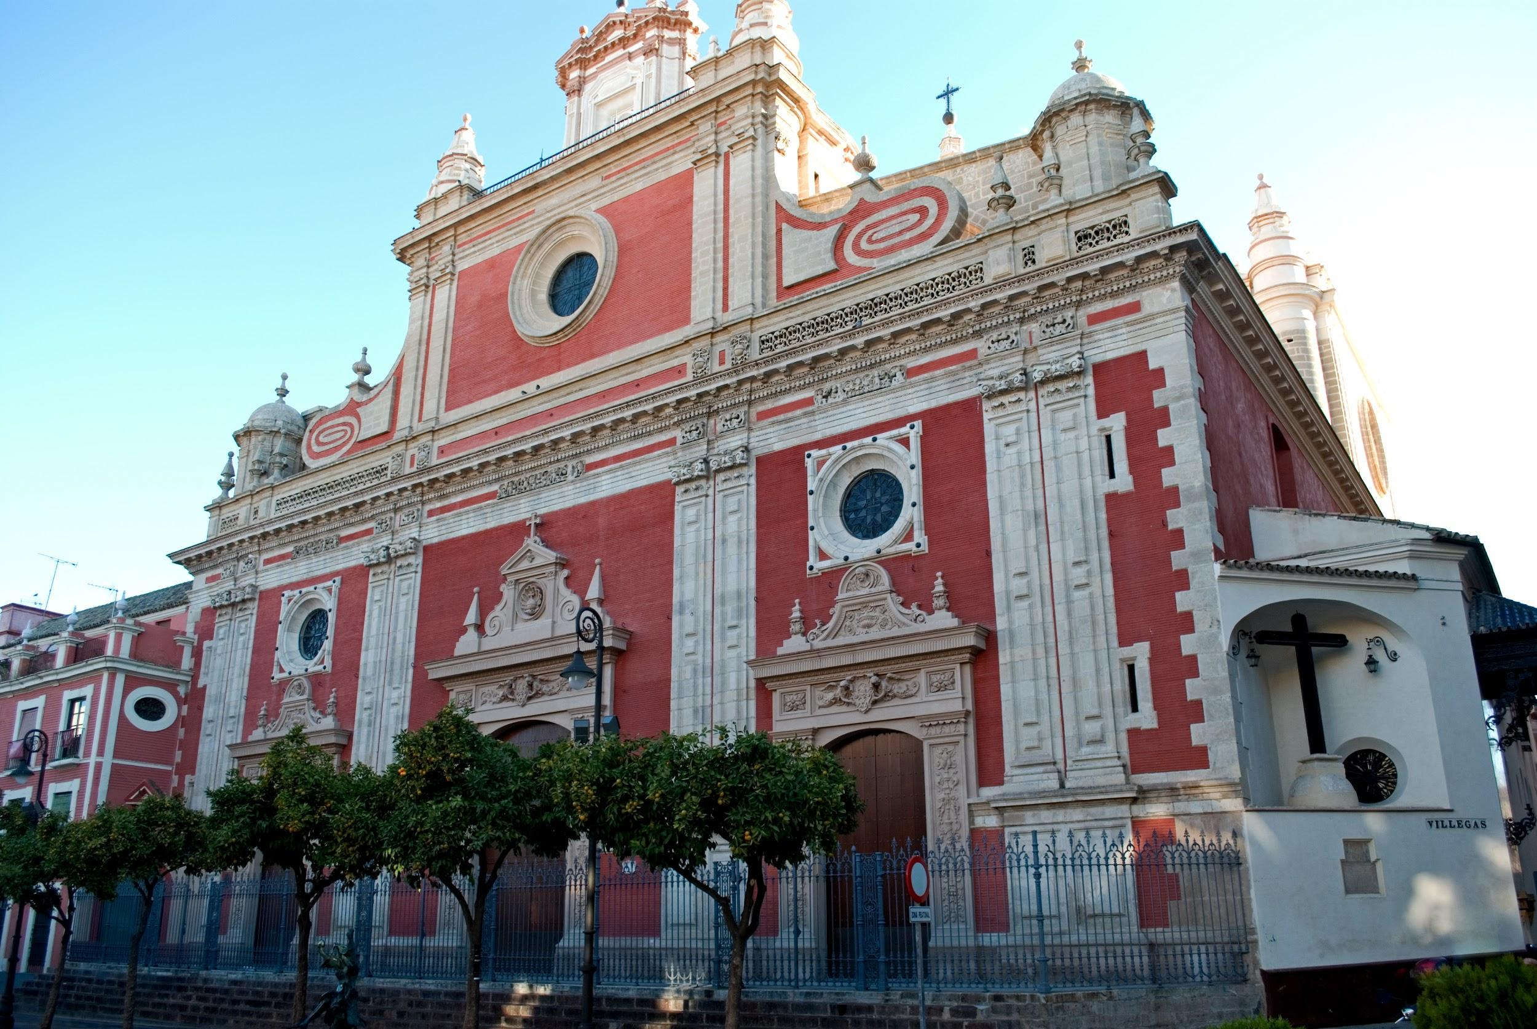

The building was erected on the remains of the Ibn Adabba, the Great Mosque of Muslim Seville (ninth century). This religious temple, as well as its surroundings, had great importance in the daily life of the people, which is why when the Christians conquered Seville, they allowed it to be used as a mosque in the beginning, but in 1340, it was converted into the parish of Salvador. In addition, it was agreed to maintain the ostentatious rank of the second temple of the city; for it was granted a collegiate character. Thus, this building would continue to be used religiously until 1671, when the passage of time left it strongly deteriorated. Its construction as we see it today began in 1674 with the architect Esteban García. Work ended in 1712 under the architect Leonardo de Figueroa. Later it would again be restored with work ending in early 2008, returning the temple to all its splendor.

7 curiosities that you didn’t know about the church of El Salvador:
1. It is the second largest church in Seville, after the Cathedral.

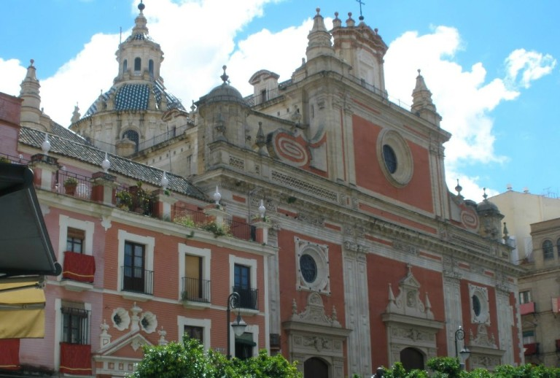

2. If you visit the patio of the church of El Salvador you can see remains
from the Roman and Visigothic times
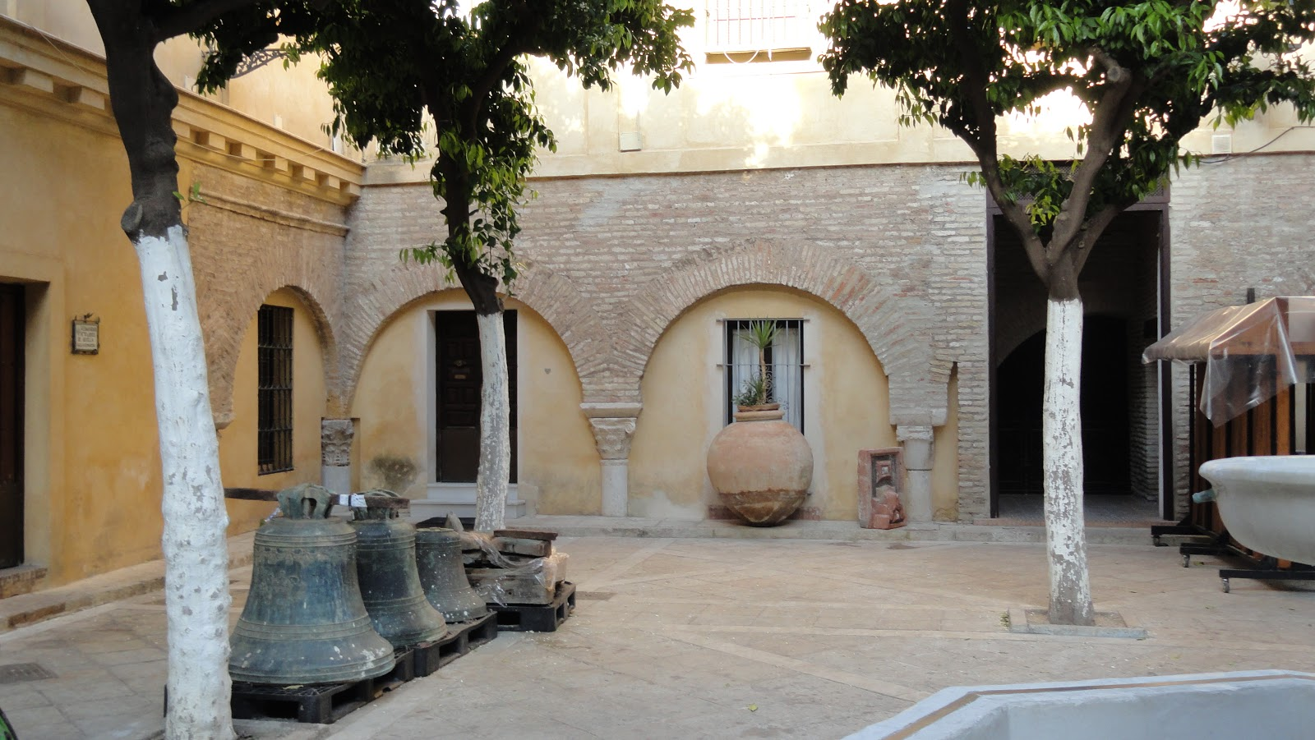

3. He was granted the character of a collegiate church to maintain the rank of the second temple of the city, being one more parish of Seville.

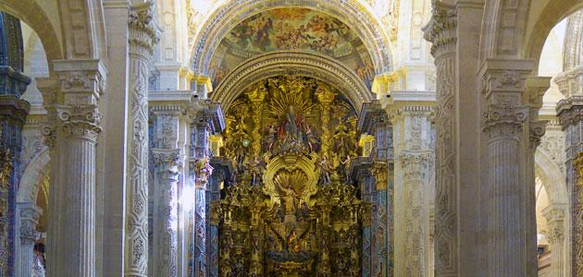

4. The church of the Savior, of Baroque style, has three covers, being the highest one that gives to the Plaza del Salvador. On this facade we can see two angels holding a shield with the Agnus Dei.
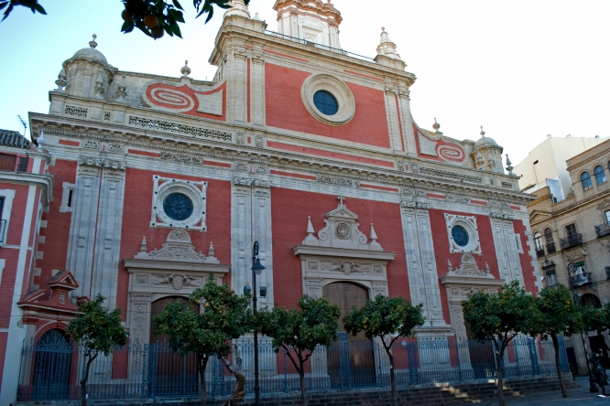

5. The Plaza del Salvador was also known as the Cemetery Square, since it was used as such until the 18th century.
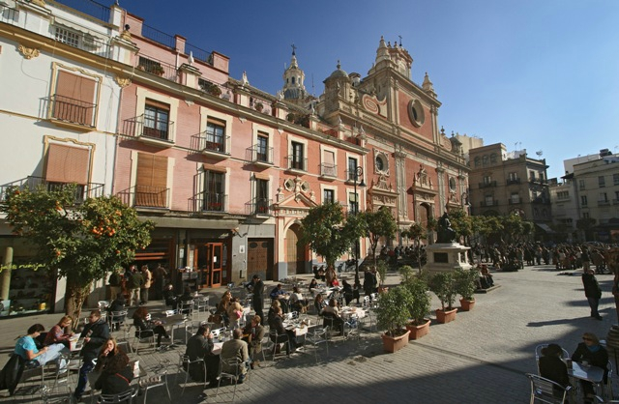

6. In the crypt of the Church of the Savior lie the bodies of Don Carlos de Borbón and Borbón, his children and his wife, Dona Luisa de Orléans, the granddaughter of Fernando VII and the grandmother of Juan Carlos I.
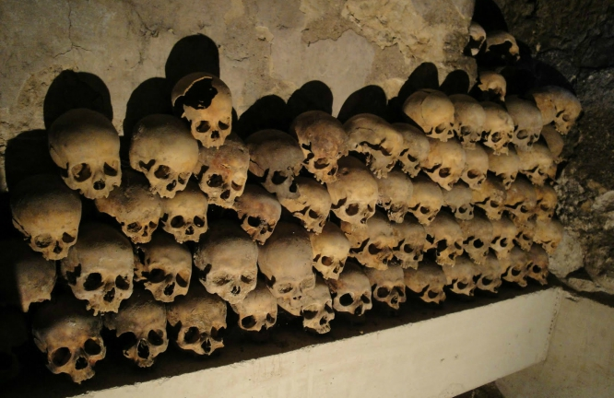

7. The Church of the Savior has been a movie theater in the film Nobody knows anyone in which Eduardo Noriega appears, witnessing a somewhat grotesque situation.
