Group 3: Cathedral/Giralda

CATHEDRAL
-What is it? When was it made?
It’s a Roman Catholic cathedral in Seville. It was made from 1401 to 1507 but there is no documentary evidence of the beginning of work until 1433. The building was made in the space that was left after the demolition of the ancient mosque of Seville.
-The cathedral of Seville is a gothic architecture
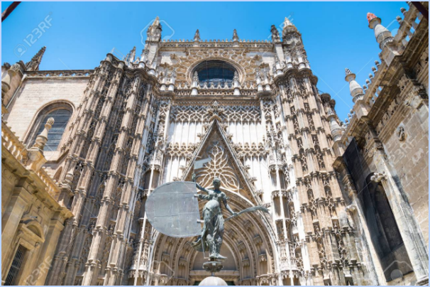

If you visit the cathedral you will see different types of architecture besides the Gothic because of the long duration of construction time. We can see Renaissance, Gothic and Neo-Gothic styles

EL PATIO DE LOS NARANJOS
-What is it?

El patio de los naranjos is the sahn of the old Great Mosque.
When the Gothic building was built it was used as a cloister, although being open to the city has always been a place of passage, a public square, a market place and playground for children.

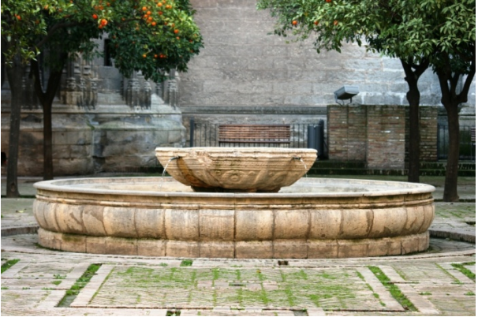

Today, the Patio de los Naranjos is one of the most important annexes of the Cathedral of Seville and is fully integrated into the tourist and cultural route, having become an area without religious meaning

QUIZ - (ANTONIO)
How many trees are there in the Patio de los naranjos of the cathedral?

GIRALDA
-What is it?

The Giralda is the bell tower of the Cathedral of Seville. Originally it was the minaret of the Almohad Major Mosque of Isbiliya.

World Heritage since 1987, not only stands out for its location and history, we must also emphasize its architectural invoice, its function over the centuries and its significance within the Old Town of the city. It was built in the image and likeness of the minaret of the Koutoubia mosque in Marrakech (Morocco).

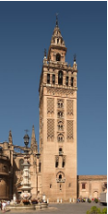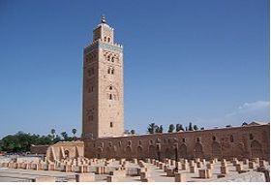

The Giralda measures 94.69 meters in height, including the Giraldillo, which measures 7.69 meters. It was for centuries the tallest tower in Spain, as well as one of the highest and most famous buildings in all of Europe. On December 29, 1928 was declared a National Heritage and 1987 Integrated in the List of World Heritage. Its unique and original architecture of exact quadrangular forms, adorned with turrets and pinnacles, has served as inspiration a multitude of later towers in the United States, Russia, Poland and other countries of the world.

QUIZ - (ANDREI)

How many windows have this place?

