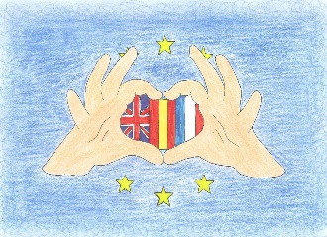
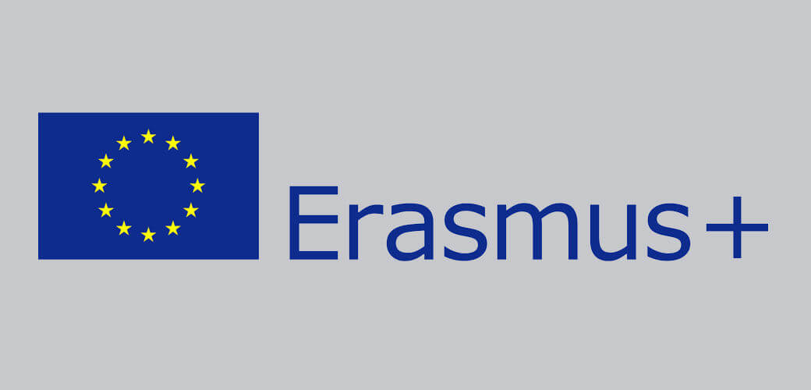
Co-funded by the
Erasmus +Programme
Of the European Union

One person in the team throws the dice, the smallest number starts.

Throw again the dice, if you make 1 or 4 it's a yellow question on Reunion Island.
If you make a 2 or 5 it's a pink question on England.
If you make a 3 or 6 it's a blue question.

If you answer correctly a yellow question you get a filao seed, if you answer correctly a pink question you get a palm tree seed, and if you answer correctly a blue question you get a volcanic rock (tiny bit...)
It's one question for one team only and then you change. You don't play again even if you answer correctly.

The winner is the team who is the first to have collected 3 of each : 3 filao seeds, 3 volcanic rocks and 3 palm tree seeds.

