WEDNESDAY
06/03/2019
PARTNERS ARRIVAL IN ALBACETE
THURSDAY
07/03/2019
MORNING:
Meeting at school
WORKSHOPS
AFTERNOON:
Visit The KNIFE
museum
FRIDAY
08/03/2019
MORNING:
Workshops (Carnaval)
AFTERNOON:
Carnaval (Villarrobledo)
MONDAY
11/03/19
Visit Toledo
and The Mills of campo de criptana
TUESDAY
12/03/19
Visit “Las lagunas de Ruidera”,
water activities and picnic
WEDNESDAY
13/03/2019
HEALTHY BREAKFAST AT SCHOOL
Travelling back to the United Kingdom

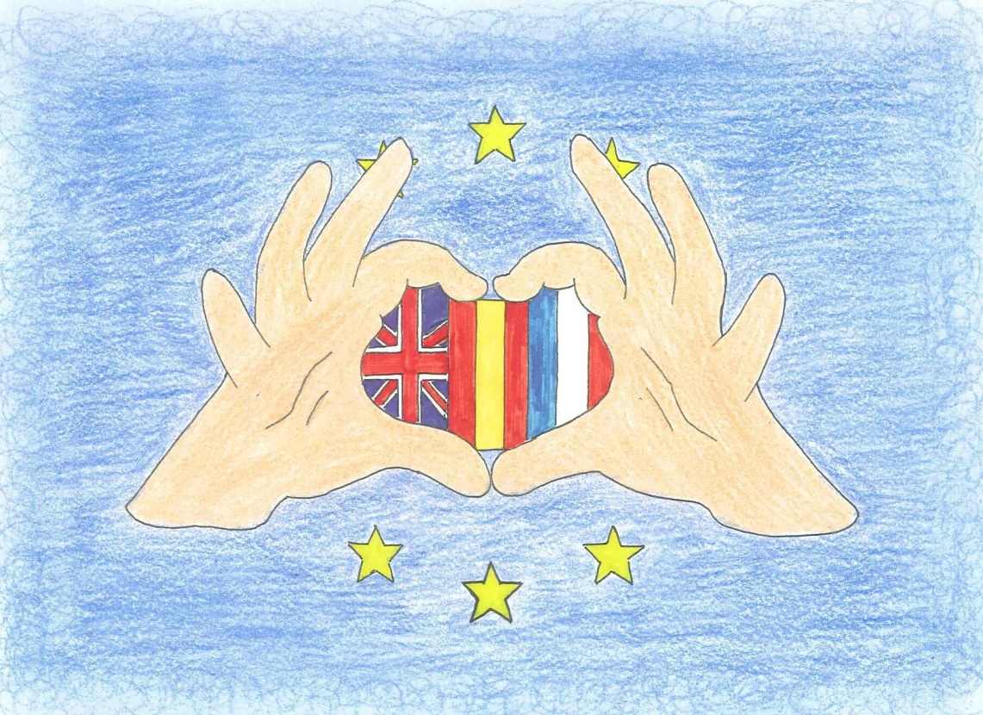

erasmus+

UNITED IN DIVERSITY

6-13 MARCH 2019

TRANSNATIONAL MEETING AT IES “ANDRÉS DE VANDELVIRA” (ALBACETE) SPAIN

PARTICIPATING COUNTRIES
KING’S SCHOOL (ELY) UNITED KINGDOM
COLLEGE CHALOUPE SAINT LOU (ISLA REUNIÓN) FRANCE
IES ANDRÉS DE VANDELVIRA (ALBACETE) SPAIN

WORKSHOP PROJECT:
GENERAL PRESENTATION
ACTIVITIES DISSEMINATION
SCHEDULE SETTLEMENTS

TARGET GROUPS OF THE ACTIVITIES:

STUDENTS (3rd de ESO)

