Intervju s migranticom iz Iraka

26.5 na satu informatike 6.b razreda imali smo intervju s migranticom iz Iraka, Aymen, koja nam je pričala o svom životu u Iraku i Hrvatskoj. I rado odgovarala na pitanja koja smo joj pripremili.
Aymen je iz Iraka došla u Hrvatsku 2014. godine jer je njezin suprug dobio azil u Hrvatskoj. Na početku nije znala Hrvatski, ali ga je počela učiti 2015. godine. Aymen je priznala da joj ne idu gramatika i pravopis i da još uvijek uči Hrvatski jezik. Smatra Hrvatsku lijepom državom, a Hrvate dragima, obrazovanima i druželjubivima. U Iraku je završila novinarski fakultet i radila kao novinarka sve dok nije otišla u Hrvatsku. Trenutno radi u Crvenom Križu kao prevoditeljica kako bi pomogla ostalim migrantima kojima treba pomoć. Najvažniji privlačni čimbenik joj je bila sigurnost. Kad je saznala da će otići u Hrvatsku, postala je znatiželjna i počela istraživati o njoj. Njezina je želja da sva njezina obitelj koja je ostala u Iraku dođe i živi s njom u Hrvatskoj.
Lana i Aymen su nam objašnjavale što migranti trebaju napraviti da postanu građani neke države. Na početku smo prošli kroz prezentaciju koju su pripremile za nas.
Lana je socijalna radnica u Crvenom Križu. Pričala nam je što sve rade u Crvenom Križu, kako slave Međunarodni dan migranata i o čimbenicima poticanja i privlačenja. Pokazivala nam je slike svakodnevnih aktivnosti migranata. Objasnila nam je da su migracije promjena mjesta boravka ljudi. Mogu biti dobrovoljne ili prisilne, a da su migranti osobe koje su napustile svoje domove u potrazi za novim prilikama za sigurniji i bolji život.
Naučili smo mnogo novih stvari kao naprimjer da na palmi ne rastu samo kokosi, nego i Datulje. Svima je bilo lijepo, zabavno i zanimljivo, a najviše nam se svidjelo to što smo saznali da u Iraku nema nikoga tko se preziva Mahin!

Izidora Tomec, Manuela Medoš - 6.b

Interview with a refugee from Iraq

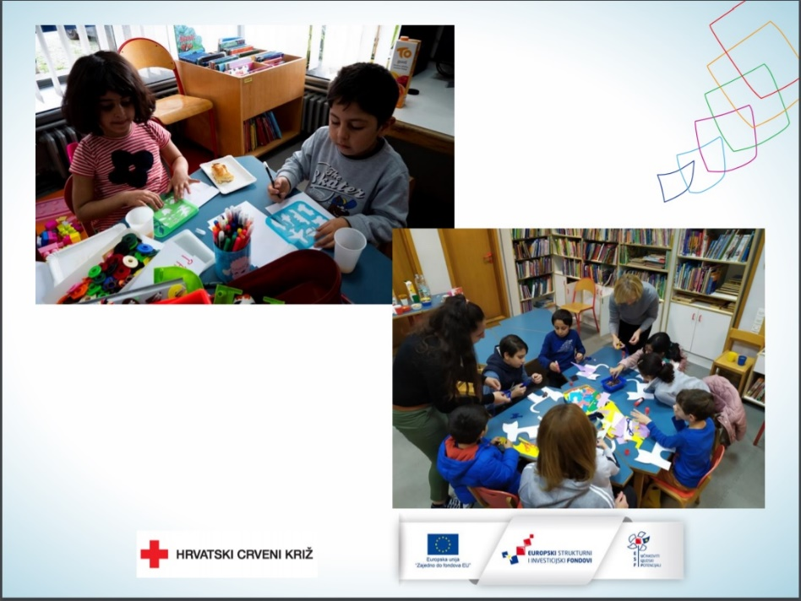
On 26 May 2021 in our ICT class we had an interview with Ms Lana Vučinić, a social worker at the Croatian Red Cross’ Migrant Protection Service, and Ms Aymen Ameen Abd Ali Al-Mimar, a refugee from Iraq.
Aymen told us about her life in Iraq and Croatia and gladly answered the questions we prepared for her. She came to Croatia from Iraq in 2014 because her husband was granted asylum in Croatia. At first, she did not know Croatian, but she started learning it in 2015. Aymen admitted that she is not good at grammar and spelling and that she is still learning Croatian. She considers Croatia a beautiful country and Croatian people kind, educated and friendly. She graduated from the college of Journalism in Iraq and worked as a journalist until she went to Croatia. She currently works at the Red Cross as a translator to help migrants who need help. The most important immigrational pull factor for her was safety. When she found out that she was going to Croatia, she became curious and started researching it. Her wish is that her entire family which stayed in Iraq comes to live with her in Croatia.
Lana and Aymen explained to us what migrants need to do to become citizens of a state. At the beginning, we went through a presentation they prepared for us. Lana told us what they do in the Red Cross, how they celebrate International Migrants Day and about the migrational push and pull factors. She showed us pictures of the migrants’ daily activities. She explained to us that migrations are changes in where people live. They can be voluntary or forced, and migrants are people who have left their home in search for a safer and better life.
It was nice, informative and interesting for everyone in the class.

