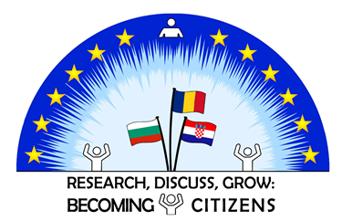

PROJECT AGENDA
C2 - Short-term exchange of groups of pupils in our project Erasmus + "Research, Discuss, Grow: Becoming Citizens" that will be held at our school, 25. Primary School „Dr. Petar Beron“, Sofia, Bulgaria
from March 21 to March 25, 2022

WORKDAY 1: Monday MARCH 21TH, 2021
09:20 – 10:00 | Welcome to our school! Greeting from our headmistress.
10:10 – 10:30 | Activity 1: presentation of the project coordinators from each partner country
10:30 – 11:00 | Coffee break
11:00 – 11:30 | Аctivity 1: Presentation of the students participating in the project ( one group representative for each country).
11:30 – 12:00 | Presentation on "Stereotypes - before and now". Discussion.
12:00 – 12:15 | Time break
12:15 – 13:00 | Activity 3: Making a poster with slogans - painting, coloring, design.
13:00 – 14:00 | Lunch
14:00 – 16:00 | Walking tour of Sofia. Return to the hotel.

WORKDAY 2: Tuesday MARCH 22^{H}, 2021
09:00– 10:15 | Wellcome again! Presentation of a presentation on "Stereotypes in my country". Discussion.
10:15 – 10:45 | Coffee break
10:45 – 11:45 | Lecture on the topic: "Children's stereotypes - one a different view".
11:45 – 12:00 | Time break
12:00 – 13:00 | Meeting with a guest lecturer. Workshop.
13:00 – 14:00 | Lunch
14:00 – 15:00 | Free time to make a movie about stereotypes.

WORKDAY 3: Wednesday MARCH 23TH, 2021
09:00-10:00 | Workshop - modeling a character wearing a chosen stereotype
10:00 – 10:30 | Coffee break
10:30 – 11:00 | Exhibition of maked art products
11:00 – 13:00 | Workshop - t-shirt design on “Stereotypes”
13:00 – 14:00 | Lunch
14:00 – 15:00 | Presentation of the films made according to a chosen stereotype.

WORKDAY 4: Thursday MARCH 24TH, 2021
08:30 | Picking partners from the hotel.
09:00 -16:30 | Excursion on the route Sofia - Koprivshtitsa.
16:30-17:00 | Return of the partners to Sofia.
19:00 – 21:00 | Official dinner of the project participants.

WORKDAY 5: Friday MARCH 25ST, 2021
09:00-10:30 | Lecture by Dr. Vanya Kastreva - Head of the Regional Department of Education – Sofia town
10:30-11:00 | Coffee break
11:00-12:40 | Meeting with a school psychologist. Creating mind maps.
12:40-13:00 | Official presentation of certificates for participation of the participants in the project.
13:15 | End of meeting. Goodbyes!

