QUIZ about POLAND
- Which is the largest city in Poland?
a)Warsaw
b)Poznań
c)Gdańsk
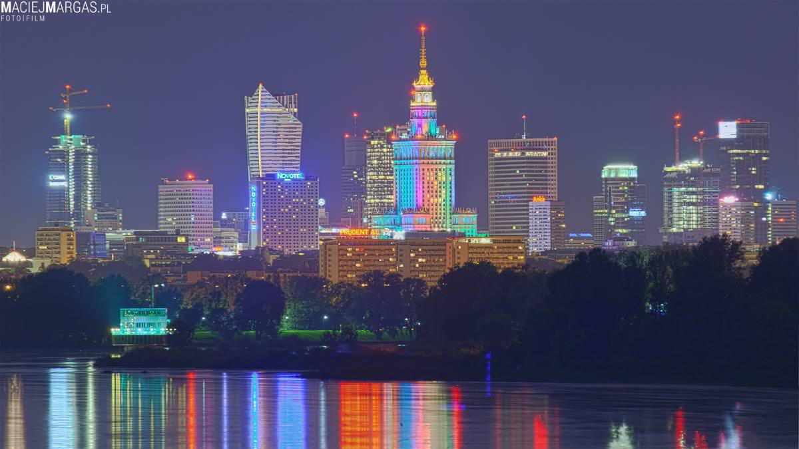

2.What is called Polish President?
a)Andrzej Duda
b)Andrzej Doda
c)Andrzej Kaczyński
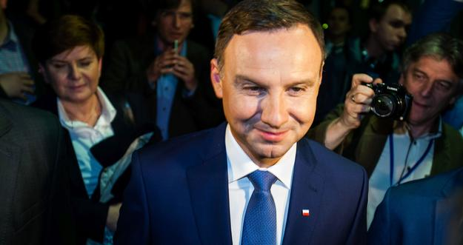
3. What is the largest national park in Poland?
a) Bialowieski National Park
b) Kampinoski National Park
c) Biebrzański National Park
