Shrove Tuesday (vastlapäev)
is celebrated 7 weeks before Easter, either in February or March (no fixed date).

IN THE PAST
People went sledging on that day. Sledging was considered to be an important activity as the longer the slide, the longer the stem of flax would grow during the summer.
It was a day to cut hair, as it was believed that your hair would grow strong and it was advised to brush your hair seven times.
Women’s jobs were forbidden, especially spinning yarn as it was thought such activities would bring bad luck to sheep. It was allowed to tie and make ropes. Lighting a fire was believed to be harmful to horses and livestock. After eating, the bones left were labelled with a name and given to the dog. Whose bone the dog picked first was to find a husband.
Bone spinners were made of bones of pigs’ feet and there were competitions for the best spinner.
It was forbidden to light a fire or to spin lamb’s wool. It was advisable and customary to comb and cut hair.
Traditional food was soup made of peas and beans and boiled pigs’ trotters.

NOWADAYS
Sledges, boards and plastic are used for sliding. Children learn to make humming spinners using big buttons. These days the most important and popular Shrove Tuesday food is pea soup and buns with whipped cream. They are served at schools and kindergartens, and at home.

RECIPES
Shrove Tuesday Soup
Ingredients
- (broth from 1 kg of pork)
- 0,5 litre boiled/stewed Sauerkraut.
- 100 g prepared or canned beans
- 1 dl prepared, pre-cooked barley groats
- 100 g dried plums
- 1 onion
- 1 glove garlic
- 50 g butter
- salt, pepper, bay leaf, mustard. If cabbage has not enough acid, add some vinegar or lemon/cranberry juice

Directions
- Melt butter, and add chopped onion, garlic and prepared barley. Mix and add boiling water (or /and broth)
- Cook until barley is soft
- Add plums, prepared beans, and sauerkraut. Let simmer and flavours blend.
- Season finally
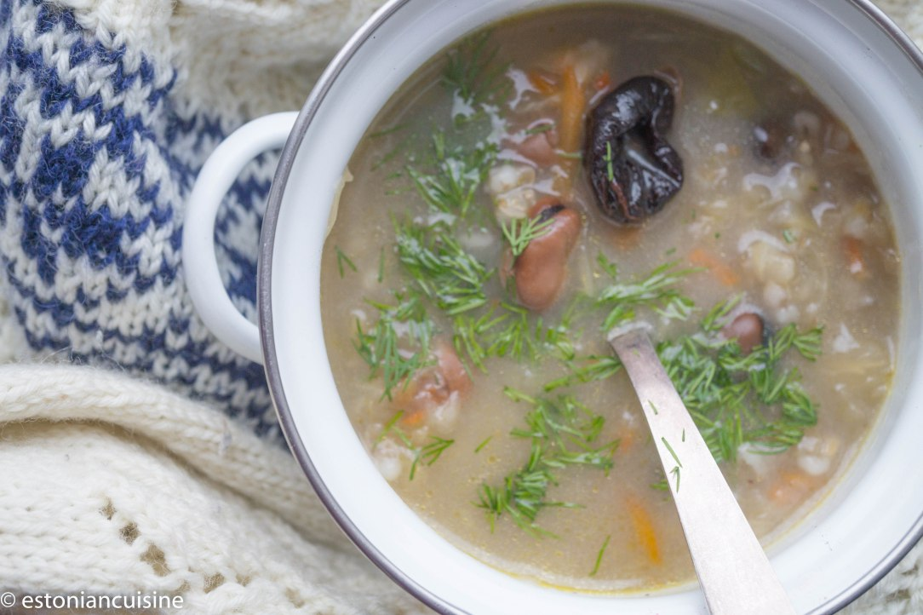
Source: https://estoniancuisine.com/2018/02/06/shrove-tuesday-soup/

Traditional Estonian Pea Soup
Ingredients
- 500 g pork, best is (smoked) leg or ribs or pork belly
- 0,5 glass of pearl barley
- 400 g dried yellow peas
- 1 onion, sliced
- 2 carrots, sliced
- for seasoning salt, mustard, pepper, garlic

Directions
- One day before, put peas and barley to soak in to cold water
- Put all ingredients in to pot and add 3-3.5 litres of water
- Bring to boil and remove the foam
- Decrease heat and let soup to simmer at a low heat min 2 hours
- Season and serve
Source: https://estoniancuisine.com/2017/02/27/estonian-pea-soup-hernesupp/

Shrove Tuesday Buns (buns with whipped cream)
A traditional Shrove Tuesday dessert after Pea Soup and Pork legs
Ingredients
- 2 dl milk
- 25 g yeast
- 3 tablespoon sugar
- 1 egg
- 100 g butter
- 1/2 teaspoon salt, 1 teaspoon cardamom
- 6 dl flour
- 1 egg for coating buns
Directions
- All materials must be in room temperature
- Dissolve yeast with lukewarm (37C) milk and sugar
- Add about half of the quantity of flour, mixed with salt
- Beat the mixture for a short time. Sprinkle with a little flour, cover the bowl with a towel and place in a warm place to rise for ca 1 hour
- Add additional flour, cardamom
- Add melted butter and the beaten egg
- Knead the dough properly, until it separates from the bowl.
- Sprinkle with a little flour, cover the bowl with a towel and place in a warm place to rise for ca 1 hour until dough has doubled in size. During rising beat the dough 2 times back.
- Form the dough into rounds buns and place on the greased /baking paper covered oven plate to rize ca 15 minutes.
- Coat buns with beaten egg before putting into the oven. Bate at 200C 15 minutes.
- Let buns cool completely. Cut off a thin slice from top of buns. Whip the cream, sugar and vanilla until firm. (Add a teaspoon of cranberry or cowberry jam) and pipe the cream onto the buns and cover with cut off part.
- Decorate with icing sugar.
Source: https://estoniancuisine.com/2017/02/17/shrove-tuesday-buns-vastlakuklid/

