Presentation of Development Projects (November 24, 2014)
Philippines
1. Localisation on the world map  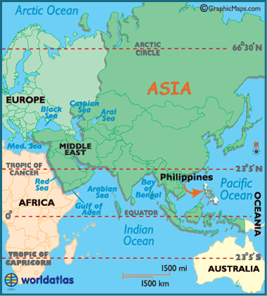 | 2. Orientation in the country  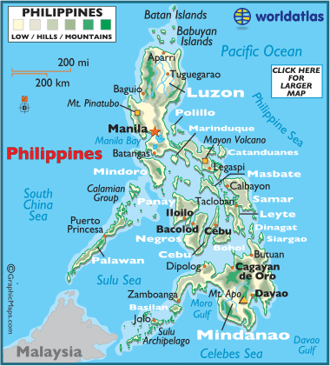

3. Initial situation (status quo)
- Problem
- Causes

4. Motivation of aid organisation

5. Measures
- Approach (practical/technical)
- Expected effects
- Problems (e.g. cross-cultural)

6. Acceptance among population

7. Participation of persons concerned

8. Sustainability
- ecological
- economic
- social

