Hello
- Hello, my name is Daniel Czepczor.
- I am 13 yers old.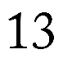
- I am from the Czech Republic.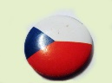
- I live in village Dolní Lomná.
- I have one sister, Mom and Dad.
- I have one small dog.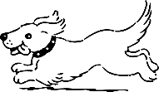
- I go to school in Návsí.
- My favourite food is pizza. 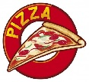
- I don’t like broccoli. 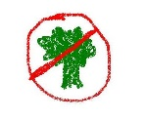
- I love playing football and hockey.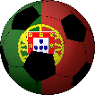
- I like to ride on a longboard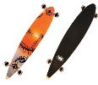, bike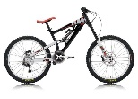 and ski.
- I would like to stay with some nice girls.

