Folk Costumes

**Lesson Activity**

1. **Read the information about the Jablunkov folk costume, look up the underlined words.**

The story of the Jablunkov folk costume

This object was used as a folk piece of clothing. It was made by hand-knitting and sewing. White, silver and gold were colors in the costume.

Jablunkov folk costumes were costumes decorated with silver *buttons*, *belts*, *necklaces and pendants*, *buckles,* and *filigree beads*.

Trousers, short *waistcoat*, jacket lined with fur, white shirt, silk *scarf*, high leather boots and cap lined with fur were parts of the men's folk costume and white shirt, woolen or silk skirt with a silver or golden lining, and *petticoat*, waistcoat, embroidered *apron*, woolen stockings were part of the women’s folk costume. Single women wore their hair plaited and coiled into a *chignon*, married women wore their hair covered with a *bonnet*, white cloth and lace.

1. **Label the pictures with the words in *italics*!**

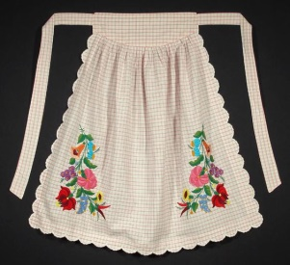 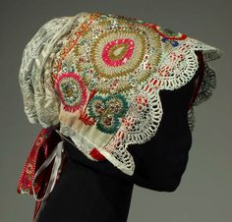 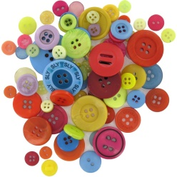 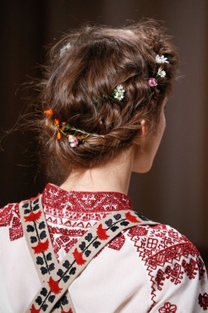

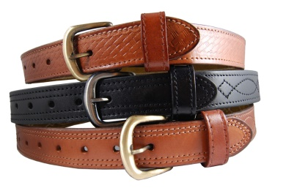 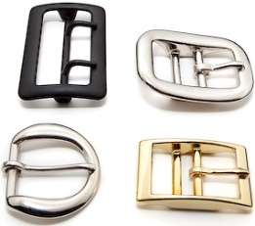 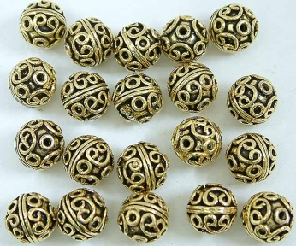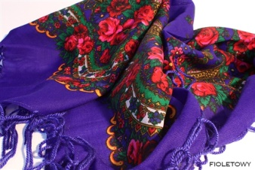 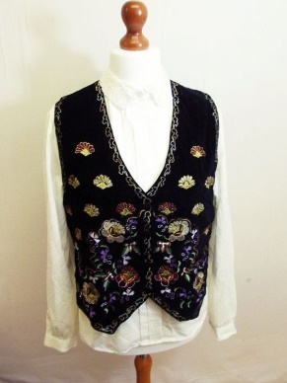 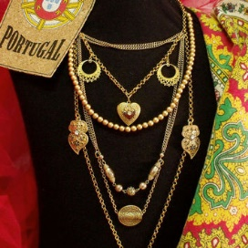 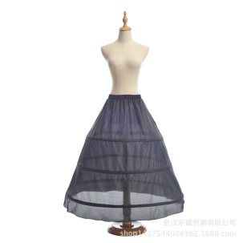

1. **Draw the picture of Jablunkov man/woman folk costume and then compare it with the original!**



Jablunkov folk costume